Lego Renault Premium Lander Instructions
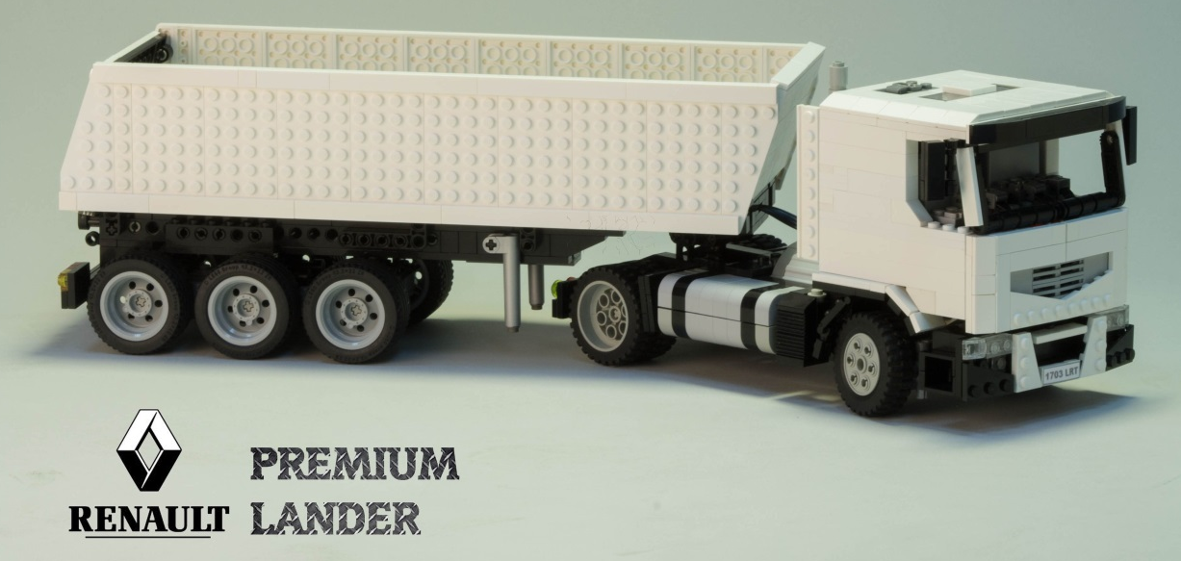
First I want to say thanks for downloading these instructions. This PDF is made because the model has some pieces attached in a strange way so I can`t connect them properly in the LDD file, also there’s some pieces that don’t appear in the program.
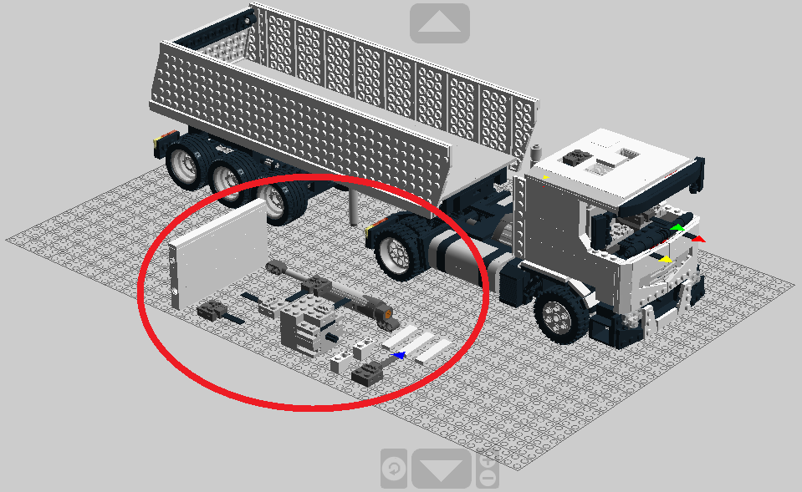
Here are the pieces that I couldn’t connect; you can see them more precisely in the LDD file. Also there are 2 pieces unavailable in the program. I tried to recreate the 9v motor in the file.

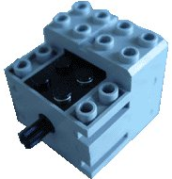 | 9v Motor – (X1)
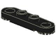 | Technic Plate 1 x 4 with Toothed Ends – (X2)
First this two pieces need to be attached to the bumper of the truck as it is shown below.

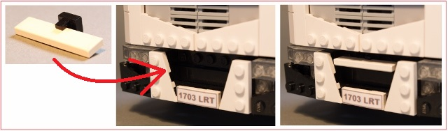
Then attach the technic plate 1x4 with Toothed Ends and the 1x4 white tile to the round.

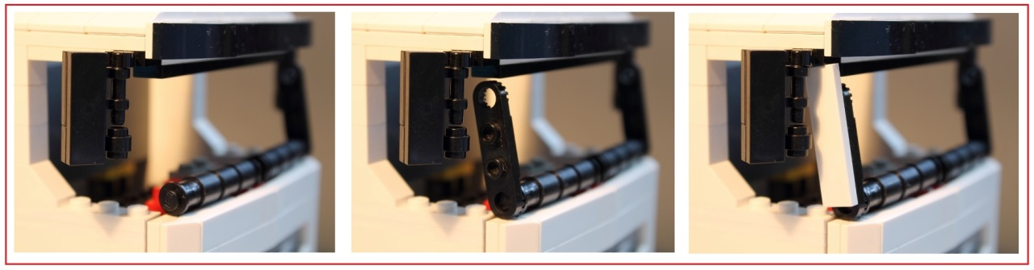
You need to connect the wires to the receivers and attach the end of the wire from the trailer motor to the back of the cab.

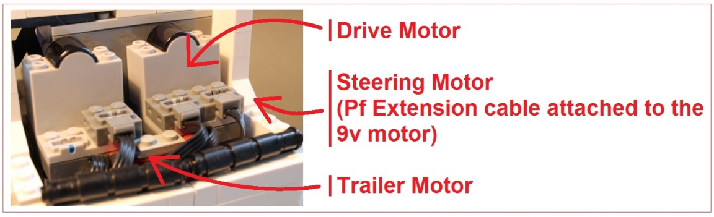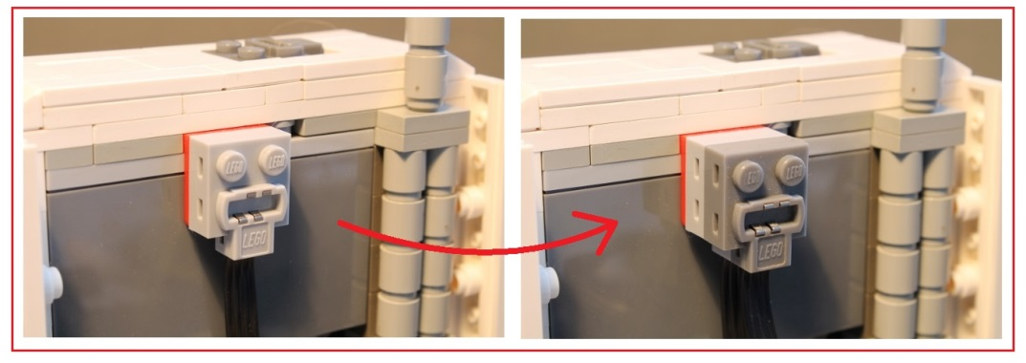
After that, attach this block of pieces to the trailer as it is shown in the following pictures.

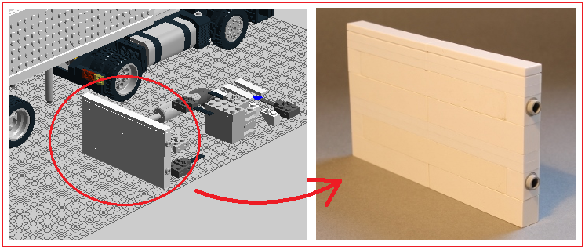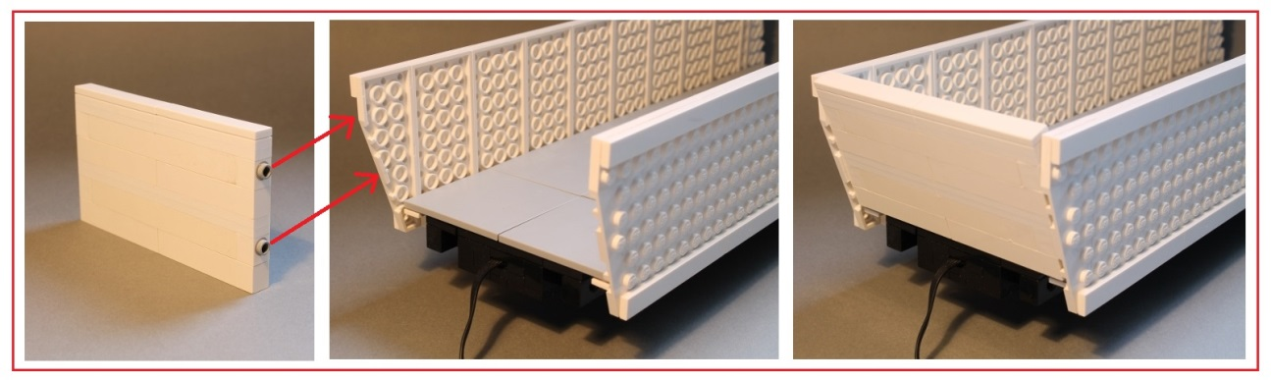
Now connect the linear actuator.

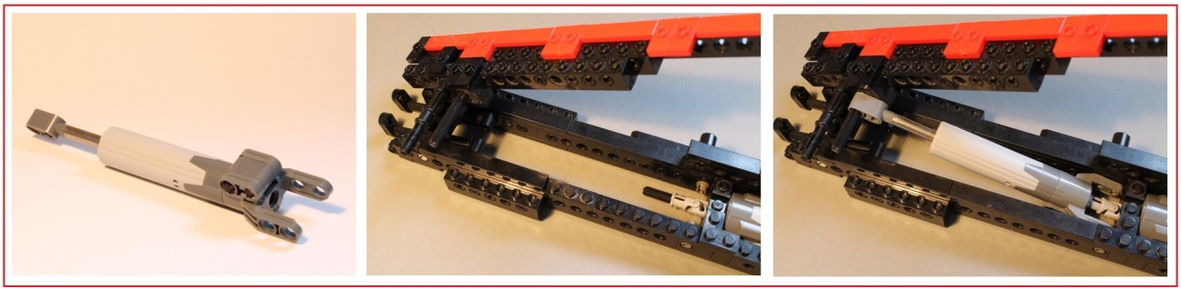
Finaly put the wire that comes from the trailer motor like in the picture below.

