FOR IMMEDIATE RELEASE
Contact:
Flemming Gammelgaard
+45 3010 2631 / flemming.gammelgaard@LEGO.com

LEGO® Factory to become LEGO Design byME

The LEGO Group to launch LEGO® Design byME greatly enhancing the LEGO Factory customization service.

(BILLUND, DENMARK, AUGUST 31, 2009) On October 1, LEGO Factory will become LEGO Design byME when the all new LEGO Design byME site goes live, and the enhanced LEGO Digital Designer (LDD) 3.0 freeware is also released.

LEGO Design byME introduces superior building, a new custom designed quality box plus a printed building guide for a premium building experience.

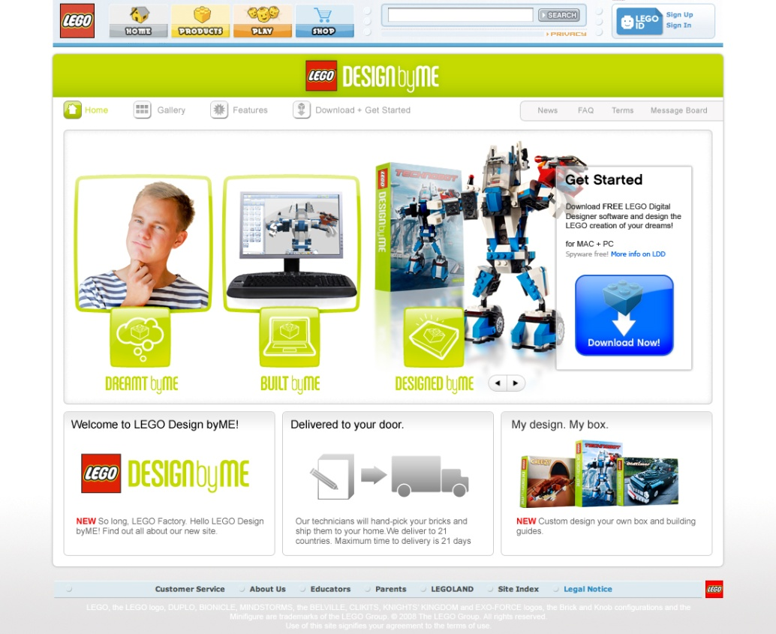

The LEGO Factory customization platform will be upgraded through the following key changes:

- Customizable box design in poster quality: a high quality sleeve that fits around the core box, and enables users to design the front and back, including name and rendered photo of the model, and the “Design by [FIRST NAME]” opportunity. (Below photos are illustrative of what can be designed. Fonts and backgrounds may vary)
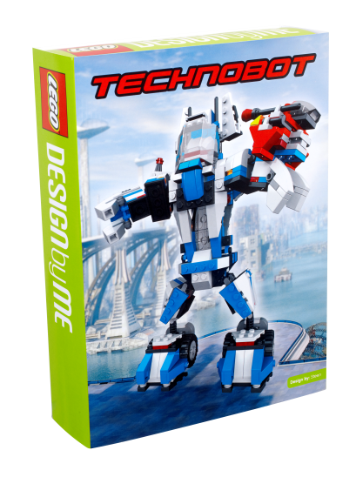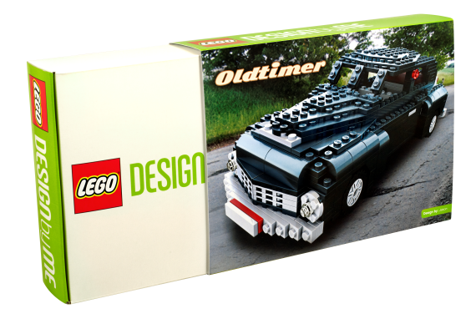
- High quality, printed building guide inserted in the box for a fully professional building experience; as opposed to building from LDD online or downloading/ printing PDF as is currently required.

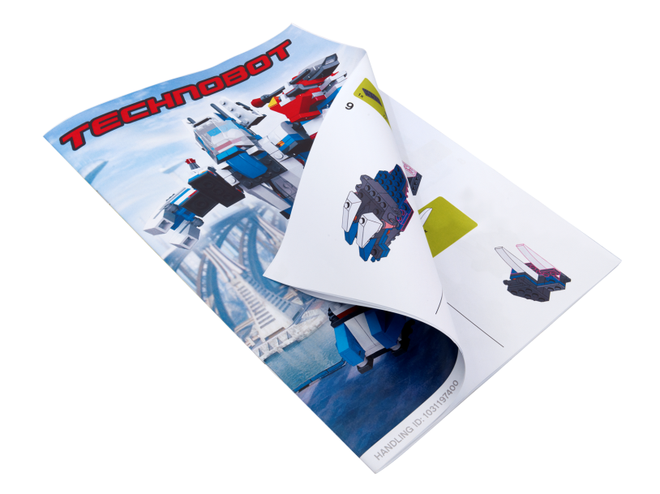

- 50% more bricks; from 950 to 1481 different LEGO elements (introduced in April 09)
- New, enhanced LDD 3.0 software (see box below).

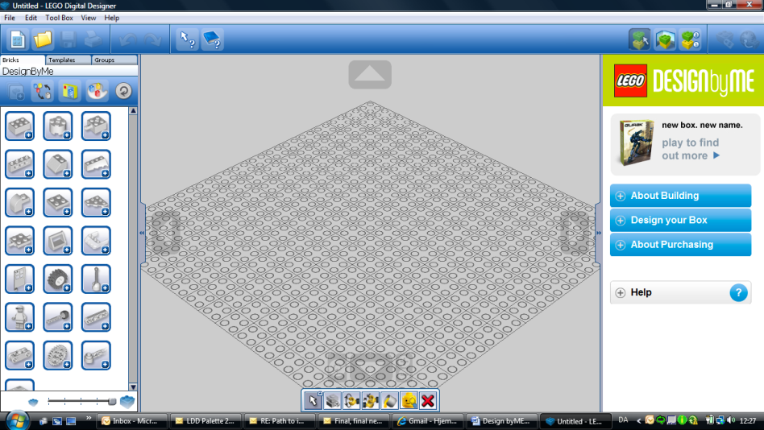

- New name, logo and playful and friendly tone of voice.

- A $10 service fee will be added to orders to offset costs of the box and building instructions.

The LEGO Design byME customization service can be experienced as of October 1 at www.Designbyme.LEGO.com. The Design byME team will also take part in BrickCon 09 from October 1-4. Here, the team will give service demonstrations and answer questions about the new service.

Background
LEGO Design byME builds on the LEGO Factory customization platform officially introduced in 2005. Starting out as an experiment based on limited experience within the field, LEGO Factory has gradually changed and expanded based on valuable input from LEGO ambassadors, fans and other users. Today, the LEGO Group has a production setup for handling personalized orders in Poland, where each brick is handpicked. This uniquely packaged order will then be received by the customer within 21 days, which is in full compliance with global standards for customized offers.

LDD 3.0 – New features:
- Online Panel
  - Integrated buying experience
  - Tutorials and hints

- Improved User Interface
  - Docked palettes
  - Panel structure
  - In-context camera control
  - Scalable icons

- Building Guide Mode
  - Completely redesigned user interface
  - Simple and more intuitive control
  - Sub-assembly overview

- Template Tool
Makes it fast and easy to group and organize your creations

- Buyability Tool
Helps you choose the right bricks when you are optimizing the model for purchase

- Updated Hinge Tool
Enhanced brick rotation control

- Hide Tool
Lets you hide bricks in order to improve your focus on building

- Improved Performance
Supports bigger models

