TransFormers: Last Stand of the Wreckers
Characters
-Springer:
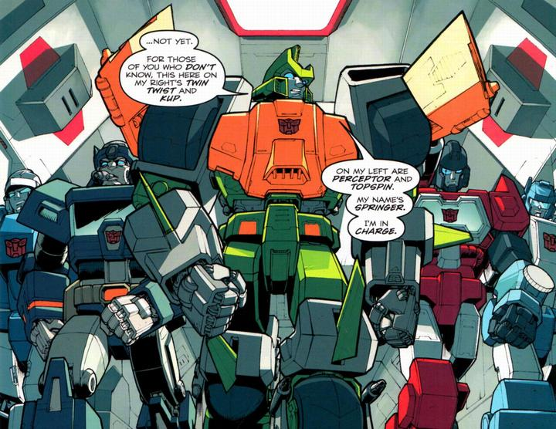
Comic Picture:

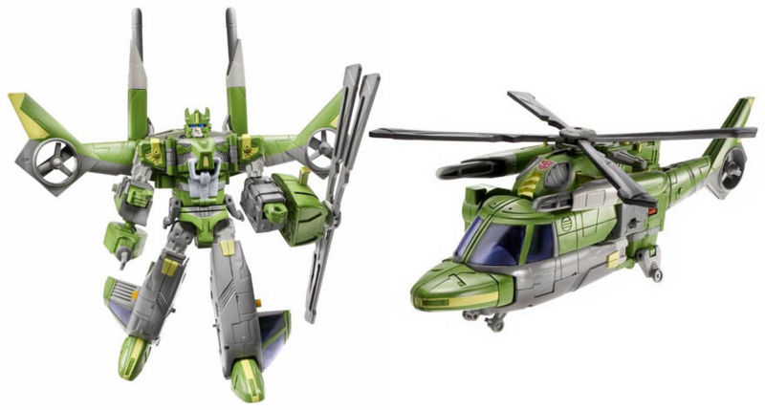
Official Figure:

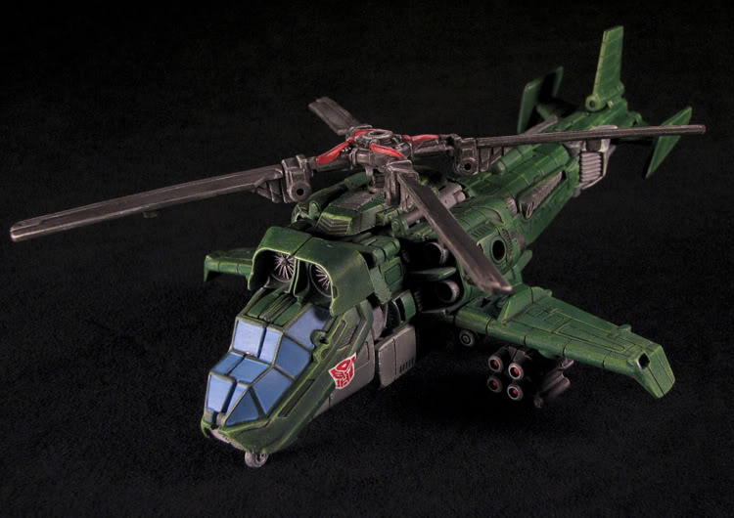
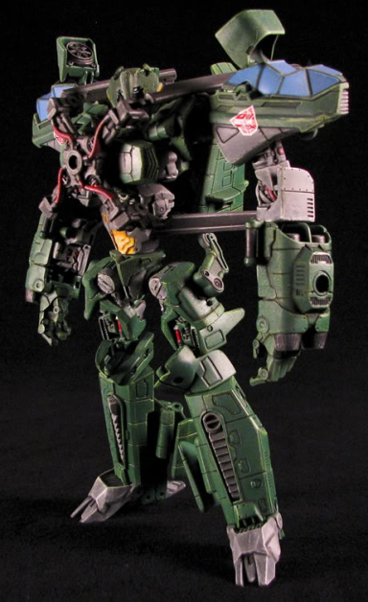
Custom Figure:

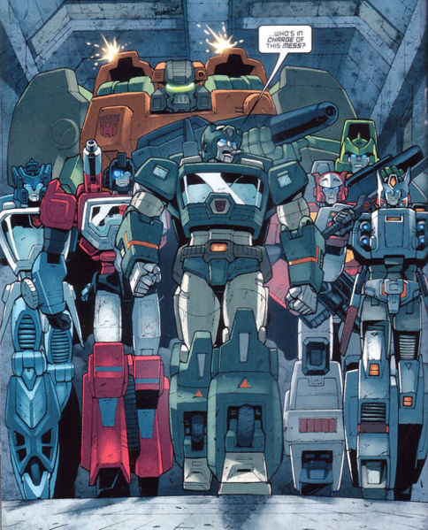
-Kup:
Comic Picture:

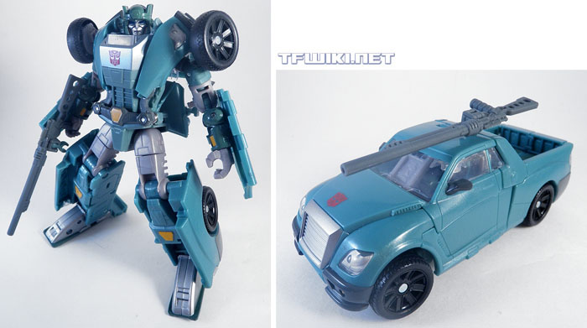
Official Figure:

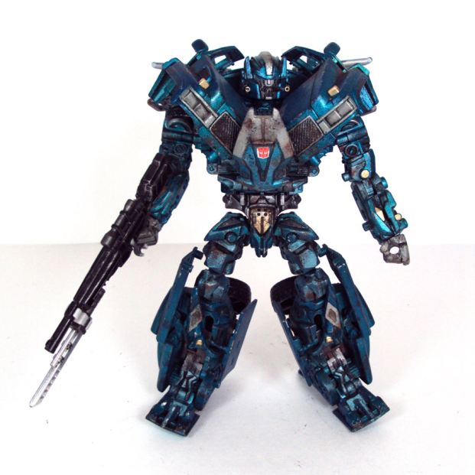
Custom Figure:
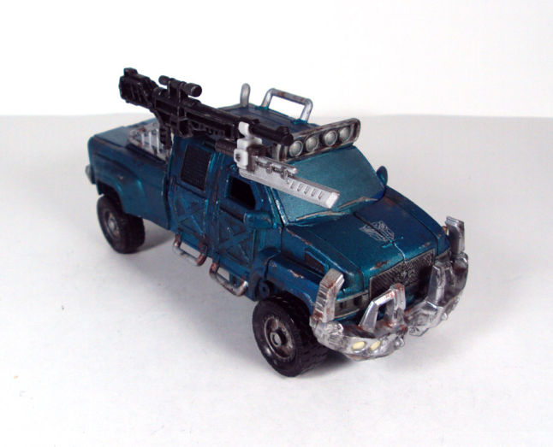

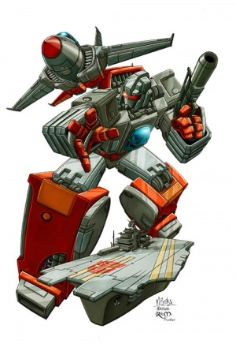
-Broadside:
Comic Picture:

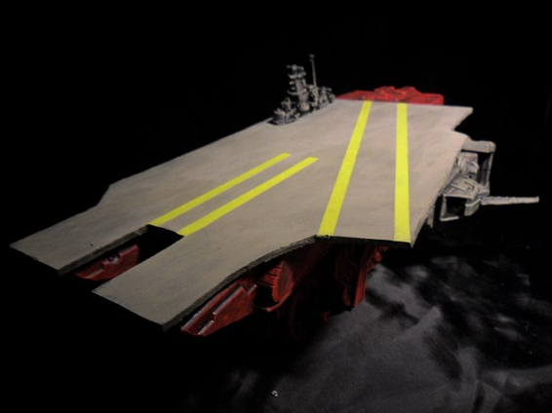
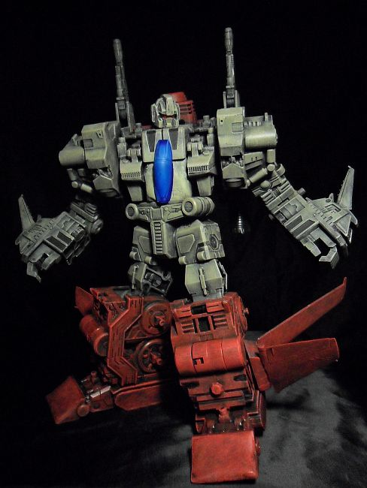
Official Figure: Not Available
Custom Figure:

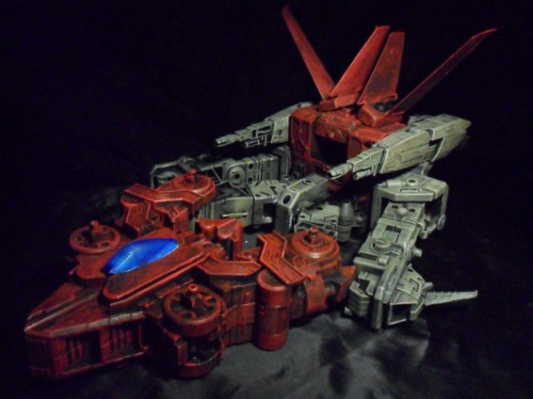

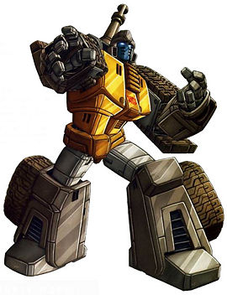
-Guzzle:
Comic Picture:

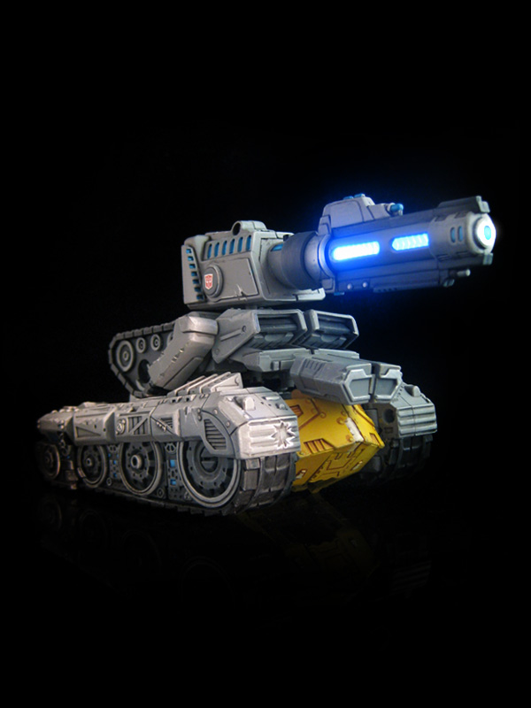
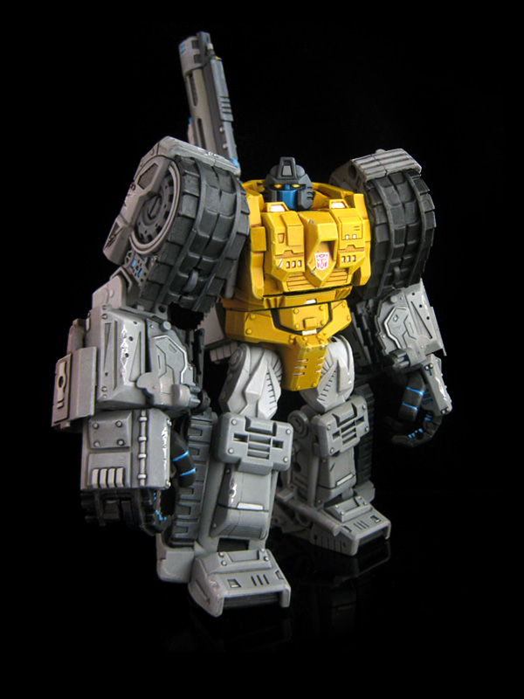
Official Figure: Not Available
Custom Figure:

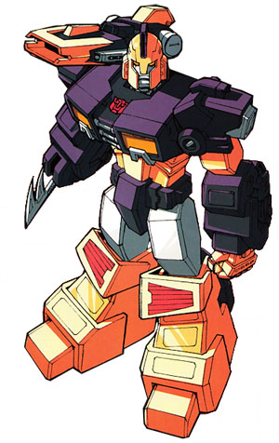
-Impactor:
Comic Picture:

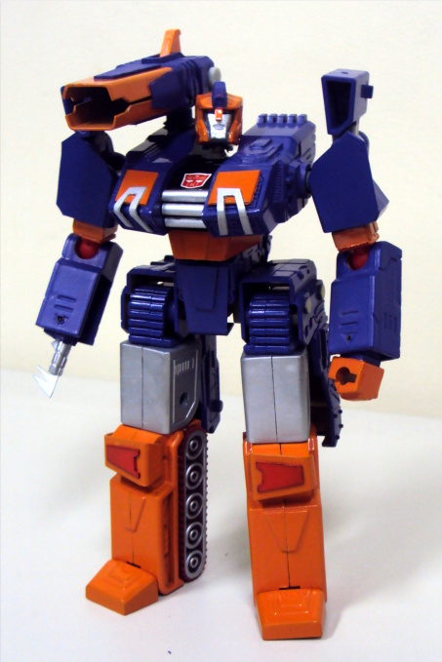
Official Figure: Not Available
Custom Figure:
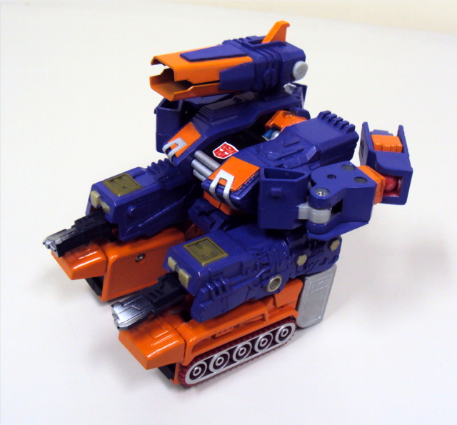

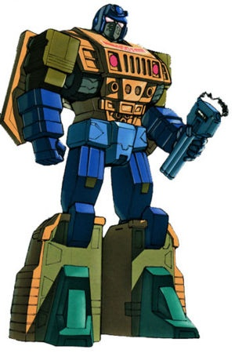
-Ironfist:
Comic Picture:

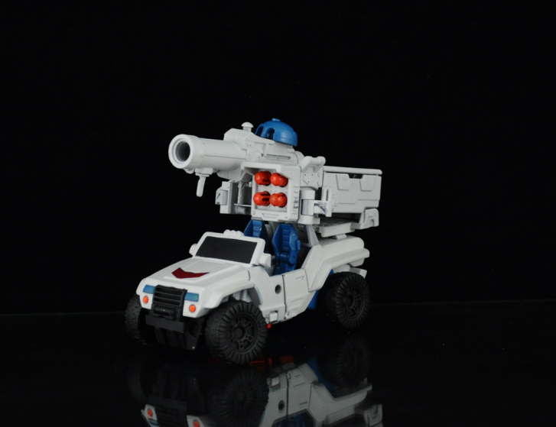
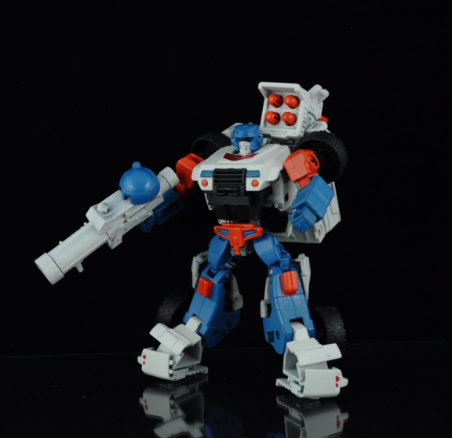
Official Figure: Not Available
Custom Figure:

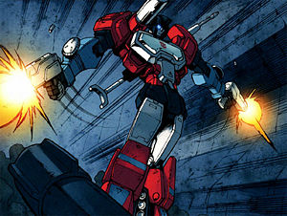
-Perceptor:
Comic Picture:

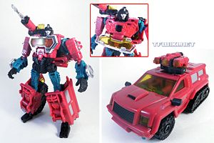
Official Figure:

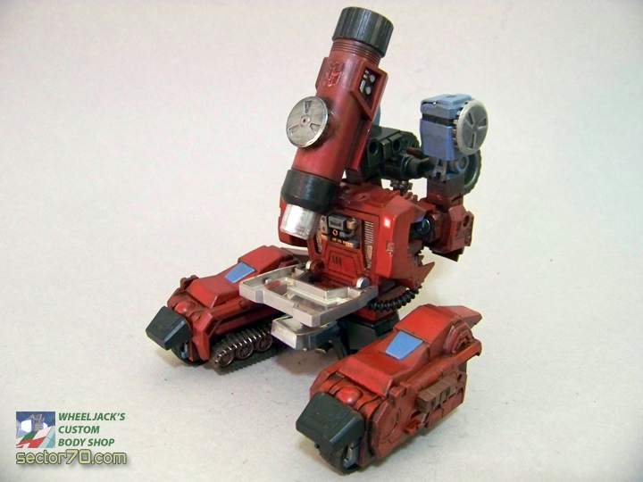
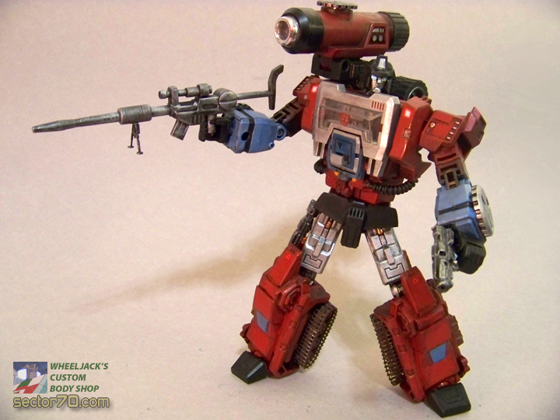
Custom Figure:

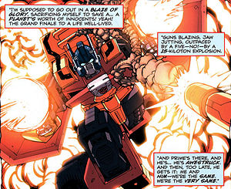
-Pyro:
Comic Picture:

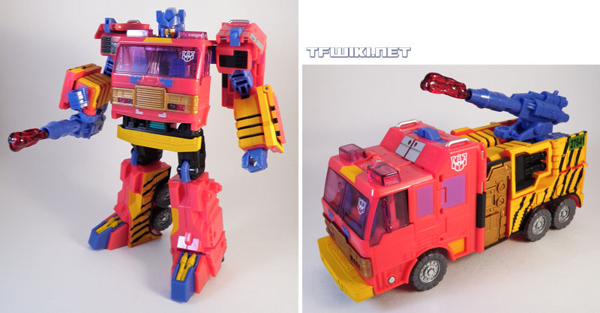
Official Figure:

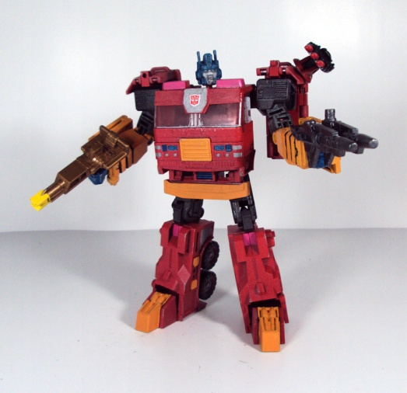
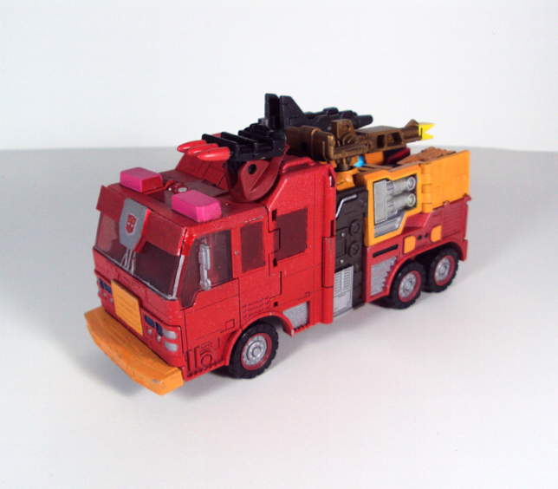
Custom Figure:

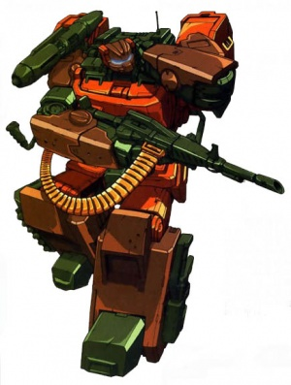
-Roadbuster:
Comic Picture:

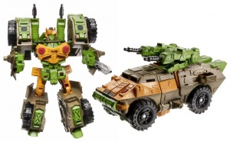
Official Figure:

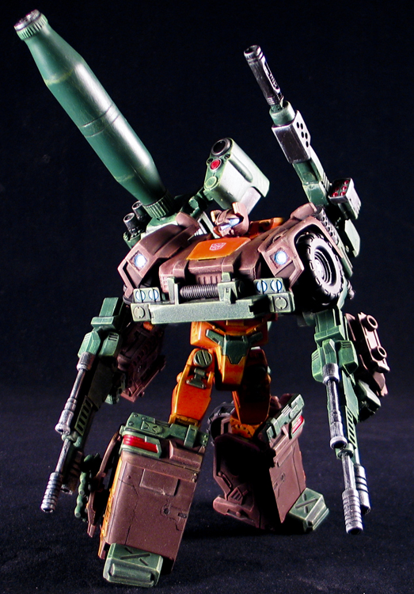
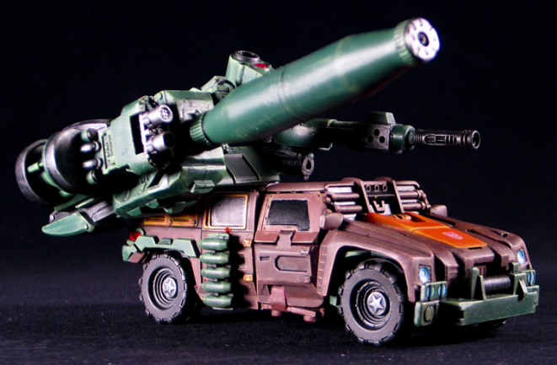
Custom Figure:

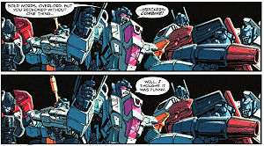
-Rotorstorm:
Comic Picture:

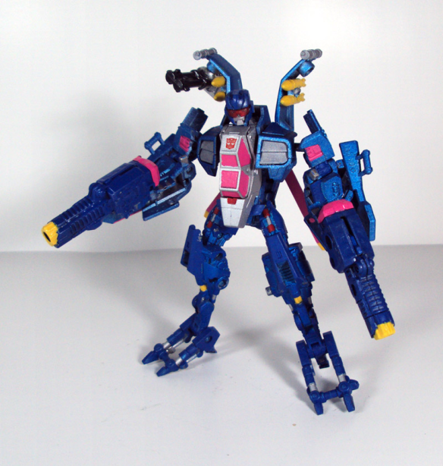
Official Figure: Not Available
Custom Figure:

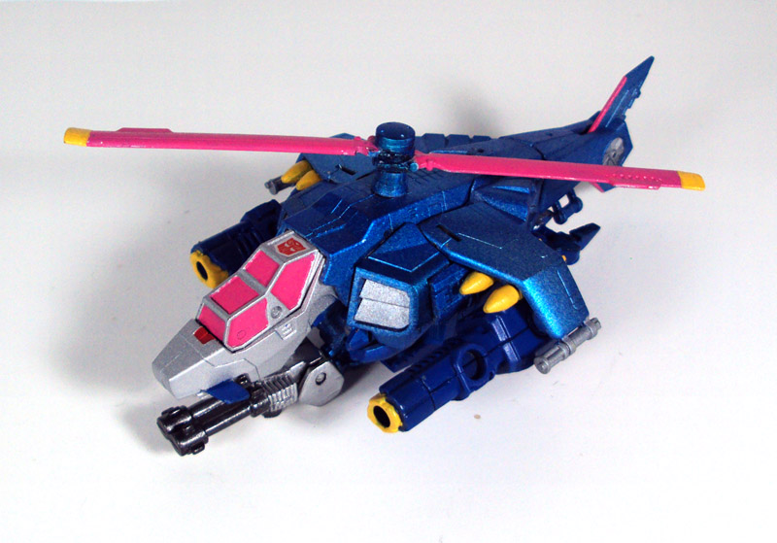

-Sandstorm:
Comic Picture: Not Available
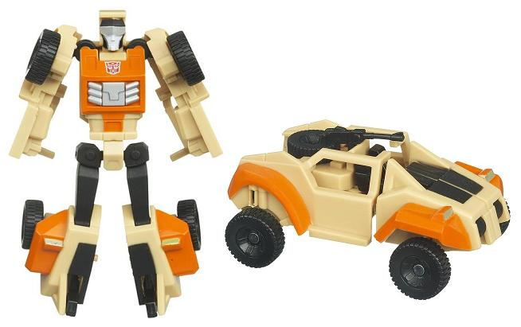
Official Figure:

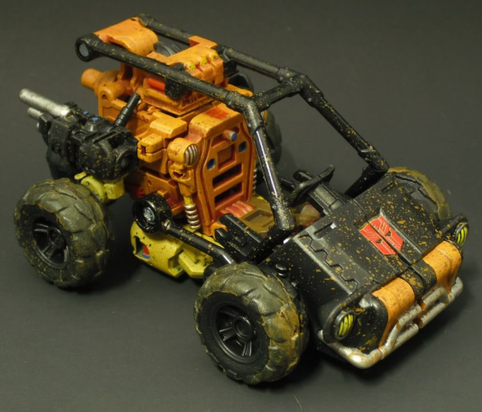
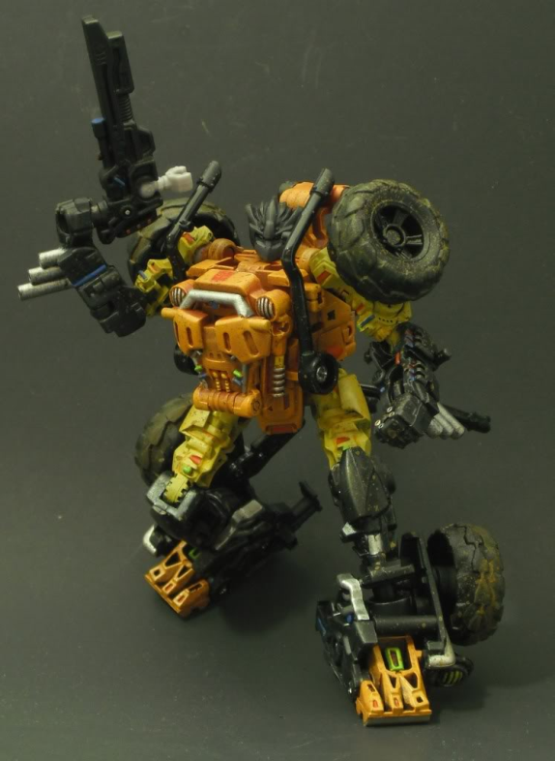
Custom Figure:

-Scoop:
Comic Picture: Not Available
Official Figure: Not Available
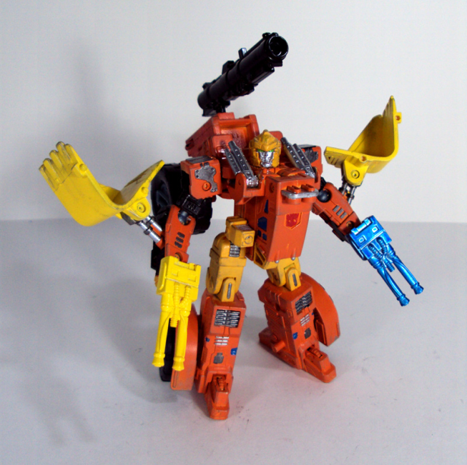
Custom Figure:

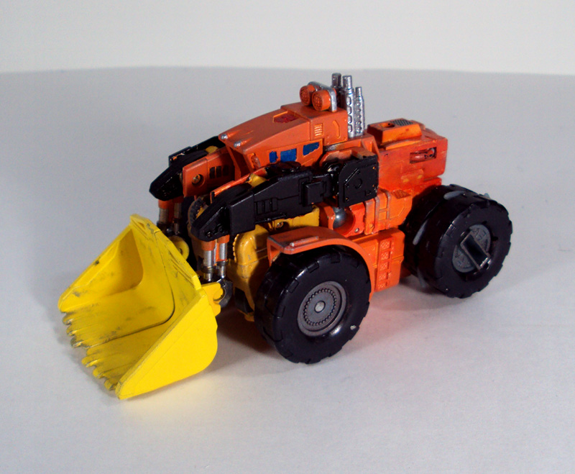

-Topspin:
Comic Picture: Not Available
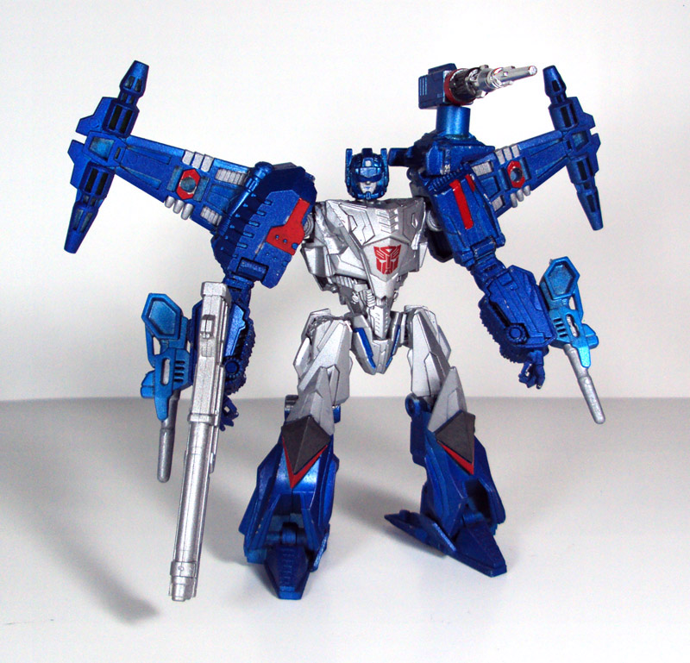
Official Figure: Not Available
Custom Figure:

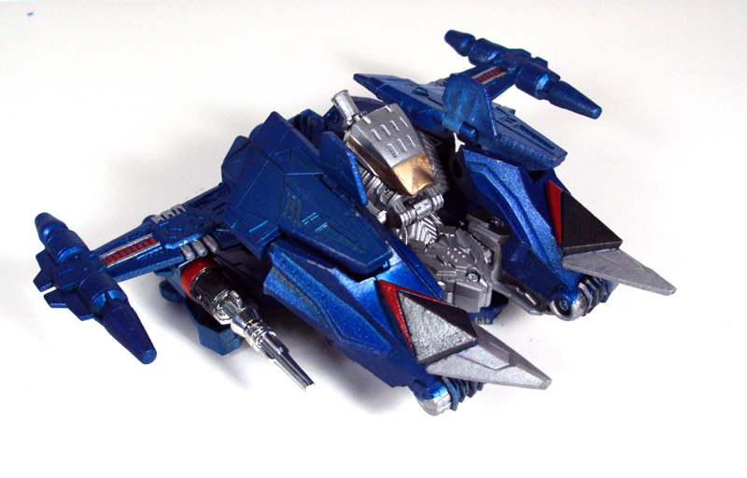

-Twin Twist:
Comic Picture: Not Available
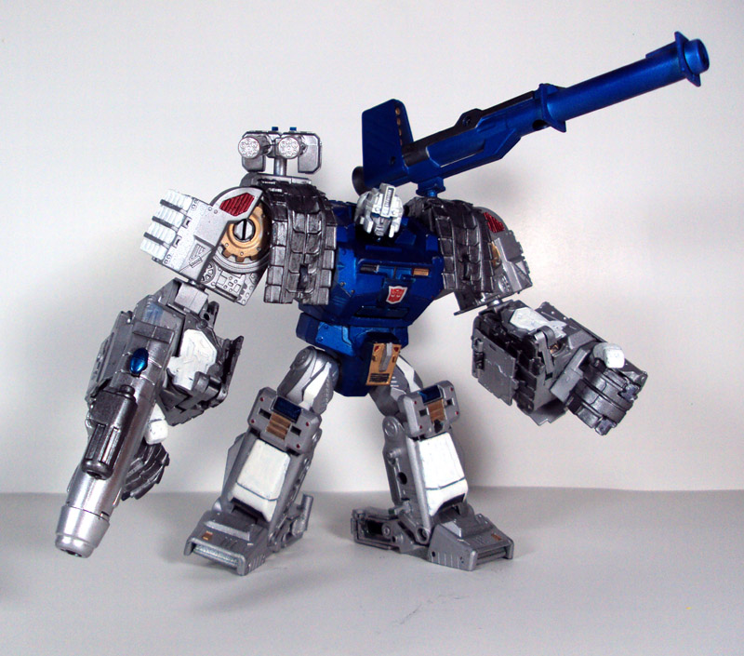
Official Figure: Not Available
Custom Figure:

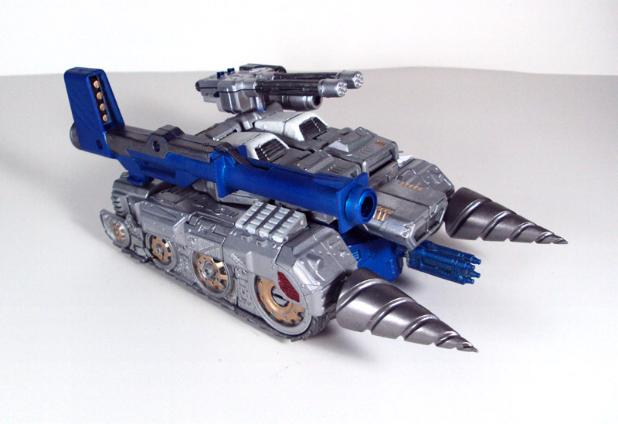

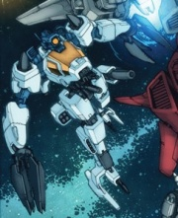
-Whirl:
Comic Picture:

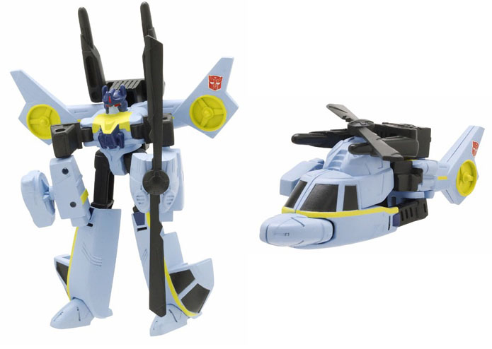
Official Figure:

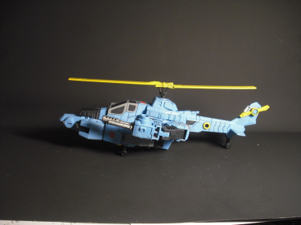
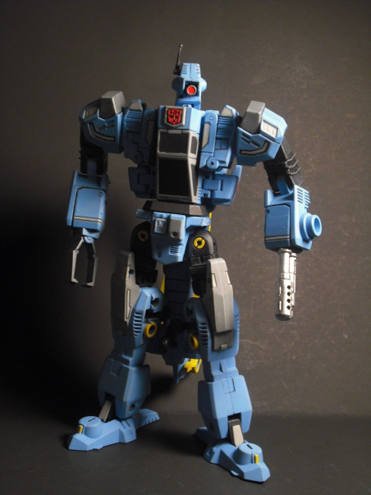
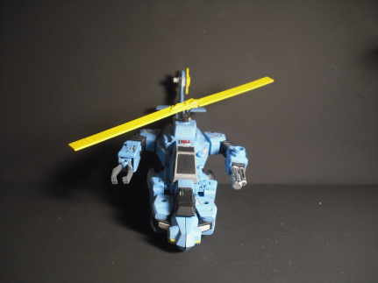
Custom Figure:


Wreck ‘N RULE!

Customs Links
-Springer: http://www.tfw2005.com/boards/radicons-customs/409332-dotm-wreckers-springer.html
-Kup: http://www.tfw2005.com/boards/radicons-customs/411618-dark-moon-wrecker-kup.html
-Broadside: http://www.tfw2005.com/boards/radicons-customs/393510-idw-broadside.html
-Guzzle: http://www.tfw2005.com/boards/radicons-customs/343042-autobot-guzzle.html
-Impactor: http://www.tfw2005.com/boards/radicons-customs/390685-impactor-lsotw-classics-generations.html
-Ironfist: http://www.tfw2005.com/boards/radicons-customs/396555-ironfist.html
-Perceptor: http://www.tfw2005.com/boards/radicons-customs/419838-idw-perceptor-complete.html
-Roadbuster: http://www.tfw2005.com/boards/radicons-customs/484818-wreckers-roadbuster-darkcaves-last-stand.html
-Rotorstorm: http://www.tfw2005.com/boards/radicons-customs/437419-wreckers-rotorstorm-extra-armed-chug-style.html
-Sandstorm: http://www.tfw2005.com/boards/radicons-customs/435185-sandstorm-dotm-ha.html
-Scoop: http://www.tfw2005.com/boards/radicons-customs/482553-wrecker-scoop.html
-Topspin: http://www.tfw2005.com/boards/radicons-customs/440081-wreckers-topspin-special-armed-chug-style.html
-Twin Twist: http://www.tfw2005.com/boards/radicons-customs/438364-wreckers-twintwist-mega-armed-chug-style.html
-Whirl: http://www.tfw2005.com/boards/radicons-customs/358179-last-stand-wrekers-whirl.html

