AFOL TIMES

Bonus Section E, Page 2



About the Atlantis Expedition, by Professor Samantha Rhodes
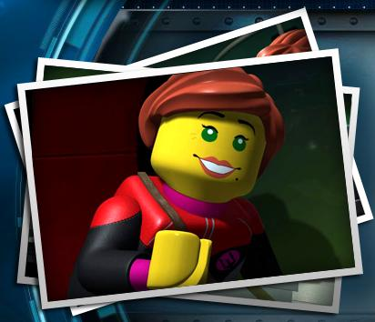
The Atlantis Crew is famous among the seas for being the best salvage crew for hire, and the modern marvel they work in, the Neptune Carrier Submarine. For years, the small four person crew of Captain Ace Speedman, First Mate Lance Spears, Doctor Jeff Fisher, and mechanic Axel Storm proved that numbers don’t matter as much as skill. Eventually, their exploits drew the attention of yours truly, who was about to pick each of them for the mission, but realized that they already had all the skills needed.
Originally, Captain Speedman tried to reject my mission, as many others had before. They considered my insistence on Atlantis’ existence to simply be the result of following in my eccentric grandfather’s footsteps, which it was, but only because I had evidence from my grandfather’s journal and the word of my grandmother.
In the year A.D. 1919, my grandfather, Dr. Artemis Rhodes, undertook the original quest to find Atlantis, using a pyramid with a map to the Lost City inscribed on it, which he had found five years prior in 1914 on an island south of Mexico. Using much of his fortune to build a submarine called the Atlantis Finder, he sank into the depths and encountered a most bizarre horde of sea creatures, and the structures they had built. Convinced that these were signs of Atlantis existence in that area, he braved all the dangers of the depths, but his quest was brought to an end by an attack of Squid Warriors.
Fortunately, then-Samantha Morris, my grandfather’s lab assistant, brought a ship to the site and the crew managed to rescue him. He could not remember any of his adventure beneath the surface, due to being struck by the ship’s anchor, yet it did not need explanation—they deduced that he had been searching for Atlantis by the name of his sub. After being rescued, my grandfather proposed to Ms. Morris, who is now my grandmother. As they were about to leave the waters of the Atlantic Ocean, a tentacle deposited the pyramid map and the journal onto the deck, and my grandmother took possession of them, not wanting my grandfather to reattempt another expedition to find the City of Atlantis. Years later, in 1991, she passed the map and my grandfather’s journal to me, and since then I had been planning a second expedition, while also establishing the Ocean Odyssey sea station to research it..
As mentioned before, I contacted Ace Speedman’s Deep Sea Salvage Crew, and Captain Speedman was about to reject until a massive crab attacked, with Atlantean words inscribed all over the beast’s shell. Captain Speedman took on the beast, and lured it into a cage built from the pieces of my wrecked Ocean Odyssey submarine, and found the first new clue to Atlantis, the Orange Treasure Key of the Crab. Convinced, he accepted the mission, and we continued.
After a grappling cable malfunction caused the heavily damaged Neptune Carrier to fall into a volcano, but it survived by floating through an undersea tunnel in the volcano. Since then, we have fought our way to the Squid Temple, but are held off from advancing by the inhabitants. We are now in need of help, not only to infiltrate the Squid Temple, but also to advance to the Shark Castle, and to help protect our ships from the Manta Warriors who inhabit the sea bed.
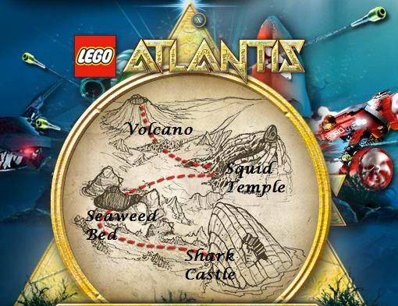

Locations

Volcano
The Volcano existed long before it was swallowed by the ocean's murky waters, perhaps even while Atlantis still thrived on land. Many dismiss it as an old and dormant undersea rock, but maybe something more lies within its dark and perilous abyss. Are you brave enough to find out what secrets it might hold?

Neptune Carrier
The flagship of the Atlantis Crew, this sub is sitting in the shadow of the volcano as Axel Storm and his crew of mechanics rebuild it, along with help from the new members of the crew, such as Bobby Buoy. Once this is off the seafloor, we can advance to the Seaweed Bed. See Axel Storm’s guide to vehicles on page 3 for more information.

Squid Temple
With its many caverns and nooks, the Squid Temple holds almost as many secrets as Atlantis itself. Its ancient walls are coated in a thick layer of seaweed and its maze of leviathan columns create peril with every winding turn. If you manage to make your way through its treacherous pathways, you may just find a key in your journey for Atlantis.

Seaweed Bed
The Seaweed Bed is an underwater jungle of coral, seaweed, and small marine life. A variety of plants lay concealed and tangled beneath its shrubbery. Be sure to use caution when navigating this watery garden - the greenery may hide more than you bargained for. (Access is not granted to the Seaweed Bed yet. First, the Neptune Carrier must be repaired, and then we can advance. Manta Rays and Stingray Guardians may still be found in the area surrounding the Volcano and the Squid Temple.)

Shark Castle
The impenetrable Shark Castle is a menacing, underwater fortress reinforced by barred doors and thick metal gates. Its entrance is locked against attack by a giant shark-head door and ominous stone guardians perch as a warning atop its high walls ... this is one castle to be wary of. The sinister decor seems to promise snapping jaws and swishing fins in the future. One of the most dangerous sea regions, the Shark Castle will be critical in unlocking the secrets of Atlantis. (Access is not granted to the Shark Castle yet, but Shark Warriors and Shark Guardians may be found in the Seaweed Beds.)

