BLUE KNIGHT ARMAMENTS TABLE

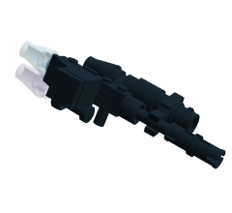 | Use:  5 | 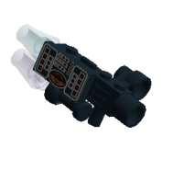 | Use:  3 | 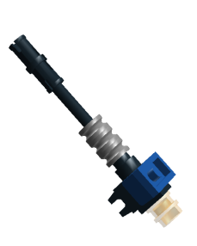 | Use:  4 | 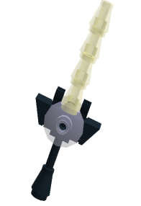 | Use:  4
 | 11” |  | 8” |  | 6”-18” |  | CC
 | 3d6 |  | 1d6+1 |  | 2d6 |  | 2d6+2
Auto Cannon  12 CP / Arc or Burst Fire |  | Auto Gun  6 CP / Arc or Burst Fire |  | Lazer Battery  6 CP / Linked |  | Lazer Sword  5 CP
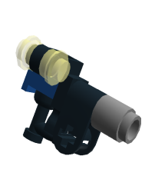 | Use:  4 | 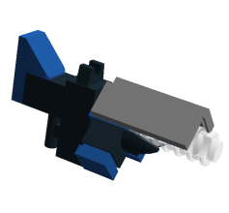 | Use:  4 | 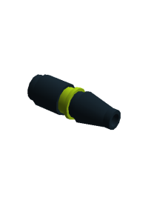 | Use:  4 | 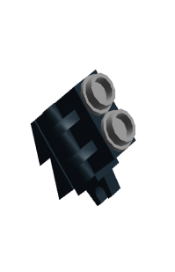 | Use:  4
 | 10” |  | 8” |  | 12” |  | 6”-18”
 | 2d6 |  | 2d6 |  | 2d10 |  | *
MKII Pistol  6 CP |  | MKII Repeater  8 CP / Arc or Burst Fire |  | MKII Rocket  4 CP Each |  | Ordinance Launcher  6 CP / Parabolic Shot / Linked  1 CP per Explosive
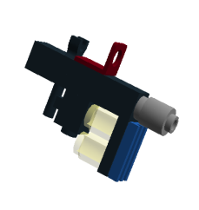 | Use:  4 | 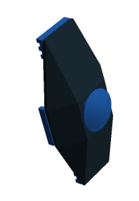 | Use:  4 | 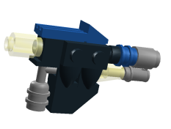 | Use:  6 | 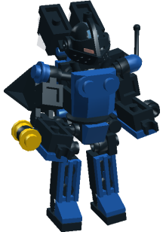 | Skill:  1d8
 | 12” |  | CC |  | 10” |  | Move:  6”
 | 2d6 |  | - |  | 2d12 |  | Armor  2d10
Plasma Rifle  9 CP / Overcharge |  | Tactical Shield  2 CP / Parry or Shove |  | Tesla Cannon  12 CP / Electric |  | Altimate Blue Knight  11 CP / Size: 2 / SL: 2

Tech Upgrades
- Communications Relay (+2CP): Allies who take a combined action with this hardsuit may increase their skill by +1 die size.
- Infrared Scanner (+2CP): This hardsuit automatically Detects Stealth units; allows Marking targets for +1 Attack Bonus
- Nanobot Surge (+2CP): Nanobots grant the hardsuit an extra action each turn.
- Raven Boosters (+1CP): Raven Boosters increase the hardsuit’s movement by 2”. The hardsuit loses the ability to sprint but may spend an action to treat its movement for the turn as flying.
- Sensors Package (+2CP): This hardsuit bypasses Unstable Ground for self and others at 1/2 speed; allows manipulation of locks and Triggers; +1 Skill vs. Field Hazards.
- Teleport Transponders (+0CP): A creation with this device may start the game off of the battlefield. Starting on Turn 2, it may teleport onto the battlefield at any location, scattering 1d6 inches from the intended landing zone. Teleporting within 6” of Comm. Drone prevents scattering. Regardless of load-out, a teleporting unit may only make a single ranged attack on the turn it enters the battlefield. Teleporting counts movement for the turn.

