New/Open
(new)After starting click 'file' & 'new', then you choose how many pixels wide(width) and tall(height) you want your picture to be(64x64 for avatars, 468x60/250x100 for banners) then, you choose if you want it to be white, or transparent, I prefer transparent, as it is easier to work with.
(open)To open you click 'file' & 'open', this will bring up a browser for you to choose a file from your computer.
Drawing
You have a few tools to choose from when putting raw pixels onto the canvas:
Pencil Tool - Hard edge painting using a brush. this means that it will make a clean dot the size of your brush with no fading around the edges.
Paintbrush Tool - Paint smooth strokes using a brush. this means that it will make a smooth dot the size of your brush with fading around the edges.
Airbrush Tool - Paint using a brush, with variable pressure. this means that it will gradually make a dot the size of your brush. By adjusting the pressure in the tool options you can make it fade in faster or slower.
Ink Tool - Calligraphy-style painting this means that it will draw as if it was in ink, making a larger dot the longer you stay in place.
Clone Tool - Selectively copy from an image or pattern, using a brush. this means that depending on the source you choose in the tool options you can either copy from the image or from a pattern in the shape of your brush.
Bucket Fill Tool - Fill selected area with a colour or pattern. this means that you may choose to fill either a solid colour or pattern into a selection. By default this tool will only fill a single colour at a time, but you can change this in the tool options to fill the whole selection(or whole image if you have not made a selection).
Blend Tool - Fill selected area with a colour gradient. this means that you fill the selected area with the active gradient by clicking and dragging(this sets the direction of the gradient)
Selecting
Here are the tools for selecting or moving what is on the canvas.
Rectangular Select Tool - Select a rectangular region. using this tool you click and drag to create a rectangular selection which you can fill; copy; delete; or move. to do each of these refer to - Drawing for filling - BIM&T for copying and deleting. To move the selection go to [Select] - [Float] and now you will be able to click and drag the selection around. However! Before you try and do anything else be sure to anchor the selection back down, either as a new layer or back to a previous layer. To make the selection its own layer go to [Layer] - [New Layer] or to attach it back to the home layer click outside of the selection(you will see the cursor turns into an anchor)
Ellipse Select Tool - Select an elliptical region. using this tool you click and drag to create an elliptical(circular) selection which you can fill; copy; delete; or move.
Free Select Tool - Select a hand-drawn region. using this tool you click and drag to draw a selection of any shape which you can fill; copy; delete; or move. This tool can be given a fuzzy or hard edge.
Fuzzy Select Tool - Select a contiguous region on the basis of colour. using this tool you click in the image and any pixels touching where you click of the same or similar colour will be selected as well. In the tool options you can change the threshold, or maximum colour difference; the higher number in the threshold, the less similar other pixels have to be. at 0 only other pixels of the exact same colour value will be selected, and at 255 the whole image will be selected.
Select By Colour Tool - Select regions with similar colours. using this tool you click on a colour in the image to select every pixel of that same colour. In the tool options you can change the threshold, or maximum colour difference; the higher number in the threshold, the less similar other pixels have to be. at 0 only other pixels of the exact same colour value will be selected, and at 255 the whole image will be selected. This tool is useful for recolouring sprite sheets(at 0 threshold, of course)
Colour Picker Tool - Set colours from image pixels. with this tool you can set your foreground colour to be the same as a colour on the image.
Move Tool - Move layers, selections, and other objects. this tool is used to move entire layers, to do so simply click and drag on part of the layer you want to move to its new destination. By toggling the layer lock in the layer dialog(in between the view option and the layer thumbnail)
Crop Tool - Remove edge areas from image or layer this tool is used to cut the edges off the image, but beware; this tool affects all layers, not just the layer selected!
Rotate Tool - Rotate the layer, selection or path. this tool can be used to rotate a layer or selection any amount you wish. For example: in the [Layer] - [Transform] - menu there are 3 rotate options, but these simply rotate on 90 degree angles. If I want to rotate, say, 45 degrees, this is the tool to use; it can even rotate as little as 0.01 degrees, if you really wanted to!
Scale Tool - Scale the layer, selection or path. this tool is used to grow or shrink the layer or selection, and can be done to whatever size you wish. You can stretch the horizontal and vertical at the same rate if you click the lock button next to the x and y axis controls.
Shear Tool - Shear the layer, selection or path. this tool can be used to alter the layer or selection in such a way as to make it look sideways or stretched either vertically or horizontally. I don't use this tool much.
Perspective Tool - Change perspective of the layer, selection or path. this tool is an interesting one, designed to make it look like you can move the layer or selection like a 3-d image. I don't use this tool much.
Flip Tool - Reverse the layer, selection or path horizontally or vertically. this tool is used to flip the layer horizontally or vertically.

Editing:
Here are some tools for editing what is on the canvas.
Eraser Tool - Erase to background or transparency using a brush pretty self-explanatory, but this tool will draw in the background colour or transparency using a brush. You can make this tool use either fading edges or hard edges in the tool options.
Blur/Sharpen Tool - Selective blurring or unblurring using a brush this will blur or sharpen the image where you draw. To change between blurring and sharpening go to tool options.
Smudge Tool - Smudge selectively using a brush. click and drag and it will make it look like you smudged your finger in there
Dodge/Burn Tool - Selectively lighten or darken using a brush this will lighten or darken the image where you draw. To change between lightening and darkening go to tool options. To change how quickly it will lighten or darken change the exposure at the bottom of the tool options.
Animation
Animation with gimp, to put it simply, is like a flip-book. you put all the images on new layers, and then save as a gif to have it run through the layers one at a time. to make a new layer, go to 'layers' & 'new layer'. this will give you another frame of your animation. Alternatively, you can duplicate a previous layer.
There are a few things you can change about the layers for animation. in the layer title, you can add a frame delay or disposal, in that order. The default frame delay is denoted by (100ms) with ms = milliseconds and the default disposal is (combine) so a default animation layer looks like this: "frame 1 (100ms) (combine)" you can change the delay by changing the number{ex. (30ms)} disposal means where the layer goes after it is shown. If you don't change anything the layer will combine with the next, which means if you have a transparent
background you'll get something like this: whereas you probably want it to look like this: (cred to rayg for those) to get the frames to replace the previous one when they come up you put in (replace) which will look like this: "frame 3 (20ms) (replace)" Thus endeth my delay and disposal intro.

Oh, and one thing to note about using the scripts or messing with colours on a previously saved and reopened image(such as a kit or some picture you have been working on for a while) make sure that you are in RGB mode, otherwise many scripts will not work. To check if you are in RGB mode, glance at the [image] - [mode] submenu. there are three options here: indexed, RGB, and greyscale. Greyscale, you may be able to guess, converts the image from colour(if there was any) to shades of grey and only allows you to paint in grey. Indexed constrains the image to a restricted palette, default of 255 colours. RGB stands for Red Green Blue, and gives you unlimited access to colours and greys alike.

QUOTE(Ro-Koro @ Mar 12 2010, 11:18 AM)
How do I get that effect so that the ground has a mirrorlike effect?
1.You open the image you want.
2. Go to image> transform> vertical
3. Go to layers dialogue and turn down the opacity level
4. Save the image as a different file.
5. Make a new image add the first image.
6. Then add the 2nd one that we just edited and move it toward the first one.
7. It should look good now!
You forgot that I needed to add a new layer...
Anyways here is the result:
(^Credit to phillipPBor for the Phinto kit^)
Actually, it's even simpler than that...
1. Make the image you plan to use.
2. In GIMP, create a duplicate layer.
3. Flip the duplicate layer using the transform tool.
4. Use the move tool to move the flipped duplicate layer into the right position.
5. Adjust the layer's opacity until it's transparent enough to be a reflection.
That's all there is to it.
I would suggest adding a white-to-black Layer Mask to the reflection layer, so that it gets more transparent the farther down it goes. Makes it look evben better.

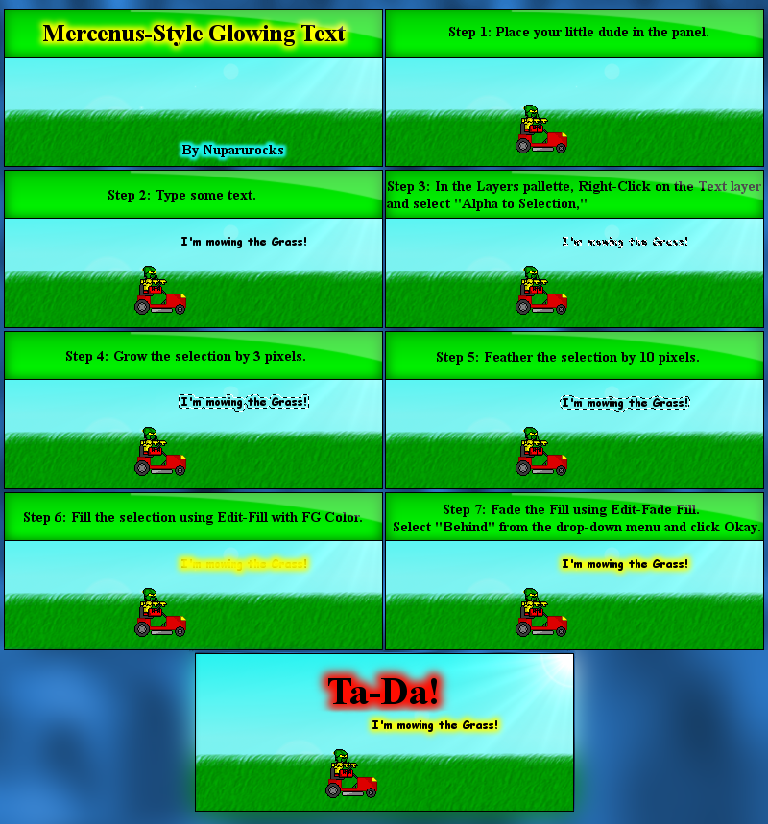
I did too. After fooling around a little, I found out that you have to Fill with FG color on the bottom Layer. Then do the rest.

Which was how do you tilt small objects without making it completely unrecognizable?
Define unrecognizable. =P
GIMP does all the weird stuff with the colors to make it more recognizable, because sprites look nasty when you don't do anything to them. The problem with things so small is that it makes it look kinda funny.
Your best bet would be to use the default settings, or make the sprites bigger.
They also look better depending on the angle you use.
The best method is to scale the sprites up by 200% or 300% on no interpolation, then rotate them
Then what? Do I rescale them?
First, the post after the one you quoted...
QUOTE(Kahi Govaki @ Feb 21 2010, 11:21 PM)
QUOTE(Nuparurocks @ Feb 21 2010, 08:08 PM)
The best method is to scale the sprites up by 200% or 300% on no interpolation, then rotate them
Exactly what I was going to say. Just to clarify, though:
Enlarge it with the Interpolation set to none, then change the Interpolation to Bicubic, and THEN rotate.
Then, yes, you re-scale them back to their original size.

When you paste an image into GIMP, how do you make the background color (of the pasted image) transparent?

QUOTE
No. move their heads onto the body and post it in the backround.
This question has been answered before, but here it is.
First, you make a new layer (transparent) if you want to move it around.
You use the select by color tool (looks like a hand pointing at a bunch of squares) and set the range to 0.
Then select the white area, and then delete it.
It's probably easier to assemble sprites in Paint, but if you're set on doing it in GIMP, you do the above steps for both body and head.
Then, select (rectangular region) the head, and cut it (or copy, if you'll use it again).
Paste it, then select the move tool in the toolbox (looks like a hand) and move the head to wherever you want it.
I try it. But I still can't move it and the transparent didn't work either.
You don't make the background color transparent. GIMP uses alpha channel transparency, so you either have to add an alpha channel to the current layer (Layer->Transparency->Add Alpha Channel). or work on a new layer with an alpha channel. If you add an alpha channel to the current layer, continue using the previous instructions with the "select by color" part. If you have a new layer, copy the kit (or whatever you want to delete the background from), paste it on the new layer, and continue with "select by color".
When you use the new layer, you should still be able to see the background of the old layer once you have deleted the background from the new layer. This should not have an effect on what you cut or copy from the new layer.

How do you zoom in characters without it turning small?
Could you please rephrase that? I don't understand what you are asking.
Ok. How do you zoom in and keep it that way like when Gavla did this? Example
Image->Scale Image...
The default units for scaling is "pixels"; you may get better results if you select "percent" from the drop down box instead, so you can make sure it's an integer multiple of the original size..
It didn't work.
It could be the interpolation; if you want to make it exactly the same, select "none" from the interpolation drop down menu on the toolbox when you press scale.
Ok. My non pic tutorial for rotates!
Open GIMP. Go into File - New. And above the options like Help and Reset, there should be Advanced Options. Click it, and in Fill with press Transparency. Choose that then press OK. Then copy the sprites into the file, and you'll see a white box around it. Well, press the Select by Color Tool, and press on the white. Then, go into Edit - Clear, and it will be gone. Then rotate, and when your ready, bring up your comic in GIMP and paste your newly rotated sprite on!
Hope that helps!
How do I tilt sprites heads and degimped it?
You mean tilting something without the blurriness? I don't think you can do that.
You can, but it looks terrible
there are four rotation algorithms in Gimp
Examples of each:
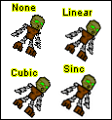

Maybe.
I think the confusion here is that the results won't be perfect, just better than they would be if you didn't do the extra steps. You can clean things up a bit by hand afterwards (zoom in when you do this).
Also, someone mentioned that some angles look better than others, which is important. Play with the slider in the range you are trying to rotate to, and see if you can come up with something that looks less distorted - a change of less than 2 degrees can make a big difference.
edit: I just remembered another thing to mention - make sure that Image->Mode is set to RGB before rotating. If it's set to Indexed, which it will be by default if you're starting with a GIF file, the limited colors will make the image look very distorted.

Okay. So I just got Gimp, and I've been using MS Paint for a while. I'm trying to figure out how to make something transparent. And I'm only talking about ONE SPECIFIC COLOR. Not that color and all colors somewhat similar to it.

It sounds like you're trying Color to Alpha, which you don't need to do for transparency.
Before you add transparency go to Layers-Transparency-Add Alpha Channel, and click that if it isn't already selected.
After that, select one of the selection tools, and change the threshold to zero, like Fire Entity said. (Like this)
Then, select the color that you want to make transparent in the image, and delete.
GIMP doesn't work with transparency like Paint does, so it may take some time to get used to it. GIMP is better, though, since it can make an image really be transparent, as opposed to Paint making it white. It can be more difficult if you're assembling something like a comic, though. That takes more time to get used to.

How do you make speech bubbles in GIMP? Like Ennar's.
What I do is, I have a separate layer for the speech baloons. I type the text first, then I make an elliptical selection around it. Then I add a tail with either the Path tool (for curvy ones) or the Free Select tool (for sraight ones). Then I fill the selection with black, contract the selection by one pixel, and fill with white.
I have keyboard shortcuts assigned to almost all of these functions, so it only takes me about 10 seconds to make a speech bubble

The shapes for the balloons are formed by simple select areas - the normal balloon is Tools->Selection Tools->Ellipse Select, the Dilbertesque balloon is Select->Rounded Rectangle on an already selected area, and the Rorschach balloon is Select->Distort on an already selected area. If you want a guide for the area to select, use Layer->Transparency->Alpha to Selection on the text layer, then use Select->Rounded Rectangle and grow the selection by the font size (Select->Grow). If you want a normal text bubble, use this area as a guide to use Tools->Selection Tools->Ellipse Select; if you want a Rorschach balloon, use Select->Distort on the selected area.
Now, create a layer under the text layer (Layer->New Layer followed by Layer->Stack->Lower Layer). Assuming that the text color and the border color is the foreground color and the color that you want to fill the bubble with is the background color, fill the area in the new layer with the border color (Edit->Fill with FG color), shrink the area by 1 pixel (Select->Shrink), and fill the new selected area with the background color (Edit->Fill with BG color).
I don't use Select->Border for the outline, because it doesn't use anti-aliasing.
I know of several ways to add tails; this is the simplest to explain
- Using the Paths tool (Tools->Paths), with Paths Edit Mode set to Design, click on three points to make a "V" shape indicating the general position of the tail. The top two points of the "V" should be in the balloon, and the bottom point should be by the character that is speaking.
- Click on a point on one leg of the "V" midway between the balloon and the bottom point and pull it down and away from the speaker a little bit to curve it. Repeat this with the other leg.
- In the Paths Toolbox, click on Selection from Path. You should now have a selected area where you want the tail.
- Use the Bucket Fill tool (Tools->Paint Tools->Bucket Fill) to fill the portion of the tail that is outside of the balloon with the balloon border color (normally black).
- Shrink the selection (Select->Shrink) by 1 pixel
- Use the Bucket Fill tool (Tools->Paint Tools->Bucket Fill) to fill the portion of the tail that is outside of the balloon with the balloon background color (normally white).
- Select the Paintbrush tool (Tools->Paint Tools->Paintbrush)and clean up the line where the tail attaches to the balloon with the balloon background color.
- Select->None

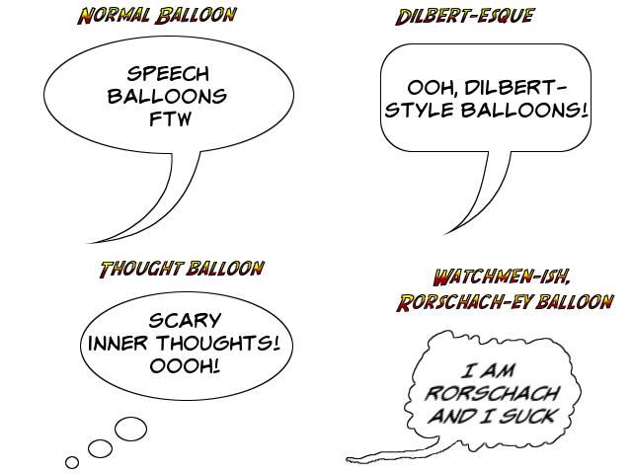

- Draw a simple yellow scribble flame that looks like it took 5 seconds in paint.
- Splatter with some orange dots, concentrated towards the bottom.
- Splatter again with even fewer red dots in a similar pattern.
- Blur the picture (Filters->Blur->Gaussian Blur) with a blur radius equal to the brush size you used to make the dots (I used five in this example).
- Use the smudge tool with the same size brush to make slighty curved upward/outward strokes. The last two pics were made from the same blurred image - the first using longer, straighter strokes, and the second using shorter, more swirly strokes.

