Things I did well:
- Went in-depth on themes and background
- Writing feels engaging to me
- Hit the length requirements

Things I could improve:
- Brevity
- Found it hard to summarize film
- Better self-critique?

Gunnar McGriff
Mike Stice
November 12, 2018
LA423B

Welcome to Pleasure Hell
Do you ever turn on the news, feel your deepest soul fester with existential dread, and then say “fuck it, I’m gonna go to Starbucks?” As I see it, this is the mood we all live with these days. The outside world is so vast, terrifying and abstract that when it leaks into our homes through a screen, we have no sense for how to integrate this knowledge into our lives. In my senior film, DANDYLAND, I wanted to capture this sensation of having the rug pulled out from under you—of eating the Fruit of Knowledge and getting it totally lodged in your throat. My cartoon is a 4-minute (counting titles and credits), fully-animated sci fi comedy. It follows Frito Libido Chung, a 20-something manchild living on Earth in the year 2777, which has become an automated, utopian world where no one has worked a job in hundreds of years…
Frito lives in a constant matrix of entertainment and fashion. The very infrastructure of his apartment is designed to keep him entertained, with a TV screen that runs across every wall, mood music on command, etc. We open on him putting together his cutting-edge new outfit; he dresses with panache, striking vogue poses and loving his own swagger. Body positive. Be yourself. Work it. As he heelies into the kitchen, all is in harmony for Frito Libido Chung…
Frito tears into a PizzaSphere™ while his favorite style show plays in the background. The TV host is interviewing a spaceman about his fashion choices. The spaceman, with gravitas and a lined face, dodges the questions and speaks many big words that Frito and the people of his world don’t recognize: mass starvation, decaying atmosphere, societal collapse. Frito doesn’t get it, but he loves the guy’s energy—such a cool, authentic vibe.
Suddenly, Spaceman starts having an emotional breakdown on TV. Work it, spaceman! Frito goes to swallow his pizza and it lodges in his throat. He struggles, knowing in a delirious way that he might die in moments. He Heimlichs out the pizza gob just in time to look into the Spaceman’s eyes before the feed cuts out. For a second, he gets it.
Frito walks uneasily to his front door. Nothing feels as groovy as it did a few minutes ago, and his video feed no longer soothes him. What is this new feeling? He walks outside into a crowd of people living much as he does, in a city designed for infinite pleasure…
(POINTS ADDRESSED: B)

---

As far as ideas go, I think the film speaks for itself, but I’m happy to talk about some of the thinking that fed into the project. The Dandyland concept originated for me in 2013, at the gym, when I listened to a podcast about universal basic income. The idea presented was that we actually have enough resources on Earth to sustain everybody, and that increasing automation could render work totally obsolete. I don’t know how plausible this really is, given the coordination problems that always emerge in communist societies, but it drove my imagination. A communism that’s so effective, through automation, that it actually beats capitalism at its own game. Consumer communism! Luxury, fully automated, gay space communism!!
I immediately left the sauna, showered, and ran home to draw some of the characters that would live in this world. Soft, pampered inhabitants of a world that provides them with endless leisure… What would they do with all that free time?

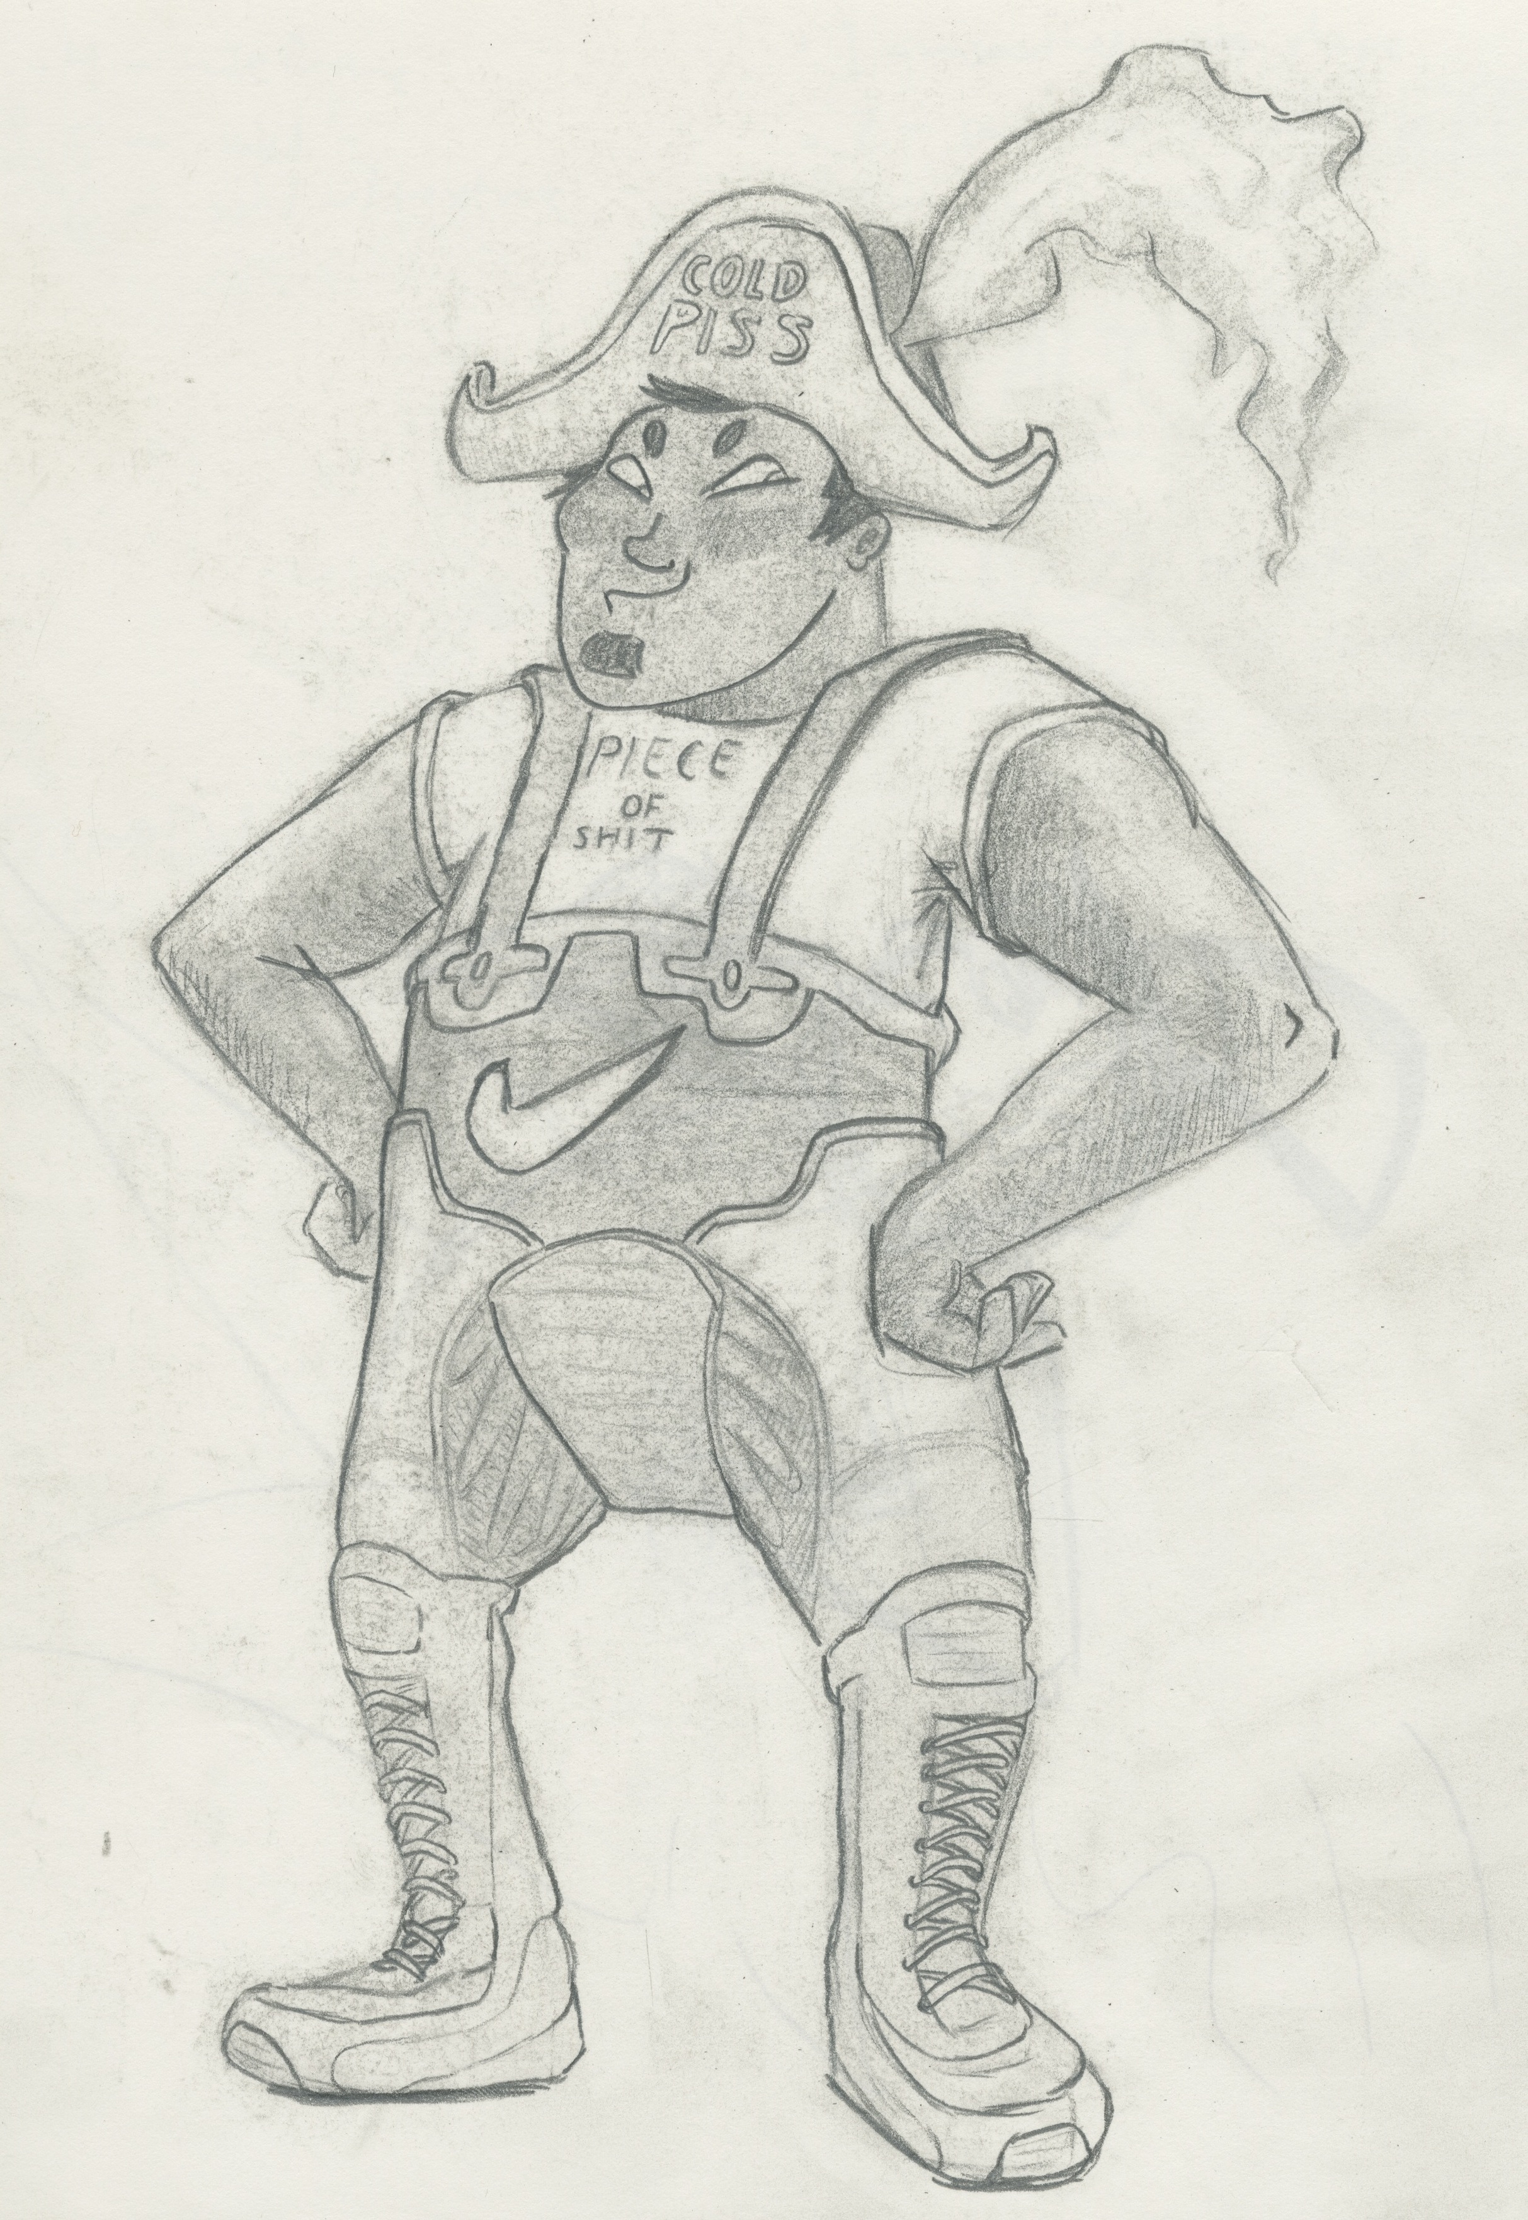
Figure 1. Frito, 2013 edition
The weird thing about social progress is that—as income and luxury increases—community, family, and cultural identity all get shredded. As individuals become less dependent on each other, entropy sets in and norms break down. There are many benefits to this—as individualism increases, gay people get to gay it up more, men and women are less bound to gendered expectations, ethnic distinctions become less important. And yet, a state of normlessness introduces a vacuum. Without any cultural codes in place, human relationships become contingent and noncommittal, communities become atomized, loneliness reigns.
Without any traditionally meaningful roles available, people hunger for a stable identity. They join social tribes, don outfits to try and project membership within a subculture. A few years ago, one of my good friends—a very suburban flavor of white guy with little inherited culture or extended family—ran down his bank account buying designer fashion and had to move back in with his parents. He had built an identity around being an androgynous Instagram fashion guy, and it was so important that he derailed his life over it. (He’s since gotten his shit together.)
Starting in the postwar years, the youth of the American monoculture began splitting apart into smaller subcultures. This accelerated in the 70s and 80s, producing flamboyantly dressed tribes, seemingly from nowhere—goths, punks, scene kids. People take this for granted but it’s actually a really, REALLY interesting and bizarre side effect of our consumerist society. This splintering of society has accelerated since then, culminating in the much-reviled
H I P S T E R phenomenon of the 2000s and early 2010s. In the hipster, the subculture that denies being a subculture, self-expression became so intense that it was no longer enough to participate in a subculture: you had to BE your OWN subculture.
Since about 2010, this attitude has become normalized, so that it’s actually harder to find straight-up goths and punks than it used to be. A lot of girls who older goths would have looked down on as “normies” are now able to buy a goth-influenced accessory—say, a lacy black choker—and wear it as a single, noncommittal gesture toward a style tribe they’re not actually a part of. This is the modern, hyper-individualistic approach to fashion, where any piece of clothing can be taken out of its original context and used to embellish the individual regardless of any actual symbolic meaning. For a few decades it’s been possible to buy a piece of clothing with an out-of-context Chinese word employed purely for aesthetic purposes; you can now find clothes that use English words in the same way.
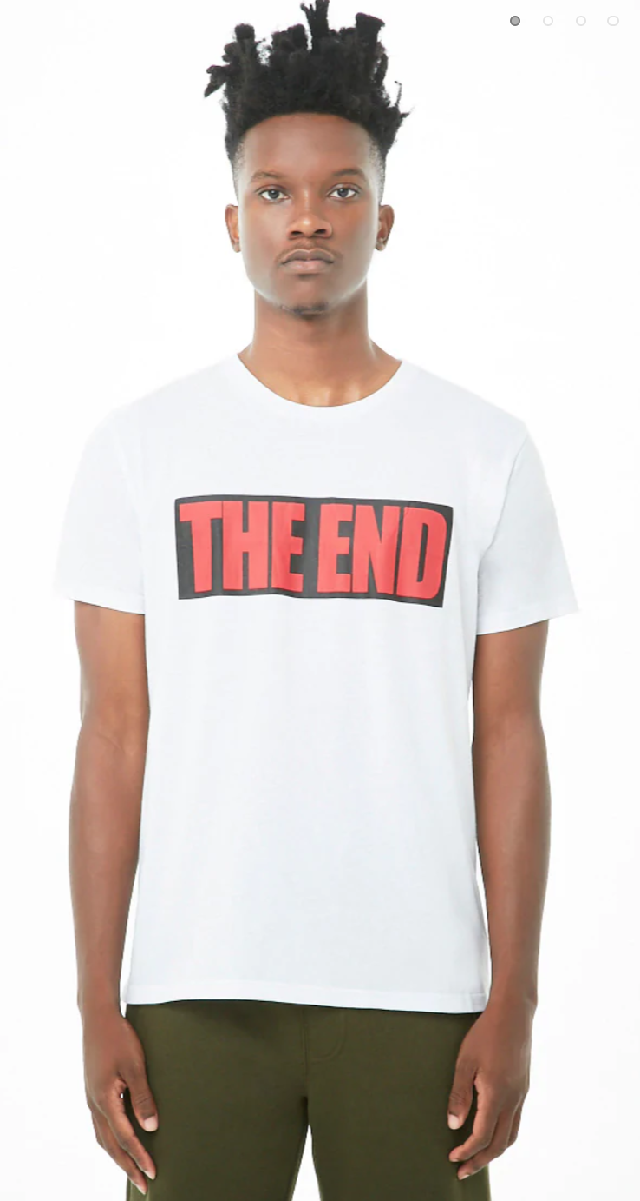
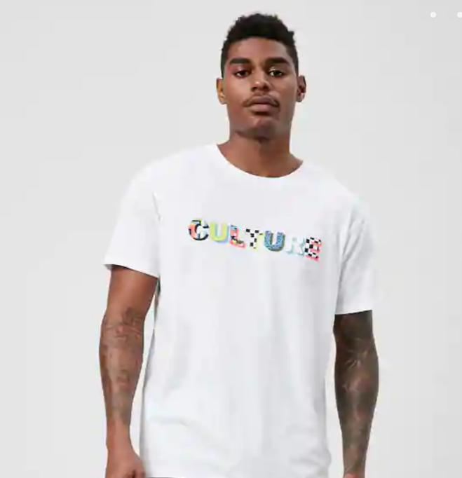
Figure 2. Some hot Forever 21 models. What do their shirts mean? Nobody knows.

All this stuff fed into my ideas for 2777, where the world has become so post-post-postmodern that people don’t even remember that there ever was a time when things had meaning. The relationship between symbols and the things they symbolize has completely disintegrated. All that exists is aesthetic.
So what was the intent behind my film? Nothing in particular, most of it just me hashing out my ideas on a screen. I find all this stuff really interesting and funny, in a cosmic sort of way. I’ve spent a lot of time in very progressive spaces, and I respect the desire of people on the left for groovy new forms of freedom. When I see the crowd of queer polyamorists and dyed-hair internet types, I feel compelled to reflect them in my work as they attempt to carve out spaces of personal freedom in the vacuum of our normless culture. I believe Dandyland is the heaven that they are trying, unconsciously, to instantiate into the world. (Thy will be done, on Earth as it is in Heaven – still the guiding principle of our culture, even in its most secular corners.)
And yet, in the end a world of infinite softness and self-expression becomes infantilizing. We yearn for adults that will keep the show running, but we don’t want to become them. What fun would that be? My version of 2777 only works because there’s an infinitely compassionate, godlike computer running everything, and even it’s beginning to have suicidal thoughts…
(POINTS ADDRESSED: C1, C2, G, E1, F, I)

---

I don’t know that I had an artistic philosophy when I came to LCAD, I just wanted to draw ugly cartoon people and maybe robots sometimes. The main thing that tripped me up was the pressure to reshape my natural artistic desires so as to appeal to the market. I’d modify my drawing style and subject matter toward what I thought Pixar would like, or what I thought Instagrammers would click on, to the point where I forgot why I was even making art in the first place. Instagram still has me by the balls sometimes, but on the whole I’d say I’ve grown more comfortable with cultivating my own aesthetic sense. Dandyland is definitely not very commercially oriented, though if I get the chance I’d still like to make boatloads of money off it.
In the future I’d like to continue exploring these sorts of themes, though perhaps from a more spiritual angle since it’s a dead end to keep pointing out the meaninglessness of modern society… Better to get down in the trenches and do the work of building meanings.
All that said, when I graduate, the first creative move I make (aside from finding a job) will likely be something really dumb and goofy. Not sure what yet, but I have some ideas.
(POINTS ADDRESSED: D1, D2, I)

---

One of the biggest influences on this project is David Bowie, who I think managed to embody a lot of these themes long before I was born—the relationship between fashion, alienation, and the self-construction of identities, the rise of flamboyant subcultures, and general sexy decadence. His music, lyrics, and visual performance art are all a huge influence:

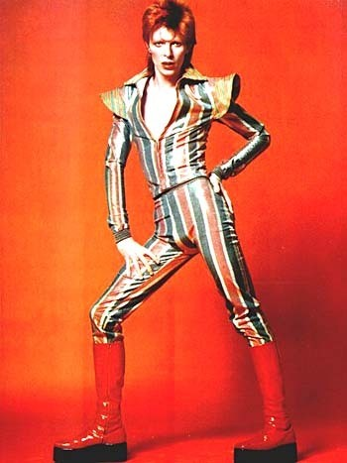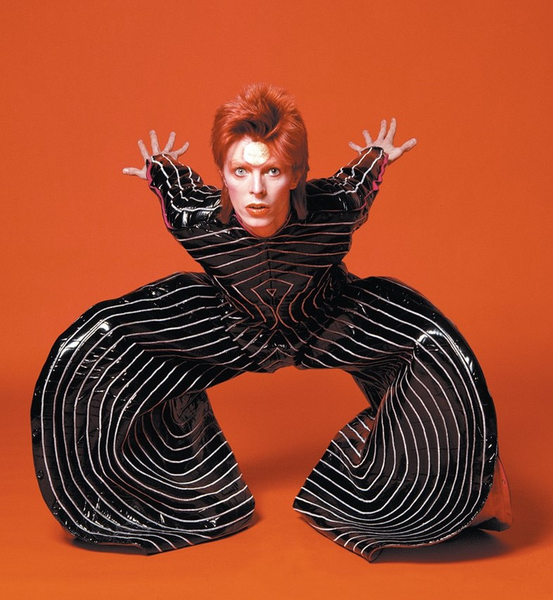
Figure 3. Some Bowies

And a shoutout to his one-time collaborator Klaus Nomi, whose Weimar cabaret aesthetic is wonderfully ridiculous:
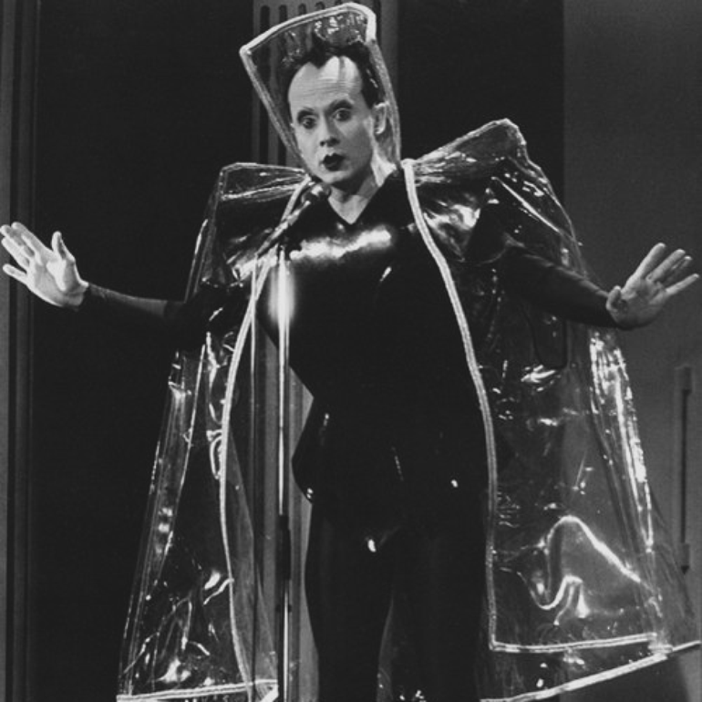
Figure 4. Klaus Nomi

In the realm of animation, I’m hugely inspired by Sylvain Chomet, director of The Triplets of Belleville, The Illusionist, and The Old Lady and the Pigeons. His drawings are grotesque but appealing and really set me down the road of cartooning. Stylistically, his work is cool because he creates these highly exaggerated character designs who don’t MOVE like cartoons at all. In order to tell my story, it was important to me that the characters move like actual people, rather than cartoon characters who might fall off a cliff and survive.

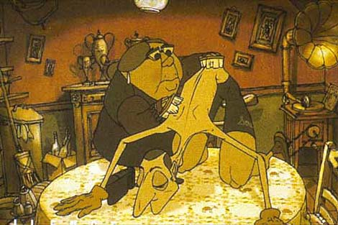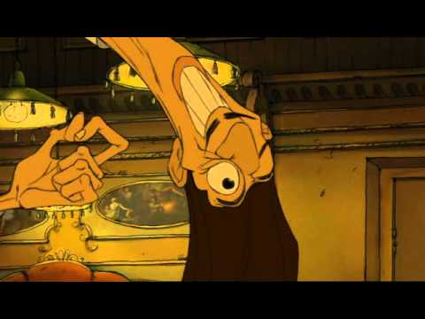
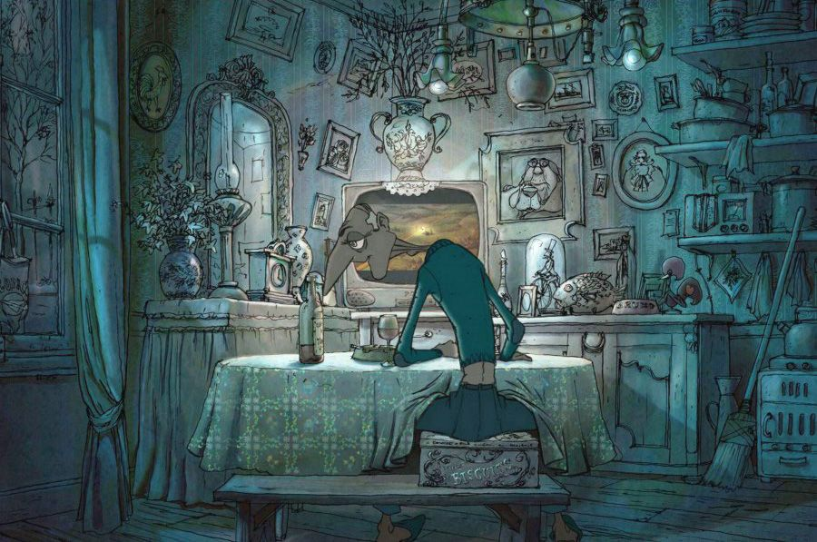
Figure 5. Rule #1 for my animation style: If Frito jumped off a cliff, he’d break his legs.

For color and costume design, I was very influenced by the French artist Moebius, as well as the studio Klasky Csupo, the latter of whom animated Rugrats and early seasons of The Simpsons. Moebius I appreciate for his visual imagination and maximalist aesthetic. Klasky Csupo was useful to me as a demonstration of “how to use weird color choices to create the feeling of lighting without animating any actual shadows.” Because I’ll be damned if I’m gonna animate shadows on every scene.

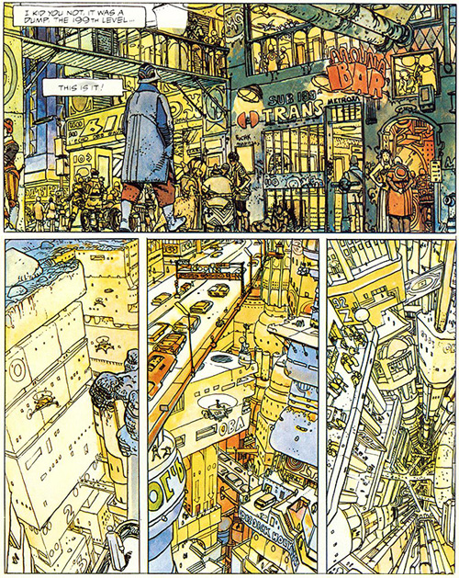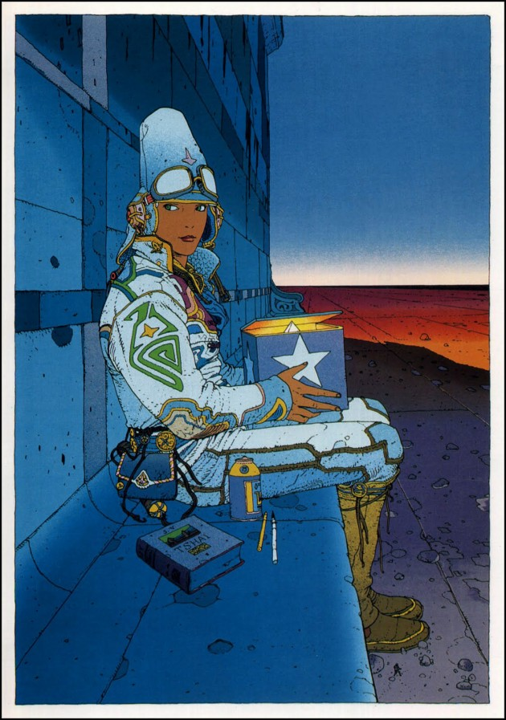
Figure 6. Moebius

Figure 7. Klasky Csupo artfully skimping on the shadows

(POINTS ADDRESSED: E1, E2, G)

---

The biggest limitation I’ve faced on this project is just getting the damn thing done. I bit off way more than I could chew and failed my first semester of Senior Port for that reason. My strategy since then has been to work with as many inbetweeners as possible to reduce my workload. All told, my original vision for the project comes across pretty well in its current incarnation, though I had to shed many details along the way.
I built this project from the outside in, starting with a big concept for a world and trying to chisel it into smaller and smaller chunks. For a long time it was hard to tell which details needed to be present to communicate the broader themes—does the godlike A.I. running Earth need to make an appearance, do we have to know that money has been replaced with rechargeable FunPoints™? If Earth is about to be embroiled in a galactic war, is that something the audience should know? Writing this story has been an exercise in subtraction, with my imagination limited by the medium and runtime. At first when I chose Dandyland as subject matter I was at a loss regarding which part of the story to adapt. An action sequence would be really cool, but would it actually convey much without any context? One day I’d like to animate Frito pursued through the streets of Earth by offworld assassins—sheepishly disguised in mesh shirts and nipple tassels—nightclubs and neon pleasure domes whizzing by in the background. But step 1 has got to be establishing the world itself, so I limited myself to that.
(POINTS ADDRESSED: H)

---

My goal setting out on this project was to convey my musings on societal trends, while expressing the sense of disorientation that I feel living in our weird, weird world. (Also to make use of my nerdy world-building hobby.) As I go forward, I think I’ll keep exploring stuff like this but find fresh angles to approach it from. I have a lot of story left to tell for Dandyland if I ever get the opportunity, so I plan to enter the film into festivals, get it in front of eyes, see if there’s anyone who wants to give me money to expand on it. If nothing pans out, I may one day write comics.
Regardless of what happens, I plan to bring it to color and move quickly onto fresh creative projects. My skills have improved so much since Senior Port 1 that I can feel a lot of different directions open to me right now. Gonna find one that really beckons to me and see what I can make—collaboratively this time!
(POINTS ADDRESSED: J)

Works Cited
21, Forever. “Men's Tees + Tanks.” Forever 21 Men, Forever 21, 2018, www.forever21.com/us/shop/catalog/category/21men/mens-tees-tanks.
Caesbroeck, Joke Van. “'Les Triplettes De Belleville' (2003).” De Standaard Mobile, 3 Mar. 2018, m.standaard.be/cnt/dmf20180302_03387832.
Chomet, Sylvain, director. Les Triplettes De Belleville. YouTube, YouTube, 5 May 2011, www.youtube.com/watch?v=L4CVtL0fuBM.
Clifford, Laura. “Les Triplettes De Belleville.” Reeling: the Movie Review Show's Review of Ushpizin (Holy Guests), 2003, www.reelingreviews.com/lestriplettesdebelleview.htm.
Created by Arlene Klasky, season 1, episode 1, 1990.
Greenberger, Alex. “Orbiting David Bowie Exhibition to Touch Down at the Brooklyn Museum.” ARTnews, 4 Oct. 2017, www.artnews.com/2017/10/04/orbiting-david-bowie-exhibition-to-touch-down-at-the-brooklyn-museum/.
Jodorowsky, Alejandro, and Girard Moebius. The Incal. Epic Comics, 1988.
Moebius, Girard. Starwatcher. Casterman, 1992.
N/a, Ross. “Ziggy Stardust in the House.” Restoring Ross, 8 Mar. 2017, restoringross.com/ziggy-stardust-in-the-house/.
Radio, NTS. “Klaus Nomi | Discover Music on NTS.” NTS Radio, www.nts.live/artists/21115-klaus-nomi.

