NEEDED:
People willing to make a game.
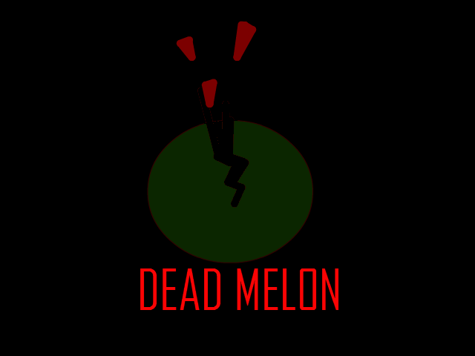
The following positions are open:
Concept Artist
Background Artist
Modeler(Must be able to work with Java or Source)
Texture Artist
Coder (Must be able to work with Java or Source)
Writer
…………………………………………………………………………………………………………………………………………………………
Send an e-mail to jorymo@gmail.com for more information and/or application. 