Rebuilding 8051 Racing Bike into the oTo Helichopper
by Gabor Pauler pauler@t-online.hu
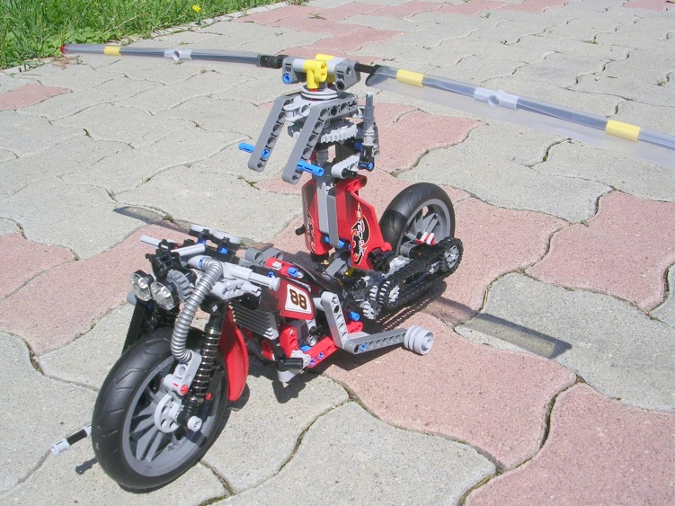
- Introduction
I hesitated long before buying 8051 Racing Bike because I thought it was overpriced, but then I got it at sale. The strong selling point was styling: it is the fanciest Technic bike ever launched by Lego.
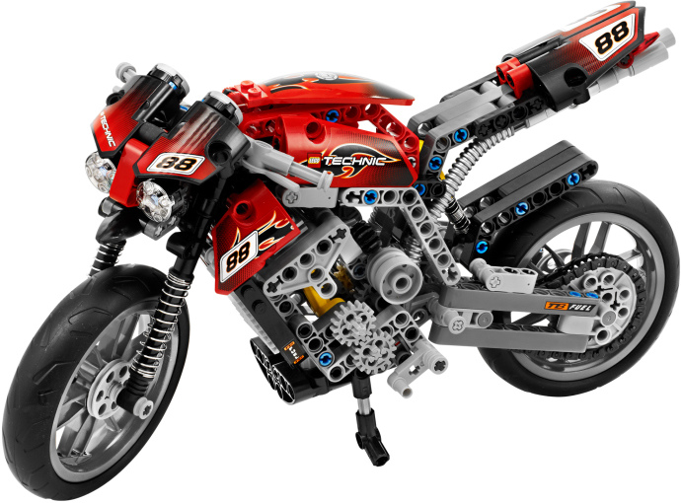
Unfortunately, high style is not accompanied by high functionality. Lego guys did their best creating reasonably good wheel, shock absorber/spring, chain components. But there are annoying mistakes in the current design:
- Both wheels have brake disks but there is no any brake assembly and any connection with fake brake levers placed on horns.
- Front wheel has no fender, so it sprays mud directly into coolant radiator behind that, reducing its effectiveness.
- Exhaust manifolds (2 bevel gears) are placed at 2 cylinders of the 3-cylinder in-line engine, but exhaust tubes are not connected to them: instead of it, they start out somewhere from the gear shift.
- There are plenty of gears at the place of gear shift, but they form only a simple fixed transmission.
- Chain does not match very well with distance of transmission gearing: taking out one unit from the chain, it is already too short, adding one unit results in too loose chain tends to buckle and jam during operation.
Of course it is more easy to criticise someone else’s design than building my own. So, its time to put there more engineering thought to achieve some extra functions: I built a helicopter-motorbike hybrid called oTo Helichopper solely from the components of 8051 set (including spare parts for the alternative model) featuring:
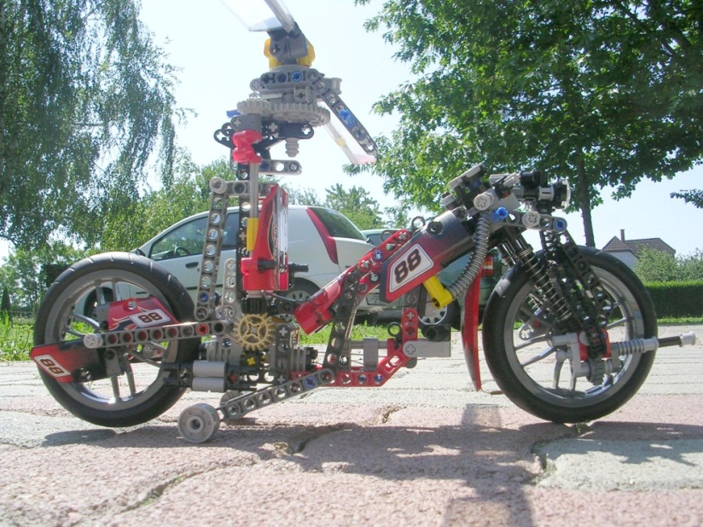
- 2-blade, semi-rigid, Bell-type main rotor with aerodynamic rotor blades foldable alongside the vehicle
- Main rotor mast foldable backward 60 degrees
- Swashplate for main rotor with cyclic (pitch/roll) and collective control levers
- Fenestron-type, 2-blade, variable pitch, ducted fan tail rotor integrated into rear wheel hub
- Echeloning yaw control pedals connected with tail rotor pitch arm through cables
- Retractable rear landing gear/trolley with lifting/locking mechanism
- Horizontally opposed 2-cylinder engine
- 2-speed gear shift connected through bowden cable with gear shift lever placed on right horn
- Front disk brake connected through bowden cable with brake lever placed on left horn
- Adjustable headlights
- Front fork lock mechanism
- Front wheel-mounted, 7.62mm, belt-feed machinegun trainable from +60 to -30 degrees vertically, and from +60 to -60 degrees horizontally
- Ammunition drum integrated into headlights
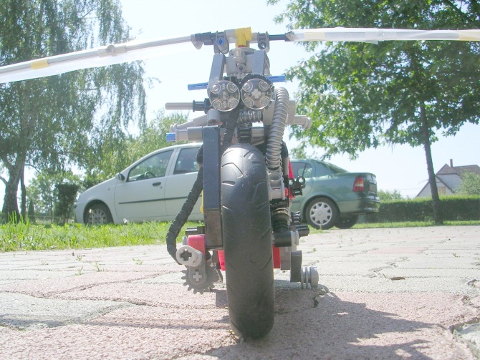

- Basic idea:
The idea of the roadable aircraft (see http://www.roadabletimes.com for their history ) was born from the desire of „flying over the traffic jam”. For my generation, the Star Wars-trilogy gave another push with empire troopers zooming among woods on jet bikes. Departing from an „airfield” with average size of 5×2.4m/17’×8’ rounded with other vehicles, road signs, traffic lights, lantern masts, air cables and other nice&sweet stuff requires excellent VTOL (Vertical Take Off Landing) capability. Done by an aircraft foldable into the dimensions of a full size car… The engineering challenge is incredible:
- Even ultralight aircrafts usually have 8-10m/26’-33’ of wing lenght/rotor diameter to produce sufficient lift, so if rigid/rotary wings are used, they should be foldable, which is risky and requires high-tech materials.
- If smaller ducted fans are used to save space, it has two disadvantages: 1. The higher the speed of air downstream, the less fuel-efficient it is. 2. The craft is not able to make controlled dead-engine crash landing. So the nasty FAA (Federal Aviation Administration) won’t certify it – and they are right: Designers of such crafts usually recommend ballistic parachute for crashlanding. But if you deploy it from a destabilized, rolling craft, flying low, it is merely an invitation to your funeral.
- Sizeable wheels, suspension, chassis providing reasonable road safety are just too heavy to fly or they should be made of expensive composite materials
- Ideal placement of COG (Center Of Gravity) and wheel layout is very different between road vehicles and aircrafts, which can be bridged with complicated folding wings/tails/landing gears
Answers to the challenge include some expensive media hoaxes (http://www.moller.com/), unmanned military drones (http://www.urbanaero.com/), but recently 2 FAA-certified crafts (http://www.terrafugia.com/ and http://pal-v.com/ ). My model is a tribute to the Dutch guys creating PAL-V, a roadable 2-seat autogyro, solving tremendous engineering challenges with 10 years of hard work:
- Electronic controlled rear suspesion of tricycle wheels to tilt the craft in road turns to maintain speed
- Retractable tail boom and rotor blades folding into 2 pieces – a risky solution requiring aerospace materials, careful maintenance and expensive spare parts.
- As it is an autogyro, not a helicopter, it still needs 50m/42yards space to take off instead of the 5m/17’ we have in the traffic jam.
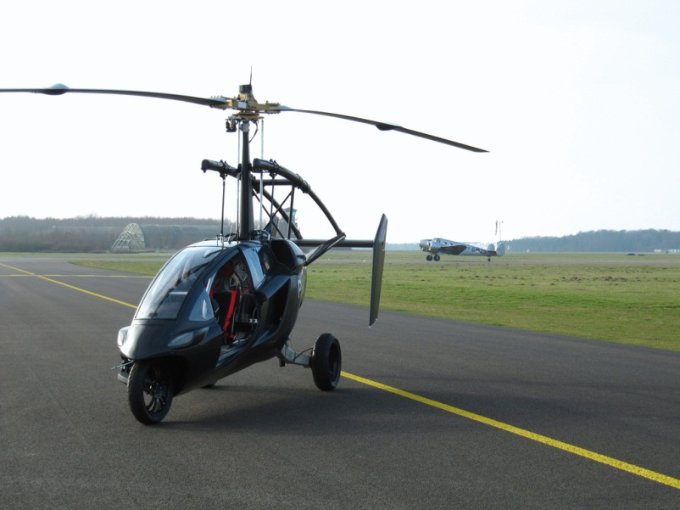

- Basic configuration and purpose of the oTo Helichopper:
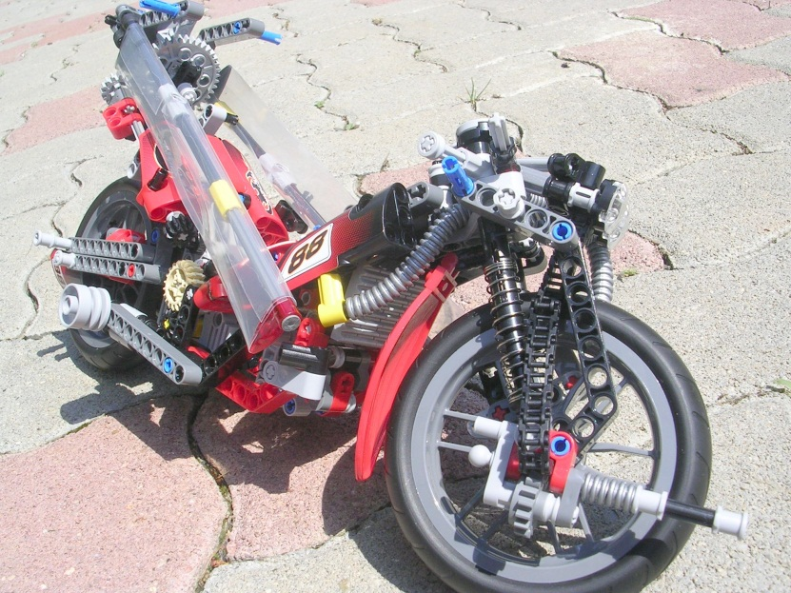
Therefore I opted for a hybrid helicopter-motorbike with main rotor mast tiltable backward, thus rotor blades foldable alongside the vehicle. This layout allows the maximum rotor diameter with the smallest folded vehicle size using one piece-blades. So blades can use relatively cheap conventional materials, eg. Dural tube spar with glass fiber reinforced resin ribs and cover.

Tail rotor is more nasty story: omitting or minimizing it requires more bulky coaxial main rotor (eg. Kamov Ka-56 coaxial personal helicopter for marine special ops) or rocket/ramjet powered blades with incredible noise and fuel consumption (usually from very expensive and dangerous hydrogen peroxide). Both solutions cannot fully eliminate tail boom, as during autorotation crashlanding flight it is required to carry vertical stabilizer surface. Therefore I selected integrating fenestron-type tail rotor in the hub of a large sized (0.95m/38” tyre and 0.7m/28” rim) rear wheel. Its disadvantage is more short arm of force than conventional tail boom requiring more power to counteract main rotor torque. However a variable pitch ducted fan can be more effective than a conventional tail rotor, moreover it means definitely less noise and vulnerability.

Wheel size requested was the primary reason to change scale of the model from 1:6 of the original 8051 Racing bike (roughly Barbie-figure scale) to 1:10 (1 stud = 0.08m/3.2”). This is not very frequent scale in Lego (Minifig scale is 1:36..1:38, Technic/Belleville figure scale is 1:18..1:20) but there were some sets (eg. 9392 Quad) close to this scale. An additional positive effect was that material was enough for a more complex model (material requirement increases/decreases roughly on 3rd power of linear size).

One can see that oTo Helichopper has armament. Why? First, I do not think that roadable aircrafts are economically viable in civilian/commercial use: you can get far better separate car and aircraft at lower price. Second, they require excellent piloting skills because of their complexity. In my vision, the only area they can succeed is law enforcement patroling and special operations forces, where time of transition between air and road is critical. So, costs of mechanical complexity and excellent piloting skill can be justified. For example, think about the Utoya Isle massacre happened in 2011 Norway: police officers notified by victims on mobile phone were ashore within 5 minutes, then they spent 50 minutes to find a boat to make the last 300m on water. Communication towards airborne units was inferior. It costed lives of dozens of innocent people. The purpose of oTo Helichopper is – whenever heavily armed criminals are encountered - to convert a police cruiser patrol into an „air force of one” in 1 minute, and hunt them down from the air at high speed.

Helichopper has road size of 3.5m/12’ lenght × 0.85m/3’ width × 1.75m/6’ height, which is somewhat bigger than a police cruiser bike, but smaller than a compact car. Main rotor diameter in flight configuration is 4.8m/16’, total height 2.1m/7’, safe clearance height under main rotor is 1.9m/6’, distance betwen main- and tail rotor hub is 0.95m/3’. Tail rotor fan duct diameter is 0.7m/28”. Main rotor disc area is 18.09sqm/200sqfeet, maximal takeoff weight based on 12kg/sqm (2.4lbs/sqfeet) maximal rotor disc area load for safe autorotation crashlanding is 217kg/482lbs. Assuming 80kg/178lbs for pilot, 8kg/18lbs for 7.62mm machinegun and 3kg/6.6lbs for ammunition, 22kg/49lbs for 30 liters/6.6imp gal 100 octane petrol fuel, 3kg/6.6lbs for lubricant, 3kg/6.6lbs for liquid coolant, its maximal unloaded dry weight should be 98kg/218lbs, which is very demanding and assumes usage of lightweight composite materials everywhere – a very different technology from conventional chopper building. Lets see it more detailed:

- Main rotor
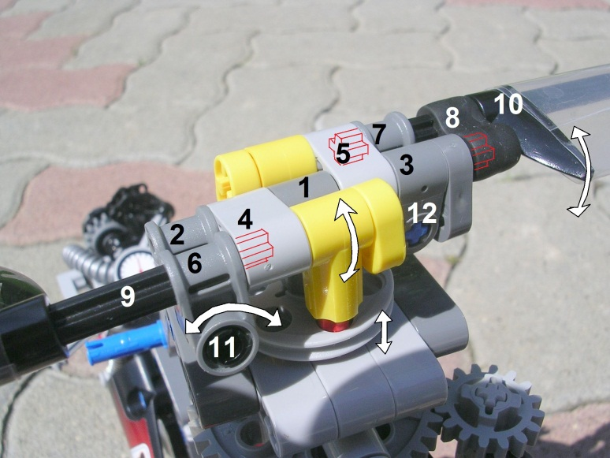
Creating the main rotor, the biggest challenge was that in 8051 set there was no any specialized parts necessary for helicopter rotor: 4 ball joints, large diameter bearing and cardan-hinge for swashplate (About working of helicopter rotors and controls, see April 2011 archive of http://technic.lego.com/en-us/Designers/Blog/Default.aspx). Moreover, I had to create a rotor with blades foldable along main rotor mast, which complicated mechanics further. Therefore I selected the simplest possible type of rotor: 2-blade, semi rigid, Bell-type. Both blades can be pitched around an axis peripendicular to main rotor axis nested in (1) hinge. However (9) blade is fixed on cross-axis, while (10) blade can rotate around that, but not entirely freely: (8) rubber tie – which was used merely to bridge unmatching geometry in 8051 – acts as a torsion spring forcing blades at 0 degree pitch default position relative to each other. A counterweight on (9) rotorblade spar balances the weight of torsion spring to keep the rotor balanced. Blades can be folded along main rotor mast by (6, 3) hinges turning around (11, 12) axises 90 degrees. Blades are locked in open position by (4, 5) sleeves nesting end of (9, 10) blade spars marked with red lines.
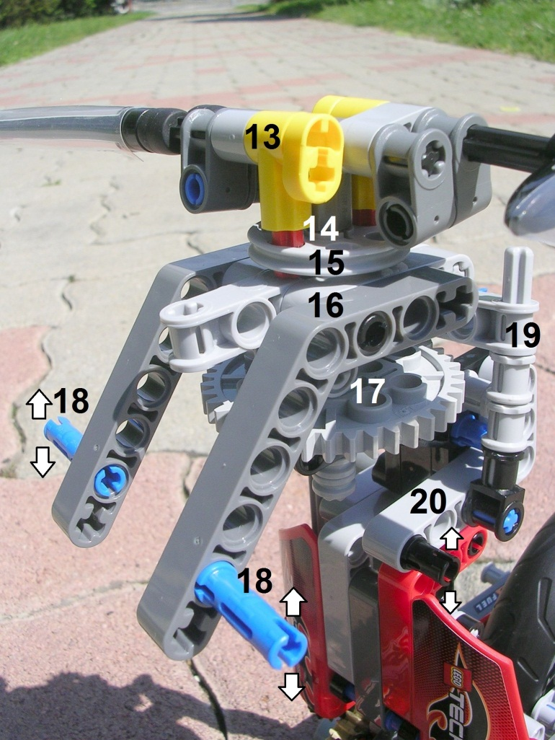
(13) hinges and (14) pushrods can increase pitch of rotor blades sliding up/down in the holes of (15) rotating drive disc. Lower tip of pushrods pushed down by (8) torsion spring slide on (16) non-rotating swashplate, which is here really just a plain plate with a hole in the middle letting through main rotor axis (this way I could resolve lack of large diameter bearing and ball joints). Swashplate can be tilted around main rotor axis in any direction on (17) double hinges by (18) cyclic control levers, resulting cyclic change in pitch of blades. Swashplate be can lifted/lowered by (20) collective lever through (19) collective pushrod resulting collective change of pitch of blades.

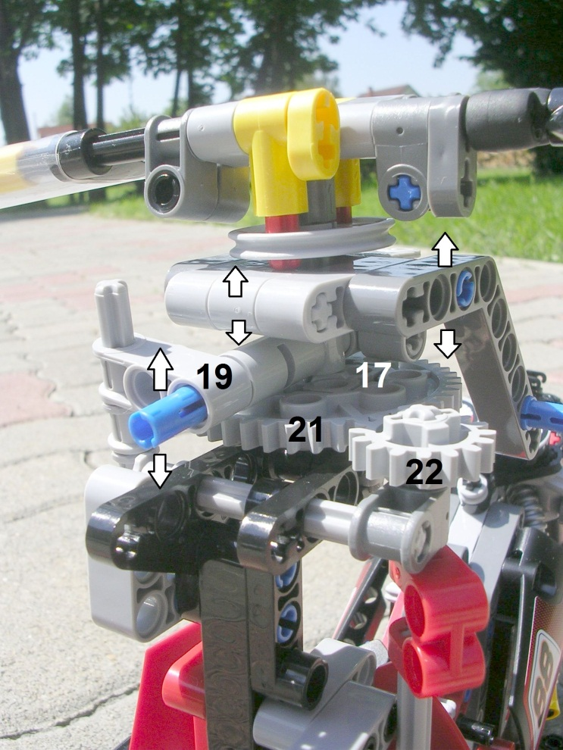
What you cannot do on computer - Dirty building trick 1: as (19) collective pushrod lifts swashplate asymmetrically from backward against the foce of torsion spring, it would twist it forward also, which would disturb cyclic control. So collective pushrod is built in twisted backward to counteract it. This way, collective lever lifts swashplate perfectly leveled.

(21) main rotor gear is driven by (22) main rotor transmission shaft running down on right side of main rotor mast.
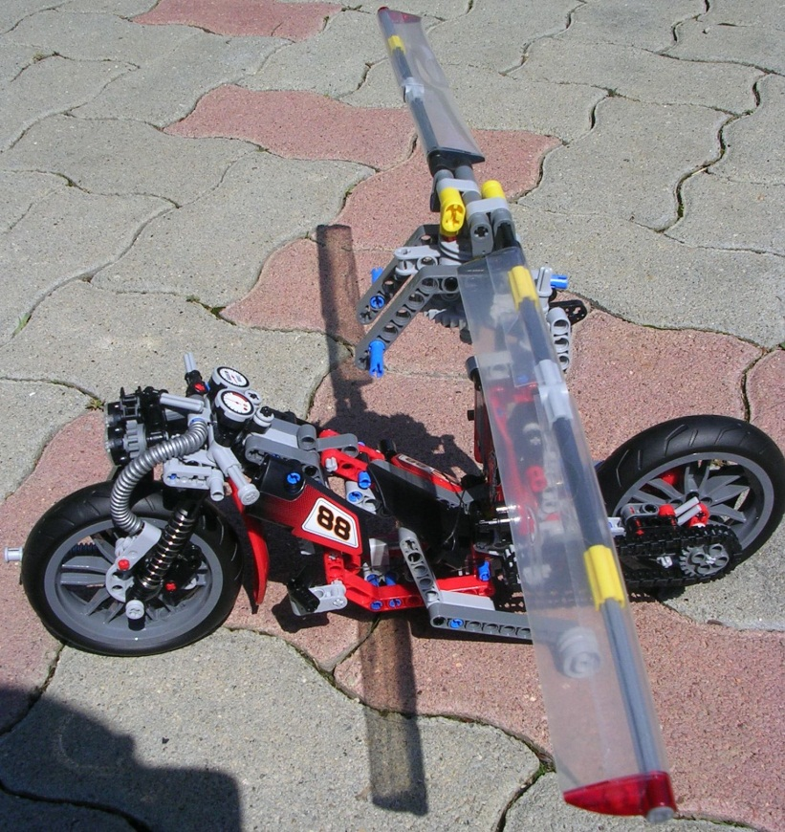
Dirty building trick 2: Rotor blades are the most controversial part of my design. I assumed that sticker sheet of decals provided to set 8051 is not pre-cut, but can be used in 2 large rectangular pieces to cover main rotor blades (I used transparent duct tape with the same area to simulate this). Why? I simply got fed up with that Lego cannot provide us reasonably aerodynamic rotor blades. They introduced specialized rotor blade component at set 8046 in 2010 but they put studs in the middle of it making it pretty ridiculus.
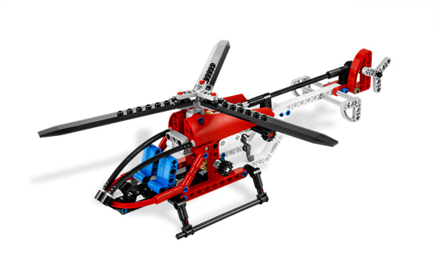
Another sad example is SgtPepper’s Aerospatiale Alouette II design from 2008 (see: http://www.brickshelf.com/cgi-bin/gallery.cgi?f=316589 ). This guy made incredibly realistic machine, but he had to put studded bars in the airflow as rotor blades:
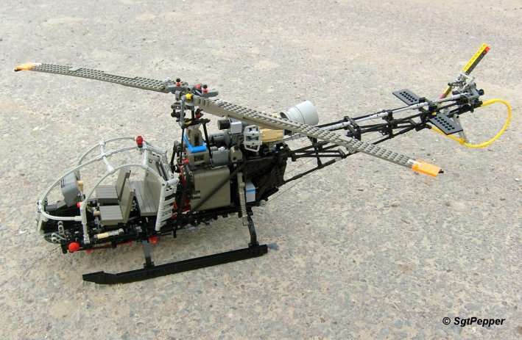
Therefore I make a recommendation: Dear Lego Technic Guys, you should introduce a set of standard sized transparent/colored stuctural decals which can be used as skin/cover/window on light vehicles – just like the very succesful set of fairing elements introduced 10-12 years ago. Advantages:
- Decals are already well-known technology for Lego being part of many sets
- They are cheap and comply children safety rules as long as they are not enogh big that kids can strangle each other with that
- Larger areas of cover can be sticked together from smaller standard parts
- Duct tape material technology made serious improvement in recent years using high tensile strenght plastic foils, water-resistant glues, sticky surfaces renewable with simply washing it with detergent, stretchable foils keeping their shape, etc.
- Combining decal covering with stiff/elastic rod structures would provide excellent modeling tool for real world’s welded steel/dural tube stuctures covered with glass/carbon fiber reinforced resin: eg. most racing cars, rigid wing aircrafts, hoovercrafts, light ships, etc.
- Mildly curved surfaces eg. windscreens of cars/planes could be modelled with ease
Building rotor blades, I used the 4 “claw” components provided in 8051 as wing profile griders covered with decal. It is still very far from a patented NACA (National Advisory Committee for Aeronautics) -aerofoil section, but it made its effect. When I prepared the open-air photos of Helichopper, there was medium wind, and blades did what they are proposed to do with annoying flipping-flopping.
(And Dear Lego Guys, when you will design the claws of the next Godzilla/ Tyrannosaurus/ Alien/ Lady Gaga set, can you accidentally use the shape of NACA 712A315 aerofoil, thanks.)
- Tail rotor
If I build it from scratch, I use two separate sets of cardan axises+universal joints+clutches for rear wheel/tail rotor alongside rear left/right fork. But in 8051 set there was not enough axises for this after building rotor blades. Moreover, it would require coaxial layout of rotor and rear wheel hub, and components of coaxial axises are weak point of Lego Technic. I tried to separate rotor and wheel drive on left and right half-axises, but it undermined the structrural strenght of rear fork. Finally, I fixed rear wheel and rotor on common axis driven by chain. This way, rear wheel has to be lifted from ground in helicopter mode by the retractable landing gear, allowing it spin fast as tail rotor. This is not very practical and clearly dictated by material limitations: At rough crash-landing, landing gear may collapse and fast spinning rear wheel may suddenly touch ground, flipping over Helichopper. A spinning fan before standing rear wheel reel blades would be also more effective aerodinamically. There is only one advantage of this forced solution. Fast spinning rear wheel acts as a flywheel increasing rotor inertia, which is critical for survival in dead engine autorotation crashlanding, reducing „dead man zone” (combination of low height and low horizontal speed insufficient for autorotation). Extra momentum of rear wheel does not influence badly maneuverability of rotors, as usually in most rotor systems, constant rotor speed is maintained by electronic engine throttle governor and all controls are done with altering main/tail rotor blade pitch. Let’s see tail rotor components more detailed: shorter type of fairing elements are used as (2) tail rotor blades, wich can be pitched around axis of (1) tail rotor hub peripendicular to rear wheel axis. Left-right movement of (3) flanges and (4) cotrol rods driven through rear wheel hub holes regulates their pitch.
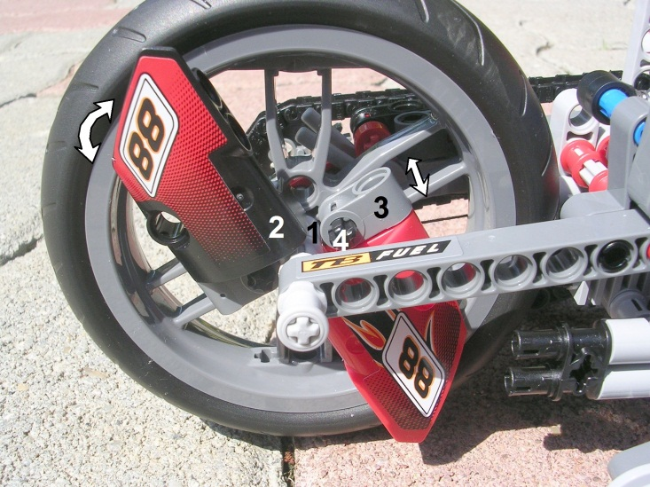
(4) control rods are held by (5) rotating slide, whose left-right movement is controlled by (6) fork of pitch control arm. The arm can be rotated around (7) axis by control cables running below left rear fork.
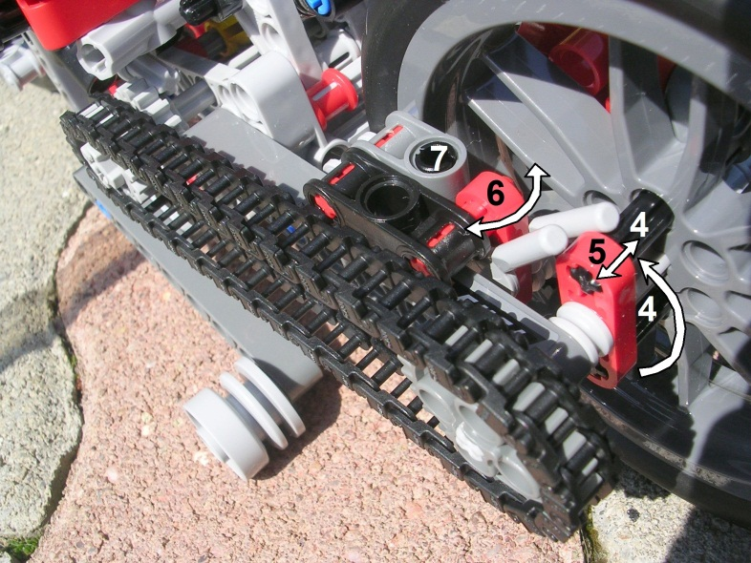
Rear wheel axis is driven by gear shift through chain. Rotating point of (15) rear fork is so close (2 studs) to gear shift axis that fork movement in normal range does not influence chain tension seriously.

- Engine and gear shift
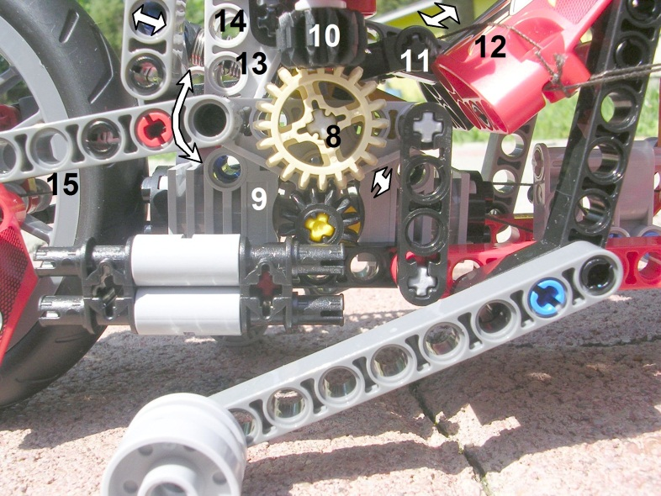
(8) gear shift axis can move 0.5 studs right and left shifting between high gear (equal sized flat gears on left side of engine) and low gear (different sized (8, 9) bevel gears on right side). The chain has enough flexibility allowing this small side movement.

Dirty building trick 3: In the reality chain drive gears have conical teeth, this way they can tolerate pretty well if they are not perfectly aligned in line with chain. However Lego did not develope specialized chain drive gears and chain can jam on flat gears if they are not perfectly aligned. But, if we deploy chain reversed compared to 8051 building instruction (chain member hooks outward instead of inward), tip of gear teeth will meet rounded edge of chain members and jamming tendency will be reduced.

In flight mode, the (10) lower bevel gear of main rotor transmission shaft connects to (8) large bevel gear of gear, locking gear shift in low gear. (13) spring of rear suspension is placed between (8) gear shift axis and (14) rotating axis of main rotor mast to save space. The placement of the horizontally opposed, 2-cylinder, 2-stroke, liquid cooled, Rotax-style engine before rear wheel is unusual at choppers, being more common in scooters. But it has serious cause: COG (Center Of Gravity) of the craft should be resided under the main rotor axis, therefore the relatively heavy engine is placed behind it, to counterbalance weight of fuel tank, forward fork/wheel and armament/ammunition. Pilot’s weight does not influence COG seriously, as he/she is positioned almost directly under main rotor axis.
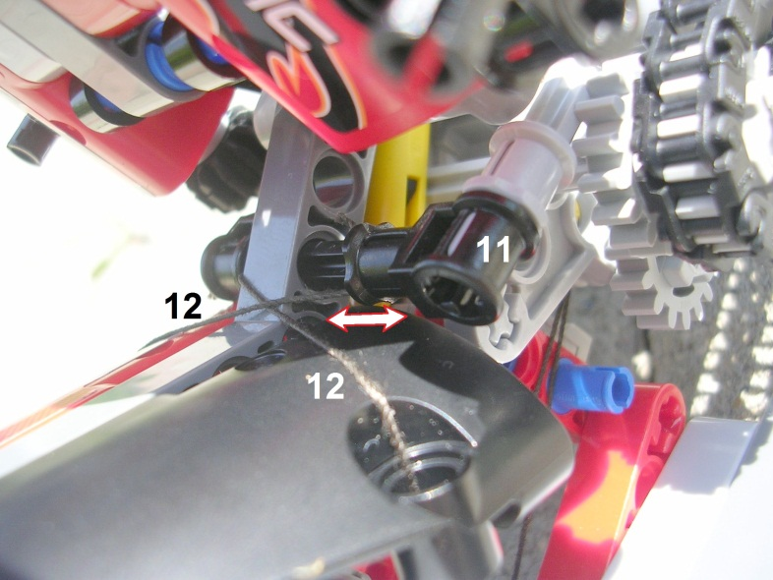
In road mode, gear shift axis is shifted left-right by (11) gear shift rod pulled by (12) gear shift cables.
Rotor mast is locked in open position by (14b) backward foldable grider strut and (14c, 14d) locking pins.
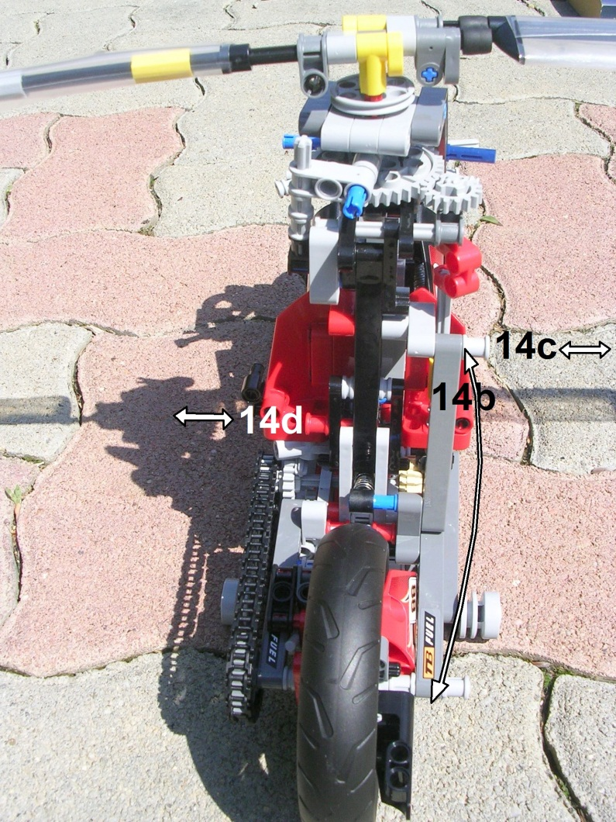

- Landing gear and yaw control pedals
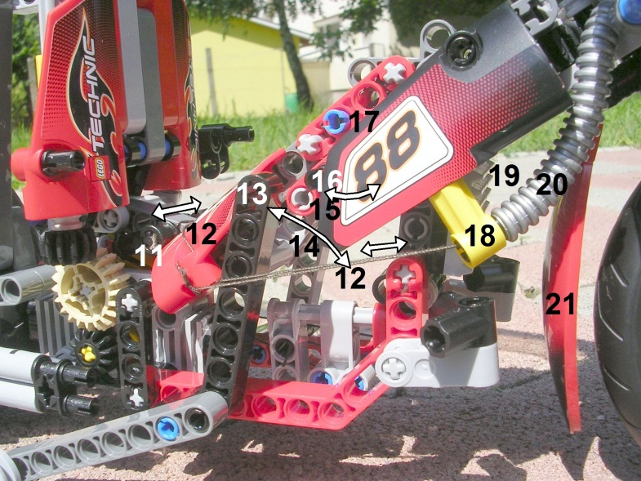
Landing gear can be lowered - to get rear wheel free spinning as tail rotor - by pulling (13) lever towards front edge of seat. However, it would be impossible to lift the whole rear part of the craft by this lever with manual force. Therefore, there is a scissor-mechanism under the middle part of seat consisting of 2 jacking hinges (14, 15) joined to (17) pin. Pulling them upward by (16) lever provides sufficient force to lift rear part of the craft and locks landing gear in lowered position. (12) gear shift cables run through (18) flange and (20) bowden towards left horn. (21) fender of front wheel prevents mud spilling from wheel clogging (19) coolant radiator.
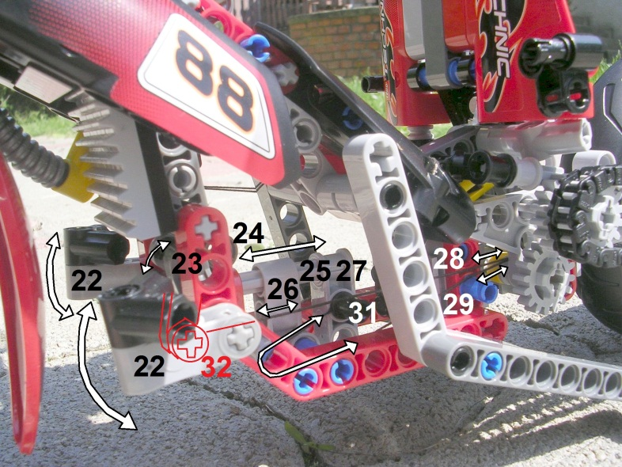
Echeloning movement of (22) yaw control pedals is governed by (23, 32) echelon-positioned arms rotating in (24) flange, which is fixed on (25) axis. The axis can slide forward/backward in (26) slide fixed to main frame, pulling either (28) control cable anchored to (32) arm, either (29) cable anchored to (27) arm with (31) pin.
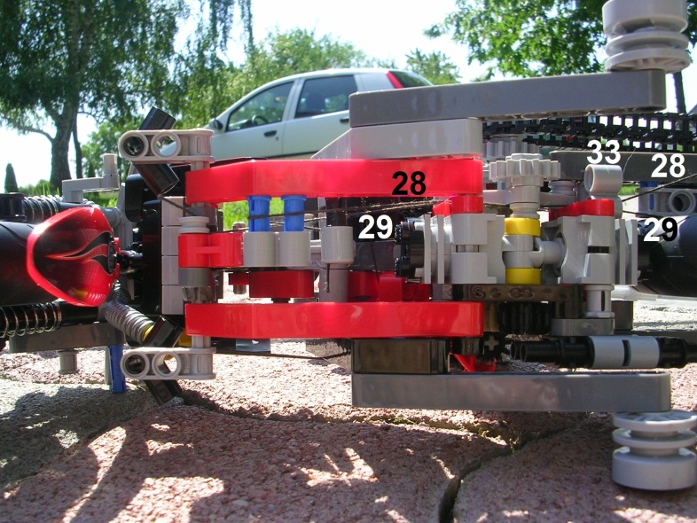
(28, 29) control cables run backward above crankshaft of engine, then through (33) lead to reach tail rotor pitch control arm rotating on rear fork.
- Forward fork and horns
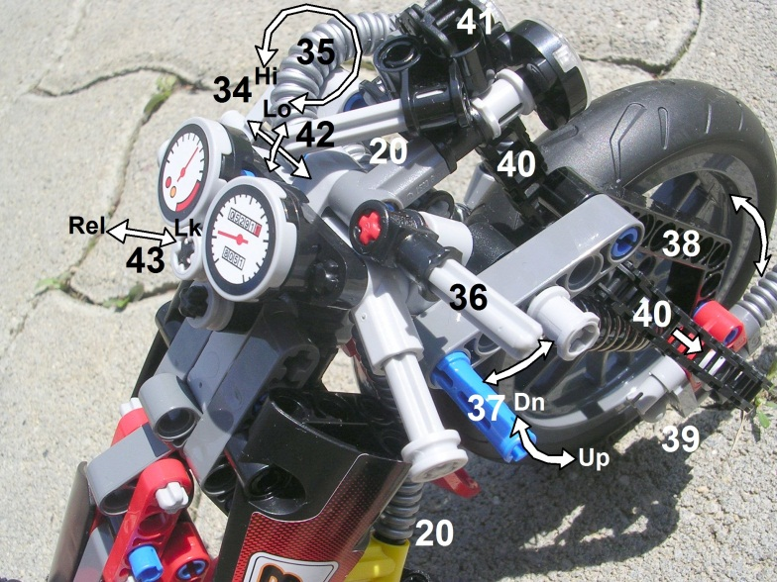
By default, front wheel and fork would not play very important role during flight. However, I use it as a virtual „gun turret” allowing (39) 7.62mm machine gun mounted on forward wheel axis to lay from -60 to +60 degrees horizontally, and train from -30 to +60 degrees vertically. Horizontal laying happens simply by rotating horns, vertical training is made by depressing/raising (37) train lever, through (38) training rod. Leftover part of chain is used modeling (40) ammunition belt, which is rolling down from (41) running gear of ammunition drum built behind left headlight. (42) ammo belt brake lever locks belt moving it to right and release belt moving it to left. Moreover, moving (42) lever up and down can raise/depress headlights, because in flight mode headlights are used to illuminate/blind targets on the ground. As axis of gun barrel does not match axis of rotation of fork, recoil force of the gun will generate torque on fork wanting to turn it to right. As it is very hard to counterbalance manually, pressing (43) button can lock forward fork in a given position forcing a rod among the teeth of a bevel gear fixed to main frame. Fork lock is also used during autorotation crashlanding, when forward fork can be hit hard, to prevent its jacking. On most bikes gears are shifted with a pedal, but here pedals are used for yaw control. So (34) gear shift lever is placed on left horn, pulling gear shift control cables running trough (20) bowden. (36) brake lever is placed on right horn, pulling brake cable through (35) brake bowden fixed to (44) brake assembly. The cable pulls (45) brake arm, which presses a shorter arm to (46) brake disk.
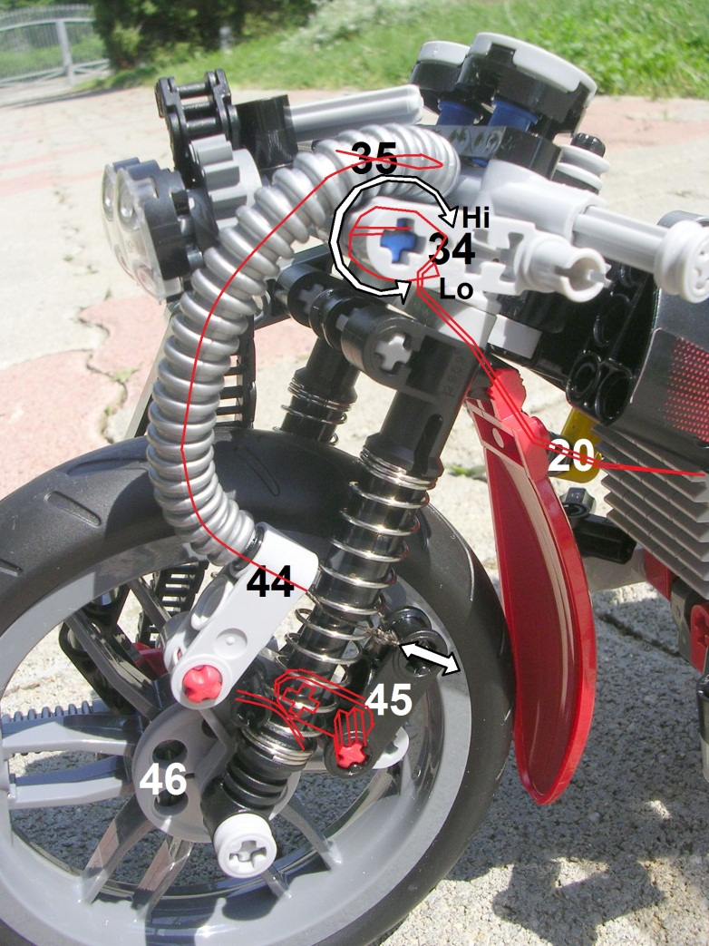
- Transition process between road and flight mode
- (34) gear shift into low
- (13) landing gear down
- (16) landing gear locked
- (43) forward fork locked
- Open rotor blades and lock them into (4, 5) sleeves
- 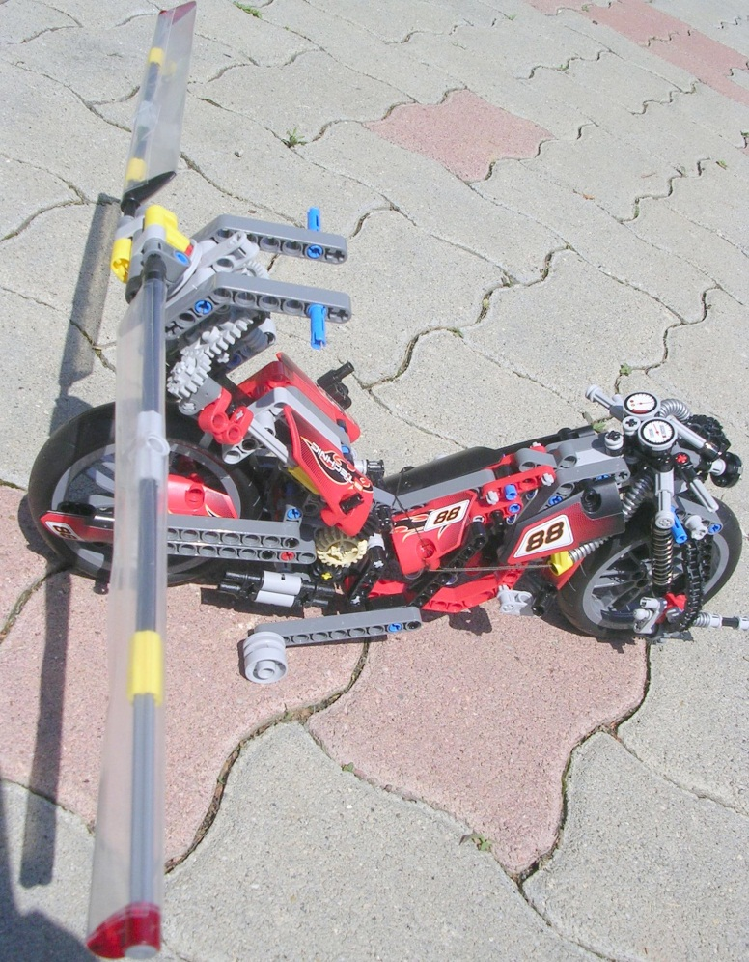
- Open main rotor mast
- Open (14b) main rotor grider strut and lock with (14c) locking pin
- Lock (14d) locking pin
- Spin up rotors to standard speed
- Raise collective lever, etc.
- Leftover materials
Set 8051 was a good source of material, in this sense, it was value for money. Moreover, altering model scale from 1:6 to 1:10 helped to create much more functionality from the same amount of material. Even we have some stuff left over:
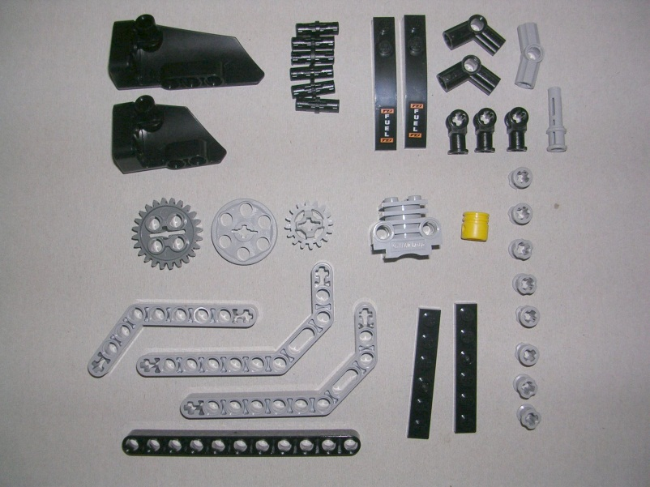
- Unsolved problems and shortcomings
- Main/tail rotor gearing ratio is 1:1: this is serious shortcoming as it is 1:10 in reality, or in case of high rpm fenestron tail rotor 1:20. The reason is that gear shift has very limited space, and 8051 had no special gear shift components, so I could not solve building there more high gear levels spinning tail rotor more fast.
- Collective control levers work 90 degrees rotated: tilting them forward causes right roll, tilting them right is backward pitch, left is foward. This is because reverser rods has no space left in main rotors constrained size, and 8051 lacked necessary ball joints
- Incorrect Center Of Gravity: in most rotorcrafts, COG should be uder main rotor axis, while here we have it 2 studs/0.16m/6.4” forward from that. But in the reality, engine placed back side of main rotor axis is more heavy than wheels, so this problem will solve itself by engine placement. Weight of pilot will not seriously influence COG position, as pilots most weight resides directly under main rotor axis.
- Engine is not connected to rotor drivetrain through centrifugal clutch: in the reality, road/flight modes would require 2 different type of clutches: road requires conventional manual clutch allowing use of engine braking. While in flight mode, a centrifugal clutch should immediately disengage engine from rotor drivetrain if engine rpm suddenly falls. This prevents a stalling engine destroying rotor momentum, which is key factor of survival at dead-engine autorotated crashlanding.
- Acknowledgements
- Name „oTo” comes from the name of Otoe American Indian tribe. This Sioux-originated tribe originally resided at Great Lakes but in 1884 they were deported in Oto Reservation Nebraska. My design is a tribute to them.
- Thanks to my wife, Cathy not divorcing me during 10 days of continous Lego Tech-narcosis developing oTo Helichopper

