Handbook of Building Working Guns for Bionicle Figures
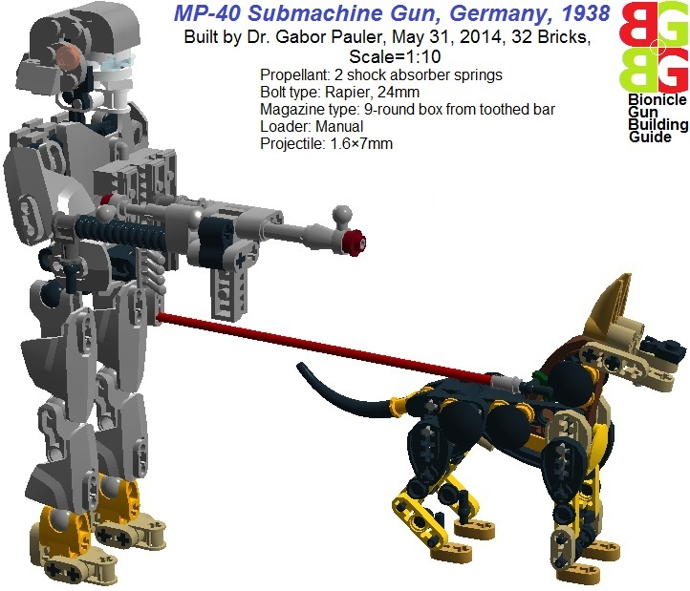
Handbook of building working pistol, submachine gun, assault rifle, machinegun, sniper rifle, RPG, Mortar for Bionicle figures

<big><b><u>0 Introduction</b></u></big>

*NOTICE: The author does not support/agree with any aggressive military/political organizations /ideology or weapons lobby. All weapons are introduced by military historical and technical point of view.
**See all models in Lego Digital Designer (LDD): <a href=http://www.brickshelf.com/gallery/gjpauler/SmallArms/MP40Scale1To10.lxf>Here</a>

Introduction of Bionicle product line by TLG marked the advent of highly poseable figures with robust ball joints in scale 1:6..1:10. Usually they have exotic names and carry all kinds of exotic or sci-fi weapons: katana, nunchaku, shuriken, battle axe, clubs, chainsaw, rotten sushi, hiper-super mega laser blaster/ rail gun, and the worst of all: tax withdrawal form. But most of these weapons are non-working decoration – being the consequence of TLG’s aversion of modeling actual firearms – so I always felt that they are ridiculously under-engineered compared to Bionicle figures.
In the meantime, we can see wide range of nicely detailed working handgun MOCs in scale 1:1 by <a href=http://www.mocpages.com/folder.php/129346>P. K.</a>, <a href=http://www.mocpages.com/folder.php/163237>Cole Edmonson</a> and many others. But they are rarely attempted in smaller scale (Bionicle:1:6..1:10, Technic: 1:20, Minifig: 1:40), as TLG parts became huge and bulky there for internal mechanic parts of automatic weapons. Additionally, rubber bands generally used as propellant destroy the outlook of working guns in smaller scale models, although there were some experiments with self-contained propellant cartridges at <a href=http://www.mocpages.com/moc.php/138874>James Rittwage</a>.
There are also lot of nicely shaped, but non-working smallarms MOC, e.g. at <a href=http://www.mocpages.com/moc.php/34539>Thomas Heinrich</a> in Technic scale, or at <a href=http://www.mocpages.com/moc.php/262806>Quad 9363</a> in Minifg scale.
My handbook is about the building techniques of creating WORKING AND REALISTIC LOOKING firearms for Bionicle figures in scales 1:6..1:10. It has 3 chapters:
- First – as a motivation - we show a number of famous historic firearms we can be built using these techniques.
- Second, we go into details of building techniques. This part contains technical text and intended for audience with at least some minimal knowledge of operating principles of automatic weapons. If you do not understand how different types of automatic weapons work, you can find an excellent summary at <a href=http://en.wikipedia.org/wiki/Gun#Operating_principle>Wikipedia</a>.
- Third, we show set of modern small arms models: pistol, submachine gun, machinegun, armor piercing rifle, sniper rifle, Gatling-minigun, RPG, flamethrower, light mortar.

<big><b><u>1 Historic small arms</b></u></big>

Building these weapons, our primary concern was to create the most similar outlook to historic weapons with some basic functionality: all they can shoot and all they have magazines to store projectiles. Playability and structural sturdiness was not an issue here, moreover autoloader mechanism is included only in larger automatic weapons.

<big><u>1.1 World War I, 1914-1918</u></big>

The Great War was first imagined by enthusiastic European politicians and crowds as a post-Napoleonic fashion show: fancy cavalierly attacks, fancy uniforms, great marches, glory and pride. In just matter of weeks, they found themselves in 4 years of bloody hopeless stalemate of a modern technical war with incredible horrors and casualties. Let’s see why.

<big><b>1.1.1 Lee-Enfield Rifle, British Empire, 1895</b></big>
(See the real one at <a href=http://en.wikipedia.org/wiki/Lee-Enfield>Wikipedia</a>)
This guy is not from the discarded beta version of Star Wars. It’s an average English G.I. Joe during gas attack in 1916. The more ridiculous looking and awkward his gas mask was, the better rifle he had. Lee Enfield was more expensive and accurate rifle with higher capacity magazine than its German counterpart, expressing the British belief in the concentrated firepower of rifles by well-trained infantry. This came from sad experiences of the two Boer wars.
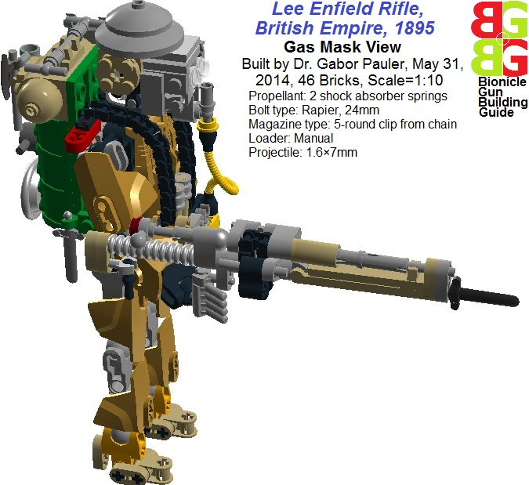
<b>Figure 1: Lee Enfield rifle with gas mask</b>
See in LDD: <a href=http://www.brickshelf.com/gallery/gjpauler/SmallArms/LeeEnfieldRifleScale1To10GasMask.lxf>Here</a>

We modeled Lee Enfield with rapier-type spring shooting mechanism and 5-round loading clip made of parts ‘motorcycle chain’, containing 1.6×7mm projectiles made of aluminum wire. This is because TLG does not manufacture reasonably small parts suitable for projectiles in scale 1:10 because of children safety reasons. Moreover, ABS material of TLG parts are too easy for projectiles. For further technical details and building techniques used, please refer to Chapter 2. We also modeled the full military gear of infantrymen of the era: bayonet, backpack, spade, blanket, pottery, axe, canned food, etc., not forgetting the ridiculous shaped and awkward helmet. Of course carrying these many stuff totally destroys playability.
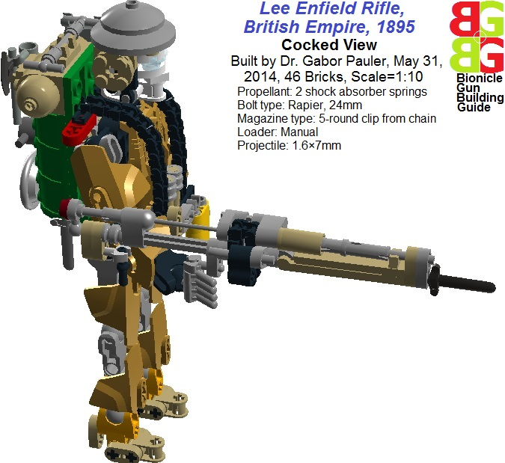
<b>Figure 2: Lee Enfield rifle cocked</b>
See in LDD: <a href=http://www.brickshelf.com/gallery/gjpauler/SmallArms/LeeEnfieldRifleScale1To10Cocked.lxf>Here</a>

You can imagine how playability was destroyed at July 22, 1917, Passchendaele, Belgium, when 280,000 British ‘lions led by donkeys’ attacked German machinegun positions in full gear crawling slowly in knee-deep mud. The heaviest artillery barrage of Earth until that point totally destroyed the drainage system of lowland, but could not penetrate most German concrete bunkers built 10 meters deep. The stupid 2 minutes break between barrage and attack allowed German machine gunners to run into positions. 21,000 young Englishman dropped dead in less than 30 minutes…

<big><b>1.1.2 Mauser M98 Rifle, German Empire, 1898</b></big>
(See the real one at <a href=http://en.wikipedia.org/wiki/Gewehr_98>Wikipedia</a>)
The basic German rifle was more simple, cheap and reliable, however less accurate than Lee-Enfield. But this was enough to serve in two world wars and well beyond that in civilian usage. German tactics stressed on firepower of machineguns instead of concentration of rifles to achieve breakthrough and was continuously refined during war. This was tailed to more limited manpower of Central Powers, which did not allow very lengthy rifle training for infantry.
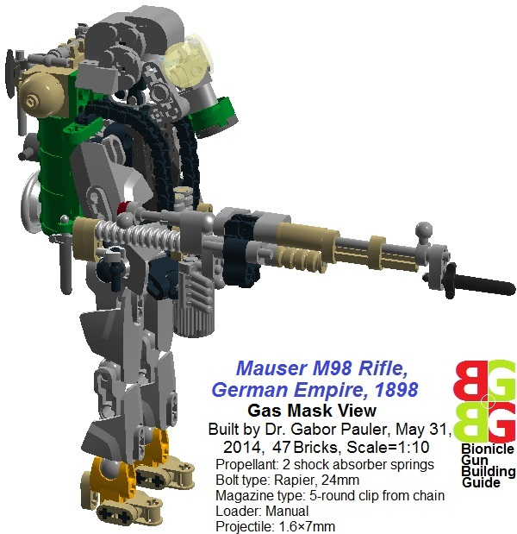
<b>Figure 3: Mauser M98 rifle with gas mask</b>
See in LDD: <a href=http://www.brickshelf.com/gallery/gjpauler/SmallArms/MauserM98RifleScale1To10GasMask.lxf>Here</a>

One can see that German gas mask design was more advanced than English, being more close to modern ones. Also the classic boiled leather Pickelhaube helmet was replaced for more useful, well-designed steel helmet in 1916. As MOCs, working of Mauser and Lee-Enfield rifles are almost identical, differing only in decorative details.

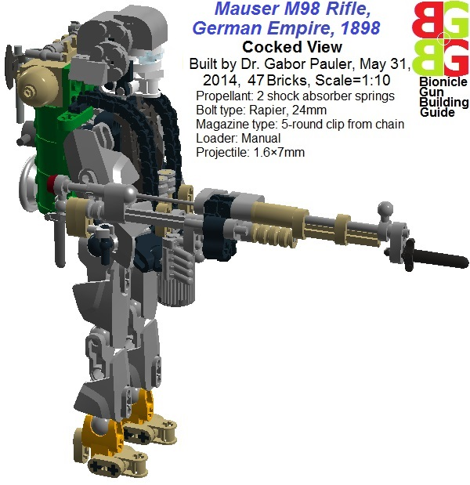
<b>Figure 4: Mauser M98 rifle cocked</b>
See in LDD: <a href=http://www.brickshelf.com/gallery/gjpauler/SmallArms/MauserM98RifleScale1To10Cocked.lxf>Here</a>

<big><b>1.1.3 WWI Pistols</b></big>
(See the real ones at Wikipedia: <a href=http://en.wikipedia.org/wiki/M1911_pistol>Browning M1911</a>, <a href=http://en.wikipedia.org/wiki/Luger_P08_pistol>Luger Parabellum 1908</a>, <a href=http://en.wikipedia.org/wiki/Rast-Gasser_M1898>Rast&Gasser M1898</a>, <a href=http://en.wikipedia.org/wiki/Mauser_C96>Mauser C96</a>)
Playability of a pistol in scale 1:10 is minimal, and we designed them clearly because of the modeling challenge of putting working shooting mechanism and magazine in such a small size. Moreover, officers always wore them, so they cannot be neglected. Most modern pistols are offsprings of the basic types invented just before WWI.

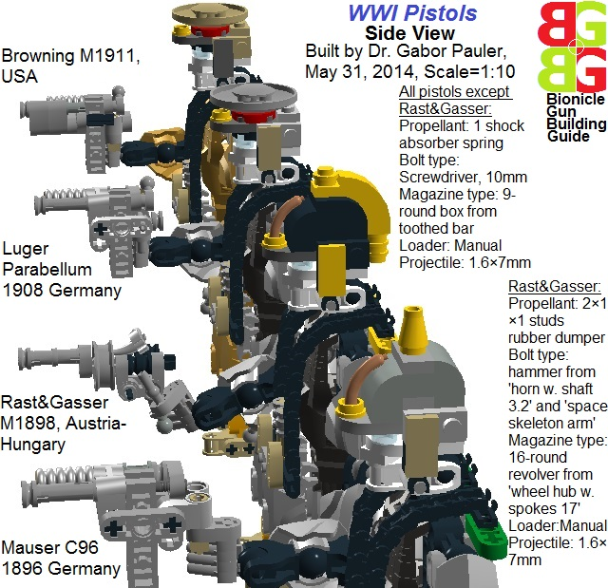
<b>Figure 5: WWI pistols from side view</b>
See in LDD: <a href=http://www.brickshelf.com/gallery/gjpauler/SmallArms/WWIPistolsScale1To10.lxf>Here</a>

Of course, all they look pretty bulky as the propellant spring has to be placed at the side of the weapon because of lack of space. The best working is Browning M1911, while Rast & Gasser revolver is left unfinished, as we could not solve triggering in such a small size. Constructive critics are welcome.

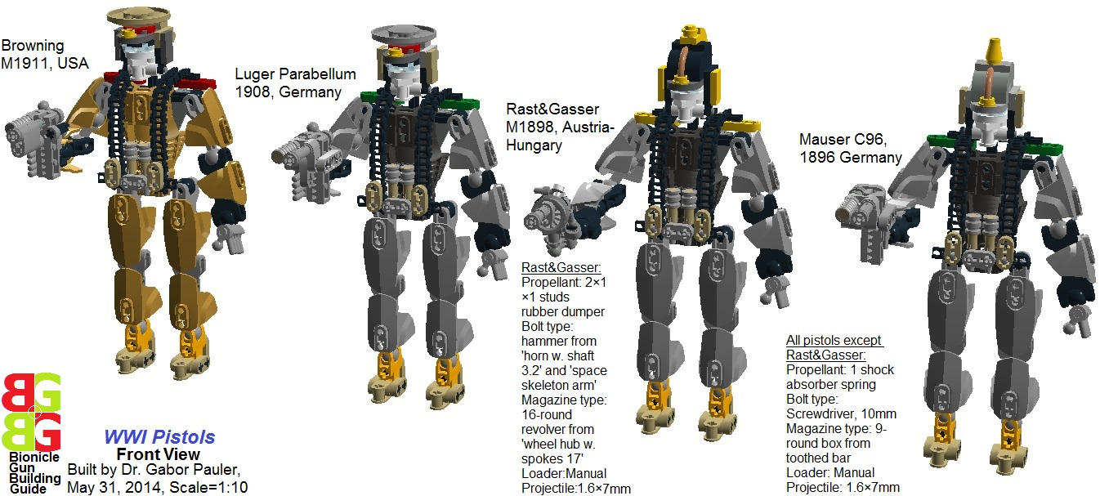
<b>Figure 6: WWI pistols from front view</b>
See in LDD: <a href=http://www.brickshelf.com/gallery/gjpauler/SmallArms/WWIPistolsScale1To10
.lxf>Here</a>

<big><b>1.1.4 Vickers Machinegun, British Empire, 1912</b></big>
(See the real one at <a href=http://en.wikipedia.org/wiki/Vickers_machine_gun>Wikipedia</a>)
If the year is 1916, and you are at river Somme, and Germans are attacking, your friend is not called Google but Vickers. In that August, in the middle of a large German attack, British Army's 100th Company of the Machine Gun Corps fired their ten Vickers guns continuously for twelve hours. Using 100 new barrels, they fired a million rounds without a single jam. The synonym of reliability for all English soldiers had difficult birth. The short-sighted conservative military leaders of the Empire before WWI (Kitchener, Haig) thought that the dominant weapon of the forthcoming war will be bayonet and cavalierly. They judged the machine gun only suitable for massacring native colonial tribes, but it was “unfair weapon” for the European war. These childish ideas were gravely shattered by Germany, and the leading industrial power of the era found herself heavily outgunned in the battlefield, costing lot of British lives.
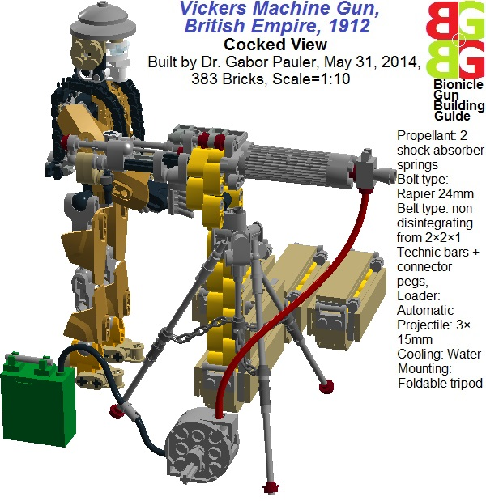
<b>Figure 7: Vickers machine gun with cooling water tank and pump</b>
See in LDD: <a href=http://www.brickshelf.com/gallery/gjpauler/SmallArms/VickersMachineGunScale1To10Cocked.lxf>Here</a>

To correct the fiasco, Vickers made lot of R&D work to refine the original Maxim-type recoil-operated machinegun. But they were sued for war profiteering, because the small lots ordered just covered huge R&D expenses, so the weapon was very expensive. Only the direct intervention of Prime Minister Lloyd George managed to cut through military bureaucracy, giving absolute priority to mass production. We modeled such a reliable gun with our best possible non-disintegrating belt feed autoloader mechanism (see technical details in Chapter 2). Barrel is the weak point: we had to model it together with the cooling water tank made from ‘2×2×1 rounded bricks with grooves’. We did not follow strictly the original Vickers tripod mount, as that was very bulky, but tried to model reserve cooling water tank, ammo boxes, water pump as realistic as possible. (Yes, the pump is working).

<big><u>1.2 Great Depression Era, 1929-1933</u></big>

At the end of WWI, all major small arms designers tried to respond to stalemate of trench warfare with new generation of automatic weapons (Villar-Perosa - Italy, Bergmann – Germany, Thompson, Browning – USA). Most of them were too late to make any difference in the course of the war. But US designs were soon revived in the new battlefield between Prohibition/ Great Depression era gangsters and law enforcement. Thompson and Browning made quite a profit selling the same products for both sides. That’s what we call free market economy.

<big><b>1.2.1 Thompson Submachine gun, USA, 1918</b></big>
(See the real ones at Wikipedia: <a href=http://en.wikipedia.org/wiki/Thompson_submachine_gun>Thompson submachine gun</a>, <a href=http://en.wikipedia.org/wiki/Machine_Gun_Kelly>Machine Gun Kelly</a>)
We present the standard gangster gun of classic movies in the hands of not so standard gangster: Machine Gun Kelly. He was an average American buddy with wife of non-average ambition. Kathryn eagerly saved penny to penny form kitchen budget to buy a Thompson for Kelly, pressing him to become influential gangster. This was not very easy, as Thompson cost almost half of the price of a Ford T-model car. Finally, Kelly died in prison serving his lifetime sentence. For us, it seemed to a lifetime sentence to figure out how to build working drum magazine for the Thompson (see Chapter 2 for technical details).

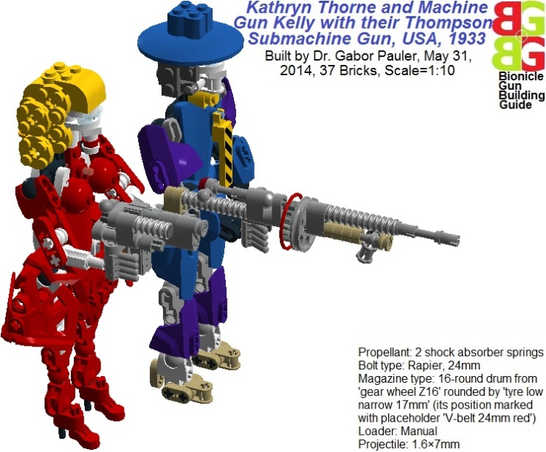
<b>Figure 8: Kathryn Thorne and Machine Gun Kelly with their Thompson submachine gun</b>
See in LDD: <a href=http://www.brickshelf.com/gallery/gjpauler/SmallArms/TommyGunScale1To10.lxf>Here</a>

Kelly killed several victims just by showing his terrible ill-tasted yellow-black striped tie. This helped to save ammo.

<big><b>1.2.2 M1918 Browning Automatic Rifle (BAR), USA, 1918</b></big>
(See the real ones at Wikipedia: <a href=http://en.wikipedia.org/wiki/M1918_Browning_Automatic_Rifle>M1918 BAR</a>, <a href=http://en.wikipedia.org/wiki/Bonnie_and_Clyde>Bonnie&Clyde</a>)
The legend of Bonnie Parker and Clyde Barrow was created by the media almost accidentally: criminal investigators found some “gun moll” photos about Bonnie posing with a gun and also some of her poems. Tabloids eagerly created a romantic “modern Robin Hood and his poet girlfriend” story around them. But as the duo killed more and more civilian victims in their criminal career, the tide turned against them, and it was more profitable for the media to create supernatural public enemy from them. Bonnie and Clyde used full arsenal of robbed automatic weapons (they could not afford such an expensive stuff), but Clyde’s favorite was M1918 BAR because of its firepower. BAR was originally designed by Browning (for US troops, not for Clyde) to replace the French-made Cauchat long-recoil operated light machinegun, which was the worst automatic weapon of WWI.

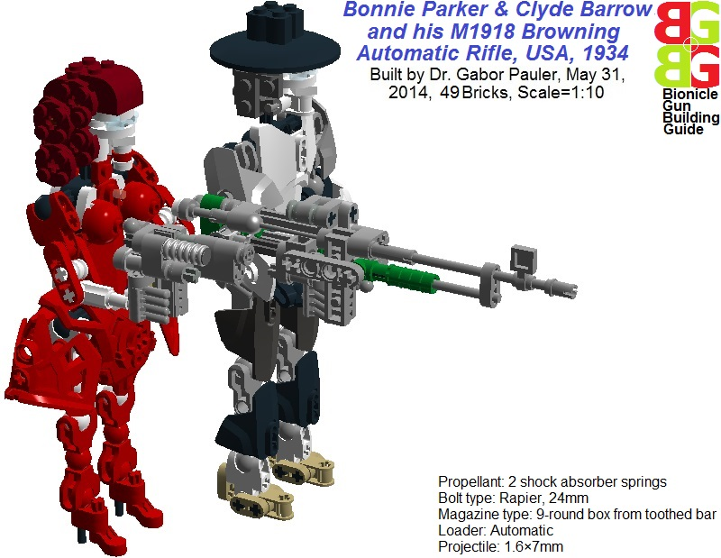
<b>Figure 9: Bonnie & Clyde & M1918BAR</b>
See in LDD: <a href=http://www.brickshelf.com/gallery/gjpauler/SmallArms/M1918BARScale1To10.lxf>Here</a>

As BAR is quite sizeable weapon, we could model it with our rifle type autoloader for box magazine (See technical details in Chapter2). Bonnie carries a Browning M1911, just for the sake of brand loyalty.

<big><b>1.2.3 Winchester M1897 Pump Action Shotgun, USA, 1897</b></big>
(See the real ones at Wikipedia: <a href=http://en.wikipedia.org/wiki/Winchester_Model_1897>Winchester M1897</a>, <a href=http://en.wikipedia.org/wiki/Frank_Hamer>Frank A. Hamer</a>)
Frank A. Hamer was retired but then reactivated ranger who killed Bonnie & Clyde in an ambush, leading a 4-men squad. In the pre-FBI era, the duo tried to avoid capturing circling around the borders of 3 states with stolen cars during their deadly rampage. Hamer, the old cunning cop observed that they make quite regular cycles among residential towns of their relatives, and set up an ambush based on a proposed meeting with Clyde’s father. When Clyde’s stolen Ford V8 car showed up, instead of telling “you have the right to be silent”, the squad put telling shots into the car from BARs and Winchester M1897 type 16 gauge shotguns. Both Bonnie and Clyde were deadly hit at least 50 times.
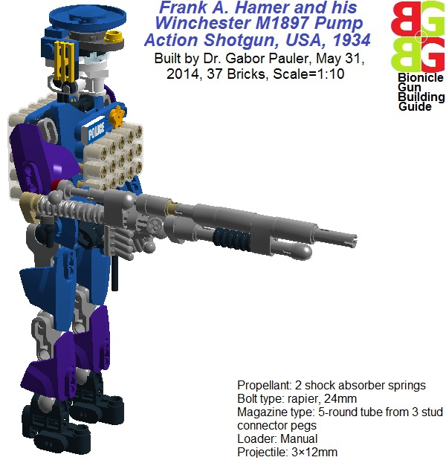
<b>Figure 10: Frank A. Hamer and Winchester M1897 shotgun</b>
See in LDD: <a href=http://www.brickshelf.com/gallery/gjpauler/SmallArms/WinchesterM1897Scale1To10.lxf>Here</a>
Building shotgun with tube magazine beneath the barrel is not an easy story, as the original loading mechanism cannot be modeled in such a small size. Therefore, we made a very strong simplification: projectiles slide backward in tube magazine just by gravity, when the weapon is raised. The chamber can be rotated manually between tube magazine and barrel, transmitting projectiles into shooting position (see Chapter 2 for technical details).

<big><u>1.3 World War II, 1939-1945</u></big>

This was the war, where submachine guns turned from luxury fashion items of gangsters into cheap mass produced commodity. Unfortunately, death of women and children also became cheap mass produced commodity in concentration camps and carpet bombings.

<big><b>1.3.1 MP-40 Submachine gun, Germany, 1938</b></big>
(See the real one at <a href=http://en.wikipedia.org/wiki/MP-36>Wikipedia</a>)
In any Hollywood movie, if you see stunts dressed in MP-40 and German shepherd dog, yelling “Halt!, Weiter! Handehoch! Alarm! Actung!”, then you can be sure they are the bad guys. MP-40 (erroneously called Schmeisser-submachine gun) became the iconic symbol of Nazi aggression together with Tiger tank and Stahlhelm helmet. In fact, Hollywood consumed more MP-40s as props since WWII than Germans really had. Only special units and paratroopers were equipped with MP-40. The average German Wehrmacht soldier carried the good old Mauser M98 rifle, as there was never enough MP-40. Except in the extreme cold Russian winter, where MP-40 tended to jam, and was quickly traded by soldiers for captured Russian PPSh submachine guns, which were less accurate but much more robust and reliable. In the desperate close quarter combats at urban sieges of Leningrad, Moscow, Stalingrad, accuracy was not an issue. Contemporary German joke: “Team Alpha, report your position! - We took the bedroom and the kitchen, living room is for the Russians, restroom is still questionable!” (Yes, the dog is also working more or less dog-like, except the neck, which is rigid.)

<b>Figure 11: MP-40 submachine gun</b>
See in LDD: <a href=http://www.brickshelf.com/gallery/gjpauler/SmallArms/MP40Scale1To10.lxf>Here</a>

<big><b>1.3.2 PPSh Submachine gun, Soviet Union, 1939</b></big>
(See the real one at <a href=http://en.wikipedia.org/wiki/PPSh-41>Wikipedia</a>)
PPSh was just like Russians: crude, but robust and reliable, and there were awful lot of them. Soviet tactics stressed more on generally equip troops with submachine guns than German one. It paid off well in urban sieges of Leningrad, Moscow, Stalingrad, where the average encounter distance was 50-100m, so firing rate superseded range or accuracy. Mass production was pursued in evacuated factories at Ural mountains – safe distance from Germans – by the supervision of high ranking communist party officials, who were responsible with the life of their family to Stalin to meet production quotas. So they were met.
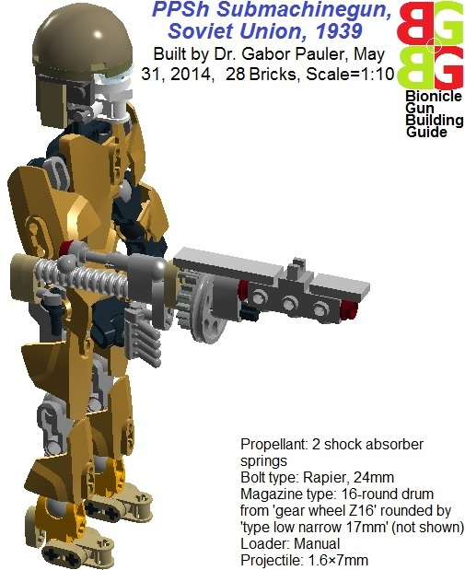
<b>Figure 12: PPSh submachine gun </b>
See in LDD: <a href=http://www.brickshelf.com/gallery/gjpauler/SmallArms/PPShScale1To10.lxf>Here</a>

Modeling PPSh, we used the same drum magazine solution as the Tommy gun, but the large perforated cooling jacket around the barrel posed quite a challenge.

<big><b>1.3.3 Thompson Submachine Gun, USA, 1940</b></big>
(See the real one at <a href=http://en.wikipedia.org/wiki/Thompson_submachine_gun>Wikipedia</a>)
WWII version of Thompson was simplified, more cheap and more reliable than its predecessor because of the usage of double-row, double feed box magazine. Our model is almost the same as MP-40, except positioning the grip and cradle.
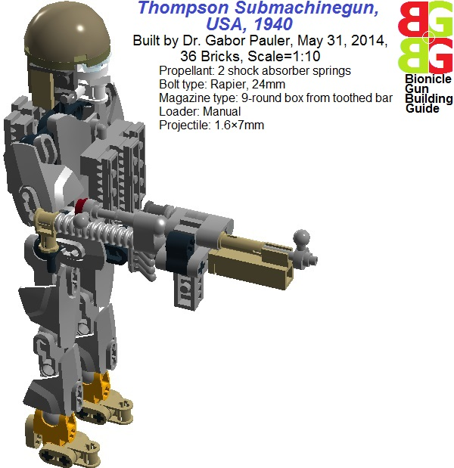
<b>Figure 13: Thompson submachine gun WWII version</b>
See in LDD: <a href=http://www.brickshelf.com/gallery/gjpauler/SmallArms/TommyGunWWIIScale1To10.lxf>Here</a>

<big><b>1.3.4 Mauser M98 Sniper Rifle vs. Russian dog mine, 1941</b></big>
(See the real ones at Wikipedia: <a href=http://en.wikipedia.org/wiki/Gewehr_98>Mauser M98</a>, <a href=http://en.wikipedia.org/wiki/Dog_mine>Russian dog mine</a>)
In the beginning of Operation Barbarossa in 1941, obsolete Soviet anti-armor could not penetrate armor of German tanks, and new, more effective weapons (e.g. ZIS 76mm gun) appeared only in very limited numbers. As a desperate makeshift weapon, German shepherd dogs were trained to act as dog mine: starved dogs were feed under tanks with running engine, so they learnt running immediately under the tank on the scene. Explosive was carried in a two-sided pouch fixed on the dogs back, triggered by a simple contact stick on the chassis, where armor was the thinnest. (Training new dogs were much more cheap than remote controlled trigger devices in the era). In theory, it was a ruthless, but effective and cheap weapon.
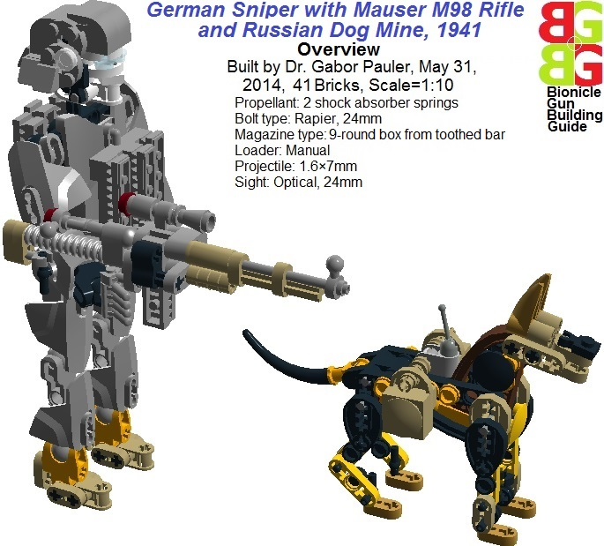
<b>Figure 14: German sniper with Mauser M98 rifle and Russian dog mine </b>
See in LDD: <a href=http://www.brickshelf.com/gallery/gjpauler/SmallArms/MauserWWIISniperRifleScale1To10.lxf>Here</a>

In the practice, it wasn’t: even best trained dogs instinctly panic from the explosions of battlefield and try to avoid them. It turned out that dogs mostly identify tanks not visually, but by the smell of the exhaust fumes, so they tended to attack friendly tanks, because they were trained using domestic fuel. There were negligible number of successful tank kills, but this tactics forced Germans to kill any dog they saw nearby instantly. But dogs were much more difficult target than men, having smaller silhouette and wearing naturally good camouflage. So Germans were forced to hunt on German shepherd dogs by Mauser M98 sniper rifles. Hitler – a well-known keen of dogs – was so angered by the Russian tactics that he ordered summarily execute anyone captured using dog mines.

<big><b>1.3.5 MG-42 Machinegun, Germany, 1939</b></big>
(See the real one at <a href=http://en.wikipedia.org/wiki/MG_42>Wikipedia</a>)
This was the weapon depreciated by both the enemy and German military bureaucracy. Until it started to fire on the battlefield… MG42 was a gas boosted short recoil operated weapon with roller locked bolt and stamped steel casing. This configuration resulted in a simple, light, reliable, cheap, easily mass produced MG, with extremely high rate of fire (1200 spm compared to 600 spm of contemporary Vickers MG an BAR). Experienced gunner could shift barrel in just 3 seconds, enabling it to shoot long covering barrage. (At contemporary American MGs barrel shift required screwdriver!). After D-day, US troops was shocked to see that from an average 6-7 member German squad - equipped with an inferior cheap stamped steel stuff at the first sight - only the gunner (usually an older petty officer) actually fought with them, sending deadly rain shower of bullets. 5-4 teenage guys did not even shoot their rifle, just carried the incredible amount of ammo MG-42 consumed. After battle of Stalingrad, manpower for Germany was real bottleneck, and MG-42 enabled to make effective fighting unit from some Hitlerjugend-teenagers and their grandpa. The back side of the roller-locked operating principle was that it had no fire interrupter, and firing rate could not be decreased because of safe cycling, so it required really experienced gunner not wasting tons of ammo in just seconds. It is almost unbelievable that prototype of this exceptional weapon (serving later well beyond 1960s) was already ready at 1939, just could not get through bureaucracy, and large scale production started only in 1943.

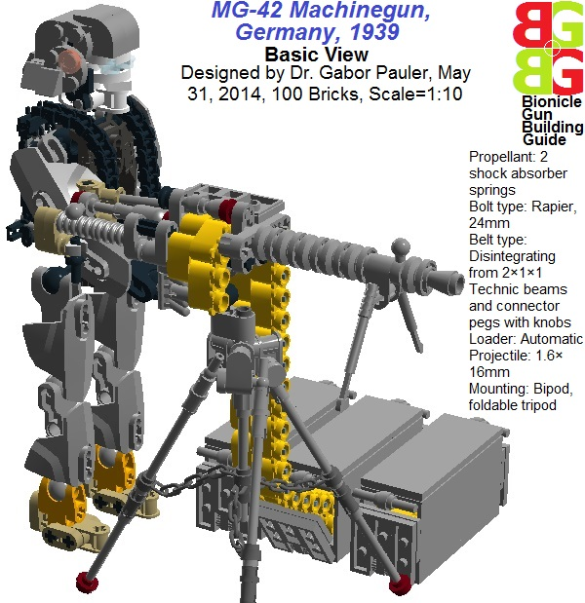
<b>Figure 15: MG-42 machinegun</b>
See in LDD: <a href=http://www.brickshelf.com/gallery/gjpauler/SmallArms/MG42Scale1To10Cocked.lxf>Here</a>
Modeling MG-42, the barrel and its sleek perforated cooling jacket was a real pain. As TLG does not produce any reasonable long barrel with 3.2mm caliber matching to my original belt design, I tried to assemble it from ‘3 stud connector pegs’. But they required some external fixture, so the result did not even resemble to the sleek MG-42. Finally I decided to use the ‘8 stud long outer cable’ as barrel, just like at my rifle MOCs. As it has 1.6mm caliber instead of 3.2mm of connector pegs, I had to redesign my original ammo belt to reduce its internal diameter from 3.2 to 1.6 mm using TLG parts ‘bracelet upper part’. As side effect, the belt became disintegrating, as it falling apart when projectile is fired from that (see Chapter 2 for technical details). I also had to redesign ammo boxes because of the wider belt.

<big><u>1.4 Cold War, 1946-1991</u></big>

Cold war was started with the public opinion that things will be decided in the future by nuclear bombers and rockets, so such an antique things as small arms can go into the museum. Finally, most nuclear bombers and rockets went into the museum, and guns went into the battlefields of Korea, Vietnam, Afghanistan. That’s why “only” several hundred thousand people were killed instead of several hundred millions.

<big><b>1.4.1 AK-47 Assault Rifle, Soviet Union, 1949</b></big>
(See the real one at <a href=http://en.wikipedia.org/wiki/AK-47>Wikipedia</a>)
The copycat national icon: according to the popular urban legend, Mikhail Kalashnikov was a young Russian POW in German custody with exceptional technical talent. Therefore his German guards trusted him with the maintenance of their new STG-44 “Sturmgewehr” Assault rifle. It was a kind of “wunderwaffe” (wonder weapon) uniting the firing rate of submachine guns and performance of rifles with an intermediate size cartridge. But it was pressed into service after a rush development with lot of teething problems, moreover it was very expensive. After the war, Kalashnikov not just copied but gravely perfected STG-44, creating more cheap, reliable, simple, compact assault rifle, the AK-47 put in Soviet service in 1949. Behind the legend, there is some truth: the gas system of AK-47 was really copied from STG-44, therefore they look very similar outside. That’s the reason why we did not create separate STG-44 MOC. But many parts around the bolt was copied from the American M-1 Garand. Finally the “Kalash” and its copies flooded the Soviet and Third World countries from 1959, when Kalashnikov design bureau managed to solve reliable working in pressed steel casing instead of machined one in the new AMD model, reducing production cost and technology requirement substantially. They also tried to reduce the “muzzle rise” side effect of recoil applying a slanted shroud, the “compensator” around muzzle, which counteracts rising by the reactive force of upward deflected propellant gases.

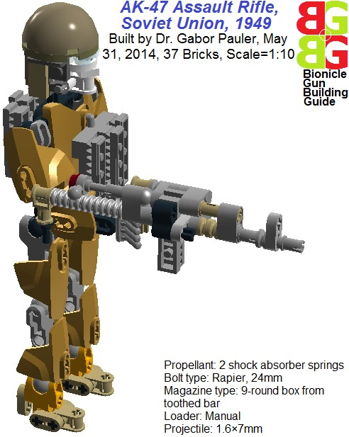
<b>Figure 16: AK-47 assault rifle</b>
See in LDD: <a href=http://www.brickshelf.com/gallery/gjpauler/SmallArms/AK47Scale1To10.lxf>Here</a>
Modeling AK-47, we had to make lot of compromises: I used simple box magazine instead of the curved one I could not solve in such a small size (constructive critics are welcome). Moreover, to maintain its characteristic silhouette, my AK MOC fires through the gas piston and tube, and the barrel is fake.

<big><b>1.4.2 Heckler & Koch G3 Assault Rifle, Spain/Germany, 1951</b></big>
(See the real one at <a href=http://en.wikipedia.org/wiki/Heckler_%26_Koch_G3>Wikipedia</a>)
If you are under embargo, turn to the next dictator: Another offspring of the German WWII STG-44/45 assault rifles is H&K G3. As Germany was forbidden to manufacture high power firearms immediately after WWII, H&K started to collaborate with Franco’s Spain. Franco was a nationalist dictator in Spain, originally an ally – but not very enthusiastic – of Hitler. But as Germany went down, Franco became more and more friendly with the USA, providing basing right for the Americans in Spain. He was reliable ally in the standoff against Communism, so USA left him at his place after WWII. But the then dictatoric ruled Spain was kept pretty isolated from western world and modern technologies, that’s why they accepted German to technology to modernize Spain’s army.
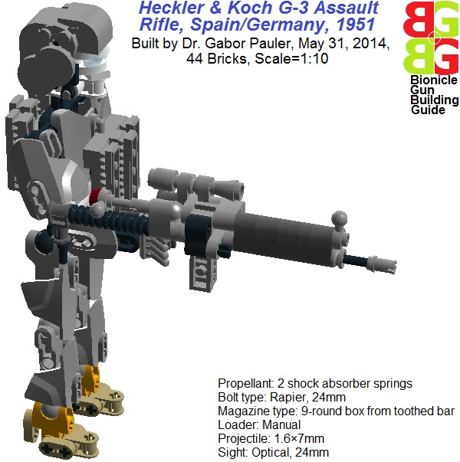
<b>Figure 17: Heckler & Koch G3 assault rifle</b>
See in LDD: <a href=http://www.brickshelf.com/gallery/gjpauler/SmallArms/HKG3Scale1To10.lxf>Here</a>
Not surprisingly, my G3 MOC is pretty similar to the same rooted STG-44/AK-47, except the external decorative elements. It also fires through gas tube, and barrel is fake. However gas tube is thinner here, enabling more exact aiming than my AK-47 MOC. This is true in the reality also: G3 is more accurate than AK-47, however longer and less compact.

<big><b>1.4.3 Stoner M16A1 Assault Rifle with M203 Grenade Launcher, USA, 1962</b></big>
(See the real ones at Wikipedia: <a href=http://en.wikipedia.org/wiki/M16_rifle>M-16</a>, <a href=http://en.wikipedia.org/wiki/M203_grenade_launcher>M203</a>)
The fashionable-futuristic-plastic gun in the rotten dirt of jungle. Eugene Stoner was a talented designer coming from the aircraft industry. He wanted to solve common disadvantage of all contemporary assault rifles. At AK-47 or H&K G3, gas piston is above the barrel, therefore shooting 3-5 round short bursts, aiming becomes difficult. The inertia of forward/backward moving gas piston raises/lowers muzzle, increasing variance of trajectories. At M-16, all moving masses and the stock is perfectly in line with barrel, because bolt serves as gas piston also. Applying muzzle brake, all negative effect of recoil on aiming is minimized, resulting in greater accuracy. As barrel was placed in line with barrel, sights had to be raised well above that in carrying handle. Another novelty was the extensive use of light aluminum-titanium alloys and plastic material resulting in smaller weight of weapon. The revolutionary weapon had an influential supporter in the competition with more conventional designs – Secretary of Defense Robert McNamara. Then it was thrown quickly in dirty, wet, hot hell of Vietnam jungle without cleaning set and chromium plating on chamber. Both resulted in many “failure to extract spent cartridge”. Against the Vietkong equipped with almost never jamming, robust, more compact AK-47, this was a deadly mistake for lot of Americans. Greater accuracy of M-16 meant nothing in dense vegetation, where the average encounter happened by surprise from less than 50m. It took lot of R&D work until the later version M-4 became more reliable and compact weapon.

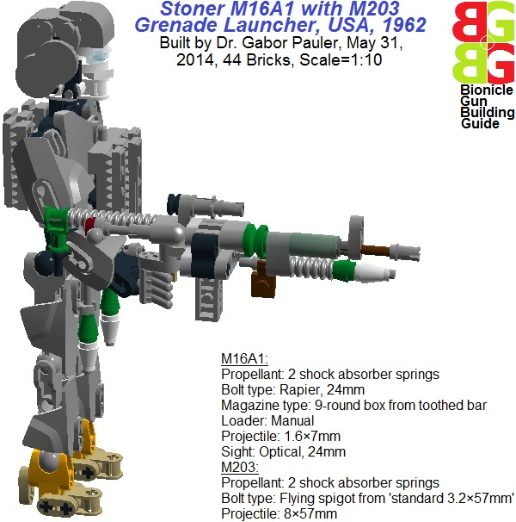
<b>Figure 18: M16A1 assault rifle with M203 grenade launcher</b>
See in LDD: <a href=http://www.brickshelf.com/gallery/gjpauler/SmallArms/M16Scale1To10.lxf>Here</a>
In my M-16 MOC, I solved modeling the new geometry rotating my rifle type shooting mechanism by 90 degrees outward, so from side view, the barrel seems to be in line with stock. (Of course they are really not in line because of the limitations of stock-mounted shooting mechanism, see Chapter 2 for technical details). There was also a modeling challenge to solve the M203 grenade launcher in working version. The problem was that the propellant spring cannot fit inside any reasonable sized barrel-like part produced by TLG. So I solved this that way that 2 compressed shock absorber springs themselves form the barrel of grenade launcher, packed around a spigot-type bolt, which flies out with the grenade, when the trigger is pulled out. Spigot is made of TLG part ‘standard 3.2×57mm’. It has a stop by which it is locked with the help of trigger made of ‘plate 1×1 with holder’, holding the springs compressed. When released, the 8mm diameter springs can extend easily around the 5mm diameter stop, ejecting the spigot with the grenade. This results in much longer grenades than the real one, but the loaded M203 unit is just proportional to the M-16 and it has similar look to the original one.

<big><b>1.4.4 M60 Light Machinegun, USA, 1957</b></big>
(See the real one at <a href=http://en.wikipedia.org/wiki/M60_machine_gun>Wikipedia</a>)
As the M60 light machinegun developed by USA in 1957 inherited many ideas from MG-42, it is not surprising that my M60 MOC is very similar to MG-42, except the fixture of the barrel, sight and folding bipod mount. It was more easy to build than MG-42, as gas piston provides reasonable structural support for the barrel made of ‘outer cable 64mm’, increasing playability.
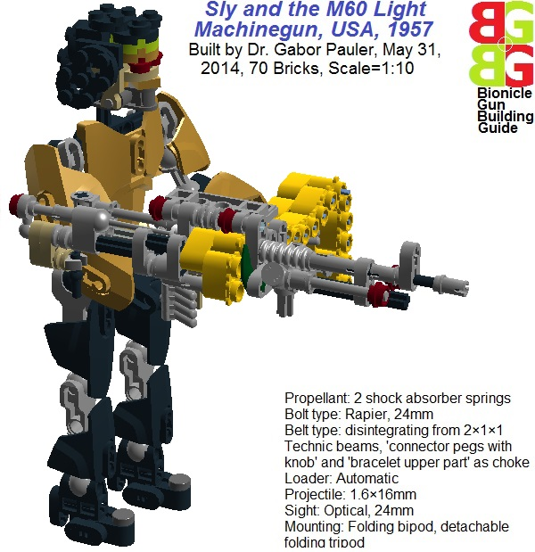
<b>Figure 19: M60 light machinegun</b>
See in LDD: <a href=http://www.brickshelf.com/gallery/gjpauler/SmallArms/M60Scale1To10Cocked.lxf>Here</a>
Of course, I could not resist the modeling challenge of building the renegade Vietnam veteran, which is compulsory accessory of M60 during Rambo I – Rambo XVIII sequels, regardless latest developments in weapons technology and Vietnam being almost an ally of USA against China. Considering that the old Sylvester Stallone may not be enough strong to hold the recoil of M60, I included tripod adapter also, besides folding bipod.

<big><b>1.4.5 M249 Squad Automatic Weapon (SAW), USA, 1984</b></big>
(See the real one at <a href=http://en.wikipedia.org/wiki/M249_light_machine_gun>Wikipedia</a>)
Just by the time Sly started to exterminate Vietnamese (Chinese???) stunts in Hollywood with M60, in the reality it was retired from service in favor of M249 SAW. The new gun was a deadly expensive engineering marvel that time summarizing all the experiences of materials technology, air cooling, recoil- and gas operated systems. Its gravely reduced weight enables continuous walking covering fire barrage without the need of shifting barrel. The dual feed (belt, box magazine) without any modification increases operational flexibility.
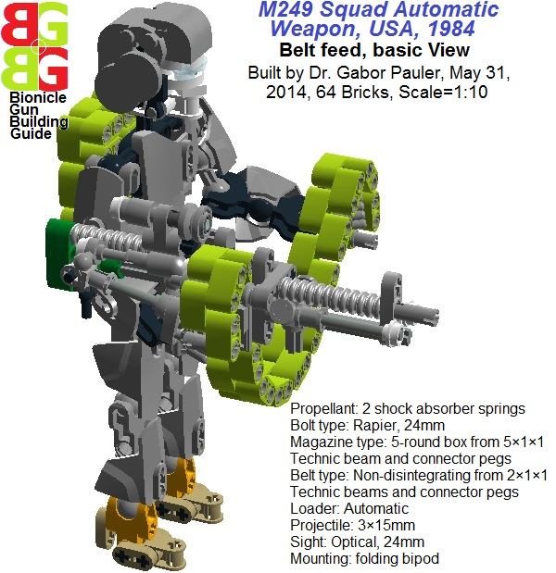
<b>Figure 20: M249 Squad Automatic Weapon with belt feed</b>
See in LDD: <a href=http://www.brickshelf.com/gallery/gjpauler/SmallArms/M249SAWScale1To10.lxf>Here</a>
The modeling challenge was there, to create working dual (belt, box magazine) feed. For the sake of robustness, I shifted back using non-disintegrating belt, modified my rifle type autoloader to advance both belt and Technic beam-type box magazine (see Chapter 2 for technical details). The only disadvantage is that besides foldable bipod, there was no place left for the adapter of tripod mount. therefore as MOC, the older type M60 has better playability than SAW.
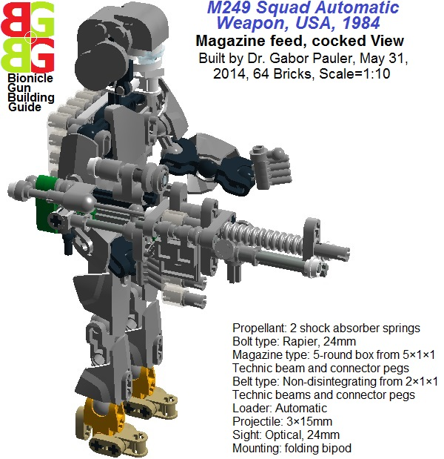
<b>Figure 21: M249 Squad Automatic Weapon with magazine feed</b>
See in LDD: <a href=http://www.brickshelf.com/gallery/gjpauler/SmallArms/M249SAWScale1To10Cocked.lxf>Here</a>

<big><u>1.5 War on Terror, 2001-2012</u></big>

It was the war where ceasefire cost much more life on all sides than the war itself.

<big><b>1.5.1 Benelli M4 Semi-automatic Combat Shotgun, Italy, 1998</b></big>
(See the real one at <a href=http://en.wikipedia.org/wiki/M1014>Wikipedia</a>)
In the lengthy urban guerilla warfare after the short formal war in Iraq, we can see the renaissance of shotgun. Originally introduced in military service to break stalemate of trench warfare at the end of WWI, it was revived in close quarter combats of counter insurgence (COIN) operations: to sweep confined, dark rooms instantly from just one shot, without any serious aiming, without the danger of ricocheting bullets, without recognizing that you are shooting on a 11-year old boy, before he shoots you with his AMD. The small Italian arms manufacturer, Benelli created an exceptionally reliable combat shotgun working in both semi-automatic and manual pump action mode, which found its way to a battlefield where sand and dust infiltrates even in the pores of human skin.
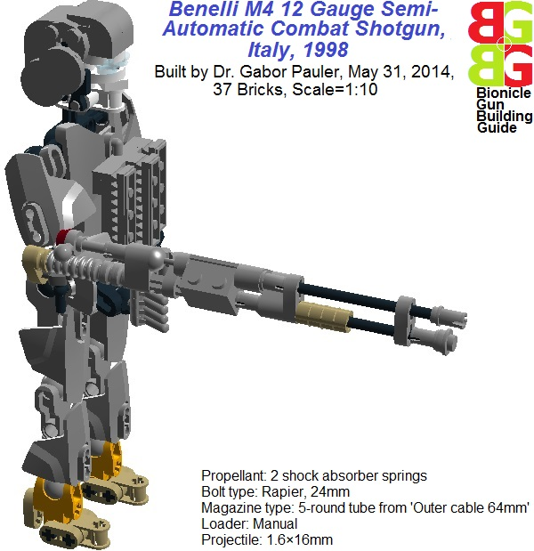
<b>Figure 22: Benelli M4 semi-automatic combat shotgun</b>
See in LDD: <a href=http://www.brickshelf.com/gallery/gjpauler/SmallArms/BenelliM4Scale1To10.lxf>Here</a>
Our Benelli MOC basically has the same structure as Winchester M1897 shotgun. But to model 12 gauge, we reduced its caliber to 1.6mm, using TLG part ‘outer cable 64mm’ as barrel and tube magazine. The only difficulty was that the axially rotating chamber required 1.6mm caliber. It was solved with the help of 2 TLG parts ‘plate 1×2 with slide’: at 2 stacked plates, slides form cavity with just the required caliber.

<big><u>1.6 War on Skynet, 2049-2050</u></big>

Skynet – the supercomputer with power ambitions of an average post-Soviet politician – is all Hollywood producers best friend. Whatever times it is defeated, it just sends back a terminator BEFORE that. This allows to make almost infinite number of blockbuster sequels with reasonable revenue, as we go backward in time to the age of dinosaurs. The only bottleneck is that Arnie finally will fight back from a wheelchair wearing oxygen mask and defibrillator. So, he should be laser-scanned and digitized as soon as possible.

<big><b>1.6.1 General Electric M134 Minigun, USA, 1962</b></big>
(See the real one at <a href=http://en.wikipedia.org/wiki/Minigun>Wikipedia</a>)
Hollywood producers worst enemy is Newton. The English noble guy with curvy long hair said some strange things in the 17th century, which makes fool from most Hollywood superproductions. For example, by his Second Law, if the recoil force of an MG134 Minigun shooting at 3200 spm “optimal aiming” firing rate is 190lbs, it is highly unlikely that any reasonable weighted humanoid robot can hold it standing and walking, not mentioning Arnie. So, the famous “Minigun scene” in Terminator 2 is just, just too fake…

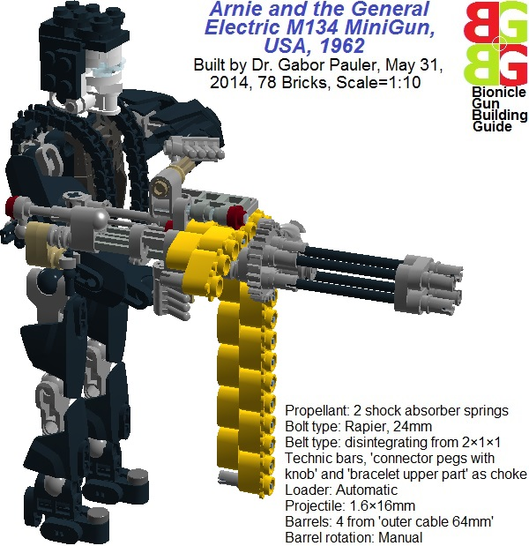
<b>Figure 23: General Electric M134 Minigun</b>
See in LDD: <a href=http://www.brickshelf.com/gallery/gjpauler/SmallArms/M134MiniGunScale1To10.lxf>Here</a>
Modeling rotating barrels of MG134 was really painful: using TLG part ‘wedge belt wheel 24mm’ as gun rotor could accommodate 6 barrels, but its diameter is too big for the Minigun size (we used it successfully in its larger brother later). Therefore we used ‘gear Z24’ as gun rotor, which can accommodate 4 barrels. However shooting mechanism this way has to be offseted half studs left and half studs up to get it in line with top barrel. Offseting is made with TLG parts ‘Plastic motor crank, cross’. But they eat up so many space, that the whole thing is not very sound structurally, and there is no room for tripod adapter, so playability is minimal. These errors are corrected in the larger 6-barrel version later.

<big><b><u>2 Building techniques of working small arms</b></u></big>

<big><u>2.1 Propellants and shooting mechanisms</u></big>

Most TLG and MOC shooting weapons until this point used rubber bands as propellant. They are pretty simple and straightforward to use, but totally destroy the outlook of small scale weapons and rapidly decay to useless status in the presence of humidity. Our solution is that the TLG part ‘shock absorber extra hard’ can be disassembled, so we can get a relatively compact propellant in form of 8×16mm steel spring, which is compressible to 8×4mm. As LDD cannot draw steel spring, we model it with the same sized and similar looking ‘corrugated pipe 16mm’ or ‘Technic bush’ in compressed position. The spring is more compact and durable as rubber band, but can store less energy. However it is modular, we can use more springs sequentially to increase force, still maintaining relatively compact propellant.

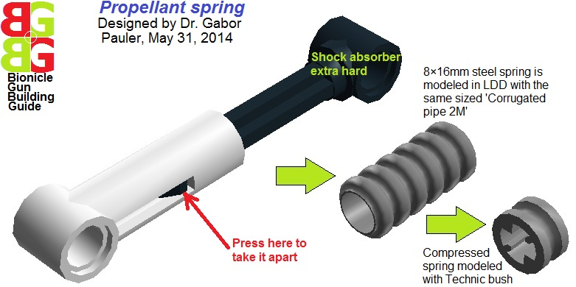
<b>Figure 24: Propellant spring from TLG ‘shock absorber’ part</b>
See in LDD: <a href=http://www.brickshelf.com/gallery/gjpauler/SmallArms/ShockAbsorberSpring1×2Studs.lxf>Here</a>

The next difficulty is that TLG does not support modeling modern projectile-based weapons because of children safety reasons, so small diameter long barrels are not very well represented in TLG parts. Therefore, building in scales 1:6..1:10 we have the following options:
- Assembling barrel from ‘Technic connector pegs 16 or 24mm’, which have 3.2mm internal bore (in scale 1:10 this is 32mm, caliber of a smaller grenade launcher), and separate pegs should be put in some fixture to form a barrel,
- We can use ‘outer cable 24 or 64mm’, which have 1.6mm internal bore (in scale 1:10 this is 16mm), but it can bend more easily because of its softer material, so the barrel needs some girders.
This is pretty limited selection of calibers and modeling long self-supporting barrels can be a problem.

The situation is even more dire at projectiles: ‘shaft 3.2mm’-type TLG parts have very strong friction in Technic connector pegs, and no TLG-part can go inside outer cables. Moreover ABS material of TLG parts has too small density for projectiles. Therefore I decided to use non-TLG part projectiles in from of 7 or 15 mm long pieces of 3mm or 1.6mm diameter aluminum or copper wires, which can be found in any hardware store as electric wiring. In theory, a cylindrical shaped metal projectile cannot fly on stabile trajectory without spin stabilization, making aiming impossible, and rapidly decelerates by drag. But the situation is different if the projectile is very small, so air getting relatively more dense compared to its mass, and its speed is not enough high to generate serious vortexes behind that. In our experiments, 1.6×7mm Aluminum projectile flew relatively stable trajectory between 2-3 m/sec speeds, and reasonable aiming was possible with that within 2m.
For modeling bolts, TLG parts ‘Rapier’ and ‘Screwdriver’ can be used, as they have the thinnest tip from all TLG parts with 1.6mm diameter. Based on them, we developed two types of shooting mechanism:
- Stock mounted spring mechanism is longer but sleeker, using Rapier bolt in rotating fixture, so triggering/releasing 2 shock absorber springs can happen with rotating bolt axially by charging handle. It is suitable for rifles, submachine guns, assault rifles, machine guns equipped with stock.
- Side mounted spring mechanism is shorter but more stubby, using Screwdriver bolt in axially lifting/raising fixture and 1 shock absorber spring. It suitable for pistols and bullpup layout weapons.
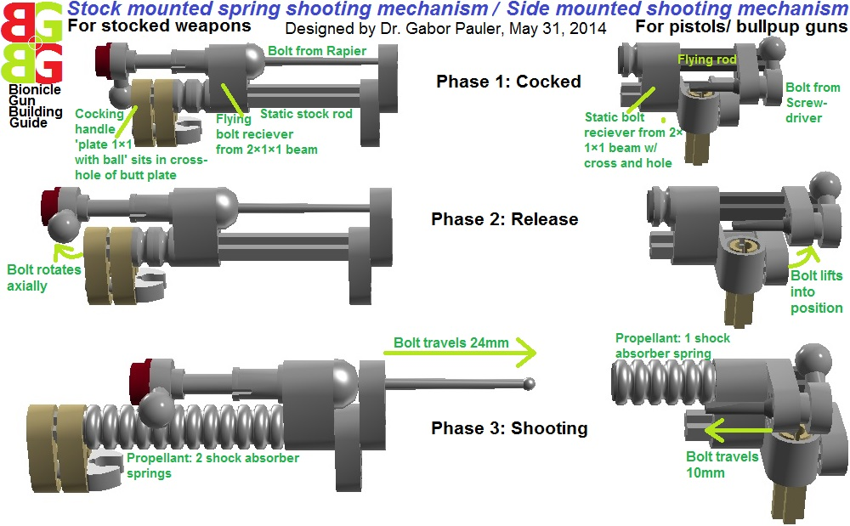
<b>Figure 25: Spring driven shooting mechanisms</b>
See in LDD: <a href=http://www.brickshelf.com/gallery/gjpauler/SmallArms/BoltsScale1To10.lxf>Here</a>

<big><u>2.2 Magazines and belts</u></big>

Modeling working magazines, we had to reject real solutions, where magazine has static casing, and projectiles sliding inside that driven by magazine spring. We clearly have no space for that. Instead of it we tried all TLG parts, which have reasonably small (e.g. 1.6mm diameter) cavities or dents, where projectiles can be loaded, and the whole loaded unit is advanced to get its cavities in line with barrel manually or automatically. Representing magazines in LDD, we model 1.6mm or 3mm caliber projectiles with front end of parts ‘screwdriver’ or ‘Shaft 24mm’ respectively:
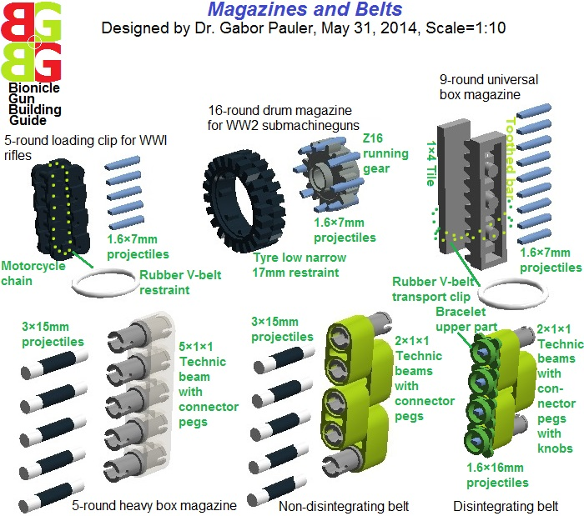
<b>Figure 26: Different types of magazines and belts</b>
See in LDD: <a href=http://www.brickshelf.com/gallery/gjpauler/SmallArms/MagazinesBeltsScale1To10.lxf>Here</a>

Non-disintegrating belt for 3×15mm projectiles was a pretty straightforward story from 2×1×1 technic beams and connector pegs. With a very tiny piece of used chewing gum, projectiles can be fixed inside connector pegs. As the gum dries up and getting aged 1-2 days, it becomes fragile. Therefore the gum breaks easily when the projectile is launched from belt by the tip of the bolt, and it will not leave sticky residues inside barrel.
Applying belt for 1.6mm projectiles was more difficult. The TLG part ‘bracelet upper part’ can reduce caliber of the belt from 3.2 to 1.6mm. But this way, belt can be held together by TLG parts ‘connector peg with knob’. These are more weak links, so belt will break up under the stress of shooting, becoming disintegrating type of belt.
Building shotgun tube magazine beneath the barrel was also not an easy story, as the original loading mechanism cannot be modeled in such a small size. Therefore, we made a very strong simplification: projectiles slide backward in tube magazine just by gravity, when the weapon is raised. The chamber can be rotated manually between tube magazine and barrel, transmitting projectiles into shooting position.
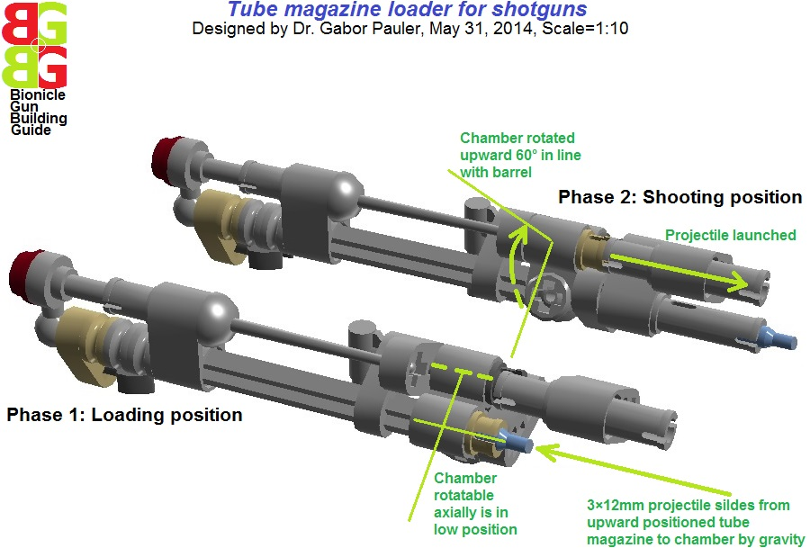
<b>Figure 27: Tube magazine and loader for shotguns</b>
See in LDD: <a href=http://www.brickshelf.com/gallery/gjpauler/SmallArms/TubeMagazineScale1To10.lxf>Here</a>

<big><u>2.3 Autoloader mechanisms</u></big>

Creating working autoloader mechanism in scale 1:10 was a great modeling challenge. Lack of reasonably small springs suitable for magazine spring means that both box magazines and belts need an autoloader mechanism similar to the real one which advances belts in machine guns. As this consumes still lot of space even after lot of experimental versions, MOCs with autoloader will be more bulky. Therefore we did not use autoloader in our historic small arms MOCs (except sizeable machine guns), where proportional look was more important than playability. All 3 types of our autoloader mechanism share the following features:
- The moving block of magazine/ or belt is locked in its position when bolt is released and moves forward during shooting
- As the bolts advances, it hits a block/knob fixed on a loading arm, pressing it down/ aside, against the force of a large V-shaped torsion spring formed from the ABS parts of loading arm and its holder.
- As the loading arm depressed, the magazine/ bolt catch clicks into a new position of magazine/belt.
- At re-cocking, the retreating bolt releases loading arm, and its torsion spring starts to press magazine/ bolt catch upward
- When retreating bolt dislocks magazine/ belt, the catch advances it into new position.

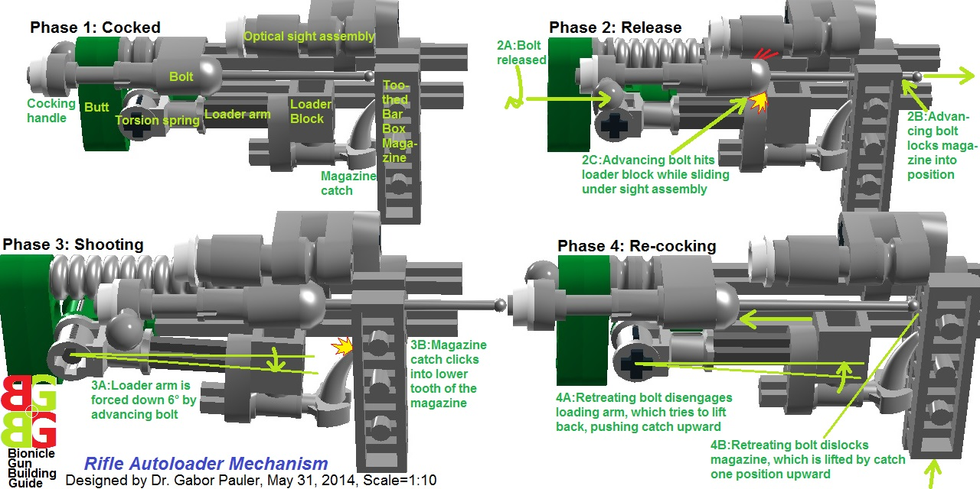
<b>Figure 28: Rifle type autoloader mechanism</b>
See in LDD: <a href=http://www.brickshelf.com/gallery/gjpauler/SmallArms/AutoLoaderBoxMagazineScale1To10.lxf>Here</a>

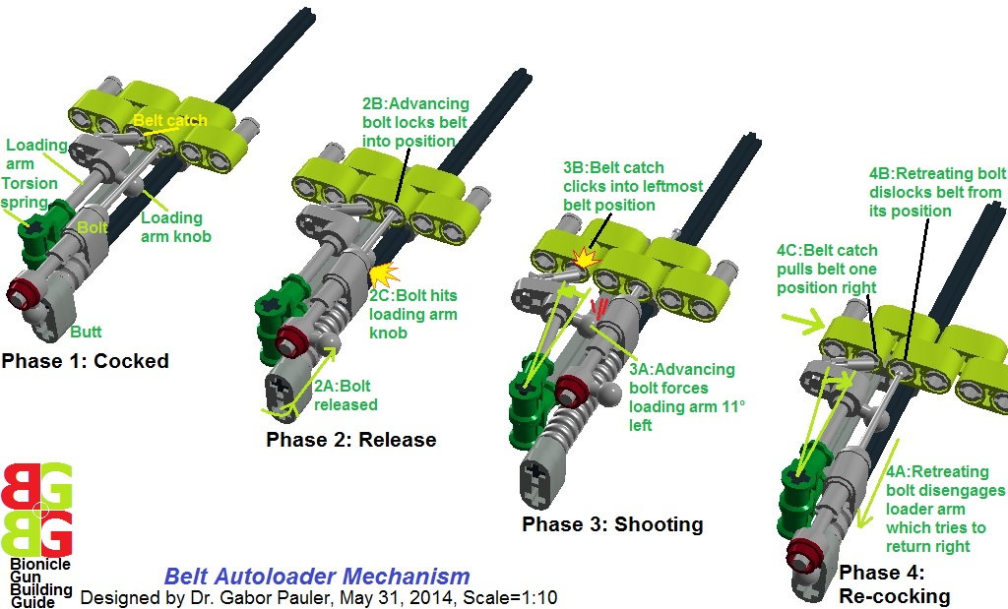
<b>Figure 29: Belt autoloader mechanism</b>
See in LDD: <a href=http://www.brickshelf.com/gallery/gjpauler/SmallArms/AutoLoaderBeltScale1To10.lxf>Here</a>

Our compact pistol autoloader mechanism uses rubber retriever spring of loading arm made of ‘rubber damper 2×1×1’, but otherwise works the same way as previous ones. However, it does not work very smoothly and it is subject of further development.
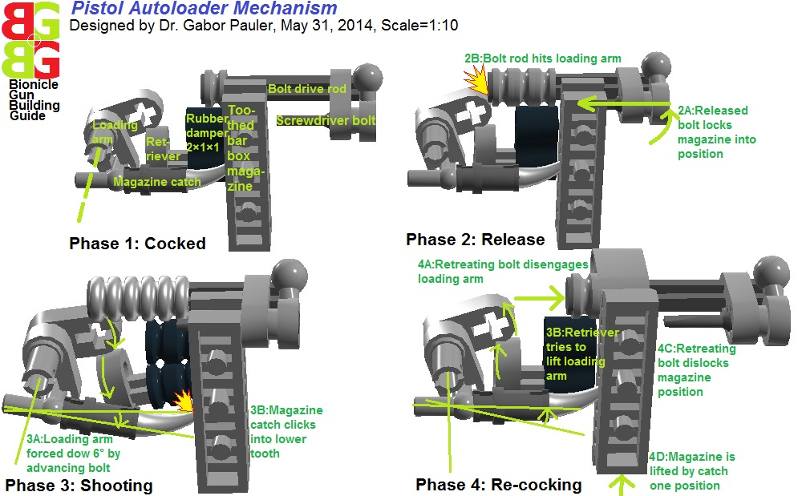
<b>Figure 30: Pistol autoloader mechanism</b>
See in LDD: <a href=http://www.brickshelf.com/gallery/gjpauler/SmallArms/AutoLoaderPistolScale1To10.lxf>Here</a>

<big><u>2.4 Custom hand- and grip designs, bipod- and tripod mounts</u></big>

The standard TLG part for fist of Bionicle figures is ‘Hand 2×3×2 ball cup’. But it is not very compact and oversized comparing to hand parts. Also it is not very realistic with its 4 fixed fingers. Therefore we developed our own palm construction with 5 separate, more poseable fingers. It is more usable when the weapon is NOT held by “broomstick” type grip, but palm rounds box magazine, or grabs cradle of a rifle. There is a further problem with butt of weapons, which is in reality pressed to shoulder and fixed by friction. However shoulder of Bionicle figures is a 10.2mm ball joint/ cup combo, which does not provide any flat fixed surface to press butt to that. Therefore, we had to solve fixing but at sleeve of lower arm using TLG parts ‘Stick with holder’ and ‘T-piece’. This keeps end of butt free, so the rapier-type bolt can be locked there in cocked position. This is important for playability that charging/release handle is in easy accessible position.
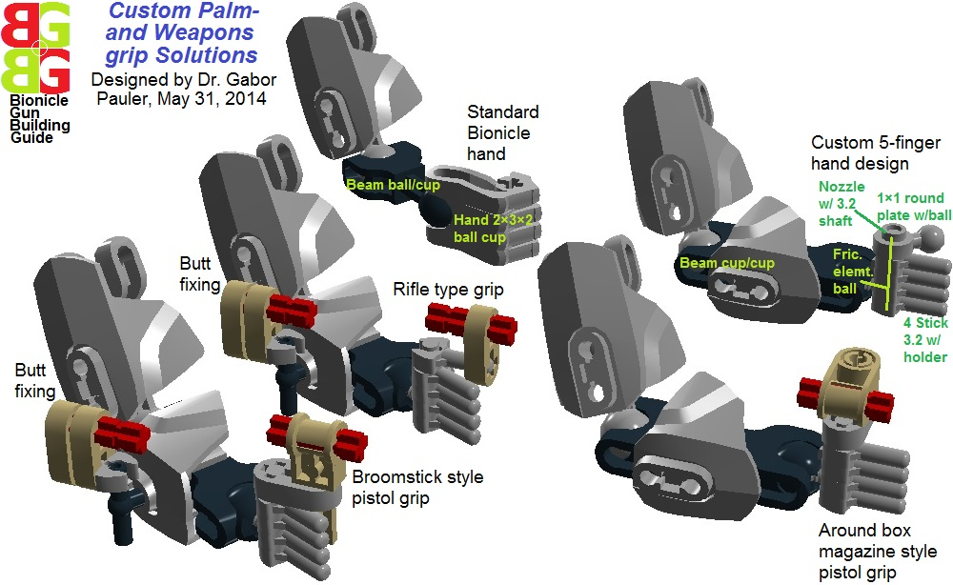
<b>Figure 31: Custom hand- and weapons grip solutions</b>
See in LDD: <a href=http://www.brickshelf.com/gallery/gjpauler/SmallArms/ArmsScale1To10.lxf>Here</a>

Foldable tripod- and bipod mounts are important both in reality and in playability of MOCs at heavy automatic weapons. For the sake of compatibility, we used the same type of tripod adapters and tripods for all our MOCs. The cradle mounted folding bipod is also standardized, except the MG-42, where there was no place to fix it.

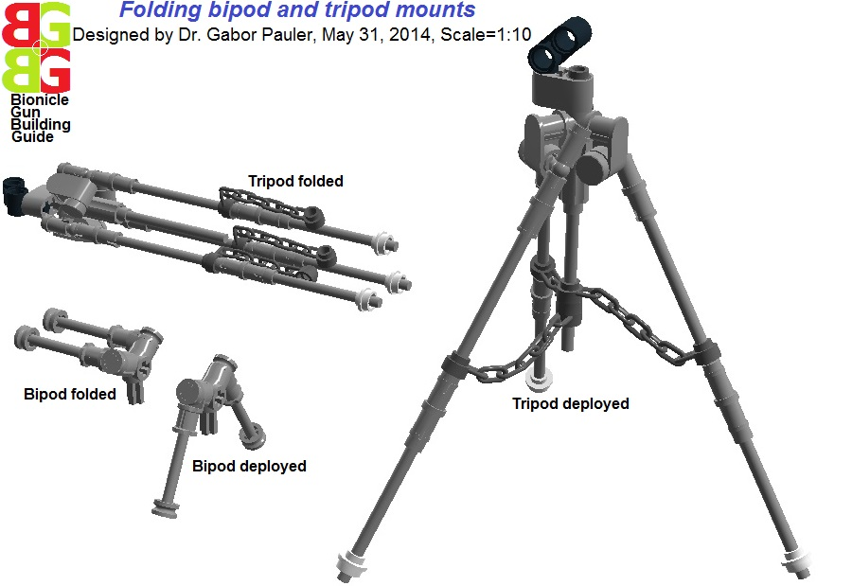
<b>Figure 32: Folding bipod and tripod mounts</b>
See in LDD: <a href=http://www.brickshelf.com/gallery/gjpauler/SmallArms/BipodTripodMountsScale1To10.lxf>Here</a>

<big><b><u>3 Modern small arms</b></u></big>

Our main purpose was to create full set of modern working small arms in scale 1:10 (pistol, submachine gun, assault rifle, sniper rifle, armor piercing rifle, light machine gun, machinegun, minigun, RPG, flamethrower, light mortar) with maximal playability and robustness. Of course it will take its toll in more bulky and less realistic outlook.

<big><u>3.1 P-12 Pistol</u></big>

Our autoloader pistol design with 9-round box magazine is partially unfinished and needs lot of further development. It is still overly bulky and not very realistic looking. Currently we are looking for even more compact autoloader solution. Constructive critics welcome.
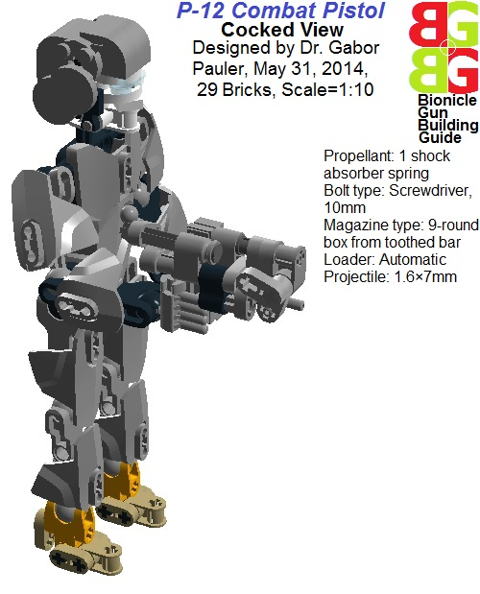
<b>Figure 33: P-12 combat pistol, cocked view </b>
See in LDD: <a href=http://www.brickshelf.com/gallery/gjpauler/SmallArms/PaulerP12Scale1To10Cocked.lxf>Here</a>

<big><u>3.2 SM-6 Submachine gun</u></big>

Our submachine gun design has rifle type autoloader shortened by 1 stud to be more compact. Butt was unified with loading arm holder that’s how space was saved: the loading arm itself is compatible with rifle autoloader. We tried to build Picatiny rail on the top of forward cradle, as most modern submachine guns use it. ‘Toothed bar 1×4’ would be better looking Picatiny rail, but it covers optical sight, so we opted for a less realistic looking solution.
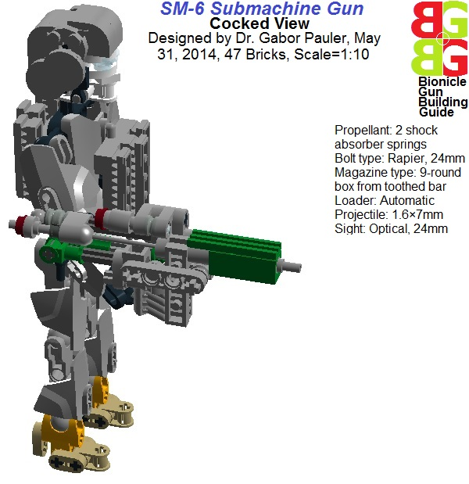
<b>Figure 34: SM-6 submachine gun, cocked view</b>
See in LDD: <a href=http://www.brickshelf.com/gallery/gjpauler/SmallArms/PaulerSM6Scale1To10Cocked.lxf>Here</a>

<big><u>3.3 AR-13 Assault rifle</u></big>

In our assault rifle design, we wanted to recreate M16A1+M203 combo, just with rifle type autoloader. Of course it became somewhat more bulky.
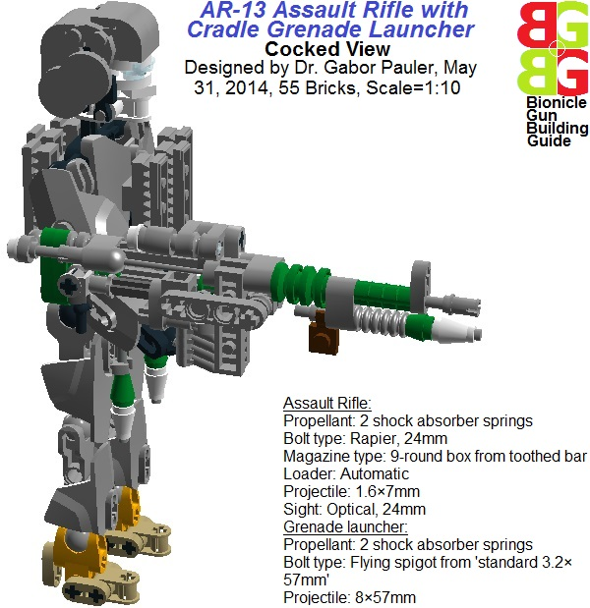
<b>Figure 35: AR-13 assault rifle, cocked view</b>
See in LDD: <a href=http://www.brickshelf.com/gallery/gjpauler/SmallArms/PaulerAR13Scale1To10Cocked.lxf>Here</a>

<big><u>3.4 SR-5 Sniper rifle</u></big>

In our sniper rifle design, we tried to create all accessories of a complex weapon system:
- Sniper rifle with rifle type autoloader, telescope sight, folding bipod and silencer.
- Elbow telescope 10 power with foldable tripod to acquire direct-line-of-sight targets.
- Foldable scout drone to acquire indirect targets through drone control console and satellite uplink
- Special sniper camouflage uniform and helmet with 6 spare magazines
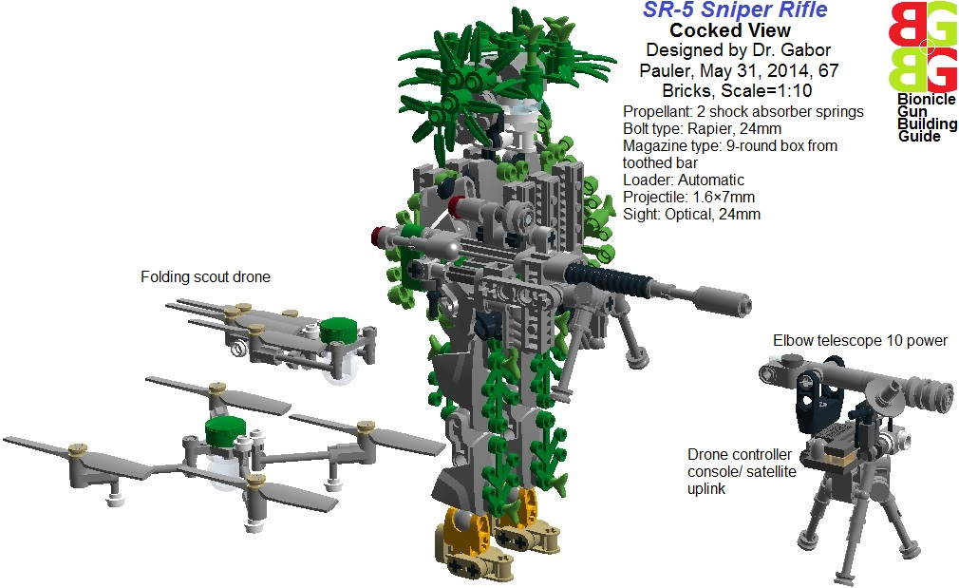
<b>Figure 36: SR-5 sniper rifle and its accessories</b>
See in LDD: <a href=http://www.brickshelf.com/gallery/gjpauler/SmallArms/PaulerSR5Scale1To10Cocked.lxf>Here</a>

<big><u>3.5 APR-4 Armor piercing rifle</u></big>

The first armor piercing heavy rifles were developed in WWII. Their heyday was in 1950-60s. With the advent of advanced ceramic block-Aluminum-Kevlar composite armor, they cannot penetrate most AFVs anymore. But they still have important usage on battlefield as anti-materiel rifle, taking out trucks, prime movers, jeeps, personnel, etc. In our MOC, we modified the rifle type autoloader to advance heavy 5-round box magazine made of Technic beam 5×1×1 and connector pegs, containing 3×15mm projectiles. Telescopic sight, foldable bipod, muzzle brake are compulsory accessories of an armor piercing rifle.
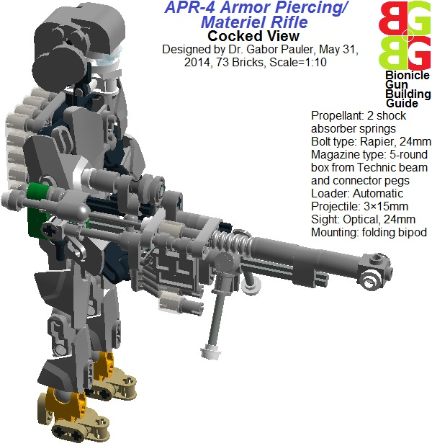
<b>Figure 37: APR-4 armor piercing rifle, cocked view</b>
See in LDD: <a href=http://www.brickshelf.com/gallery/gjpauler/SmallArms/PaulerAPR4Scale1To10Cocked.lxf>Here</a>

<big><u>3.6 LM-5 Light machinegun</u></big>

Our light machinegun MOC was designed by the principle “maximal walking firepower”, therefore cradle grenade launcher was added with reasonable ammo supply. The weapon uses modified rifle type autoloader to advance disintegrating belt. One serious drawback is that no place left for tripod and bipod mount.
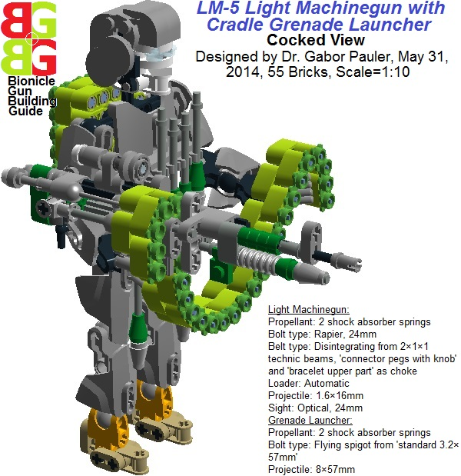
<b>Figure 38: LM-5 light machinegun, cocked view</b>
See in LDD: <a href=http://www.brickshelf.com/gallery/gjpauler/SmallArms/PaulerLM5Scale1To10Cocked.lxf>Here</a>

<big><u>3.7 MG-8 Machinegun</u></big>

Our ultimate machine gun model has the same shooting and autoloader mechanism we used at Vickers. The main difference is that it has much more strong and robust barrel design with usable folding bipod besides the standard tripod adapter to increase playability.
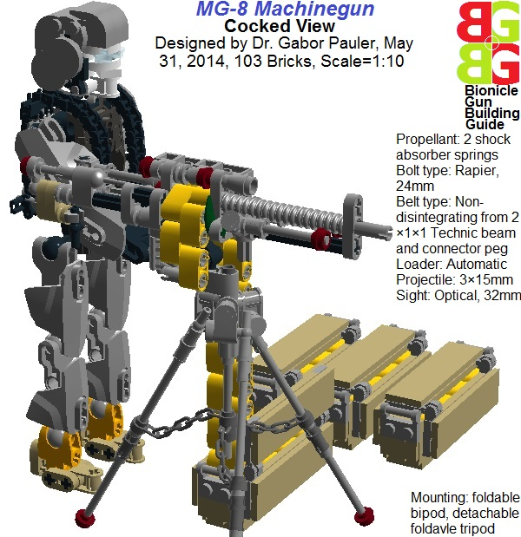
<b>Figure 39: MG-8 machinegun, cocked view</b>
See in LDD: <a href=http://www.brickshelf.com/gallery/gjpauler/SmallArms/PaulerMG8Scale1To10Cocked.lxf>Here</a>

<big><u>3.8 MGU-2 Gatling Minigun</u></big>

As our M134 Minigun MOC had serious structural problems caused by the usage of smaller sized 4-barrel rotor, we built a larger 6-barrel version which much more robust structure. However it became a little bit oversized for a Minigun, being more close to M-61 Vulcan rotary aircraft gun in dimensions.
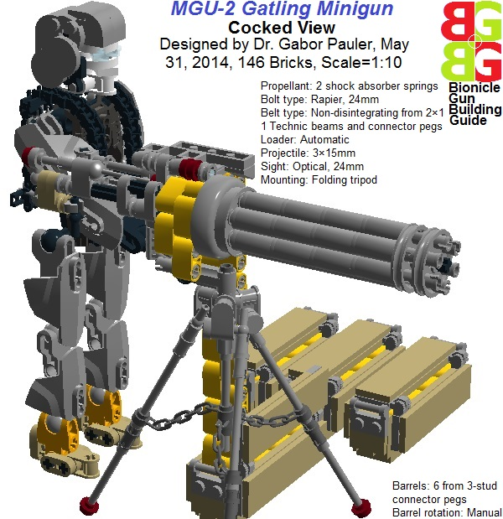
<b>Figure 40: MGU-2 gatling minigun, cocked view</b>
See in LDD: <a href=http://www.brickshelf.com/gallery/gjpauler/SmallArms/PaulerMGU2Scale1To10Cocked.lxf>Here</a>

<big><u>3.9 RPG-5 Rocket Propelled Grenade</u></big>

Building RPG launcher in scale 1:10 requires thin walled barrel with 1 stud diameter internal bore. In TLG parts, there is nothing even close to that. If we build such a barrel from separate parts, its outer diameter will be 3 studs, which is disproportionally thick. So I designed my RPG launcher as pseudo-barrel weapon: 4 technic cross-axles grouped closely in 1 stud distance round the RPG projectile as quartet of launching rails. This allows to put fixed stabilizer wings on the RPG projectile. In theory, RPGs in the reality could also use launch rails instead launch tube, just the hot propellant gases would roast personnel to death. The fixture of launching rails at the back has a hole in the middle, letting through the back end of flying spigot type bolt.
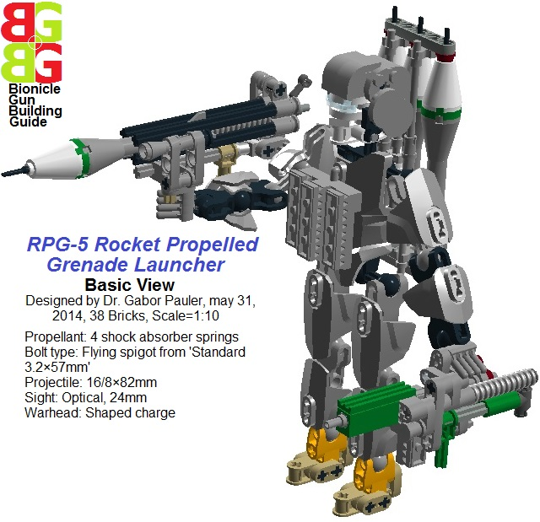
<b>Figure 41: RPG-5 rocket propelled grenade launcher, basic view</b>
See in LDD: <a href=http://www.brickshelf.com/gallery/gjpauler/SmallArms/PaulerRPG5Scale1To10.lxf>Here</a>

Bolt is made of TLG part ‘standard 3.2×57mm’, which has a 5mm diameter stop at its back end. A trigger made of ‘Stick with holder’ holds the bolt locked into the base of the launcher, keeping 4 shock absorber propellant springs compressed. When the trigger is broken down, bolt and springs fly out, launching the RPG projectile on its trajectory. the RPG launcher is equipped with a simple optical sight and triple manpack rack of spare RPGs. Auxiliary armament for personal defense includes submachine gun with 3 spare 9-round box magazines.

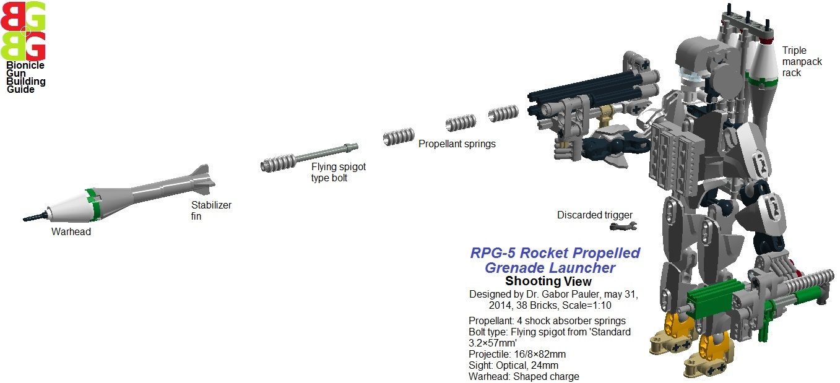
<b>Figure 42: RPG-5 rocket propelled grenade launcher, shooting view</b>
See in LDD: <a href=http://www.brickshelf.com/gallery/gjpauler/SmallArms/PaulerRPG5Scale1To10Shooting.lxf>Here</a>

<big><u>3.10 FT-2 Flamethrower</u></big>

This is the only non-working model in this handbook, but we tried to build realistic looking stuff with manpack napalm tanks, propellant gas pressure bottles, pressure gauges, valves, combustor head, etc. Using Technic pneumatics element, it would be possible to create an electric driven compressor, which vaporizes highly combustible material into air, what could be ignited. But it would be just too dangerous as a toy, as ABS elements itself can melt, burn down, not talking about the environment.

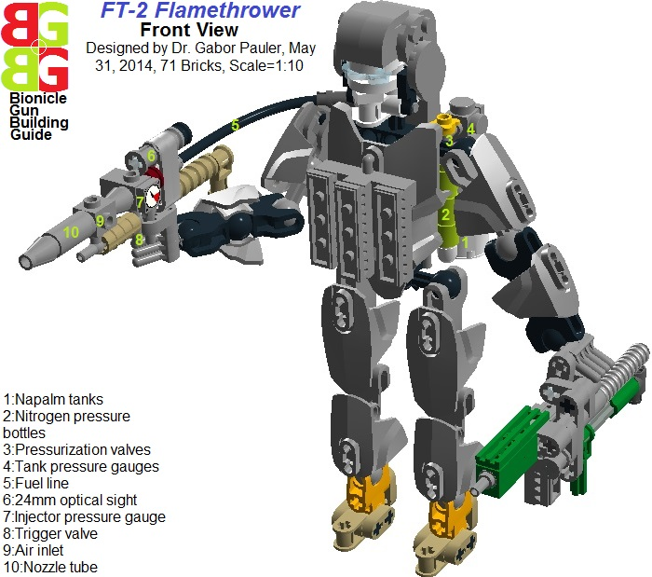
<b>Figure 43: FT-2 flamethrower, front view</b>
See in LDD: <a href=http://www.brickshelf.com/gallery/gjpauler/SmallArms/PaulerFT2Scale1To10.lxf>Here</a>

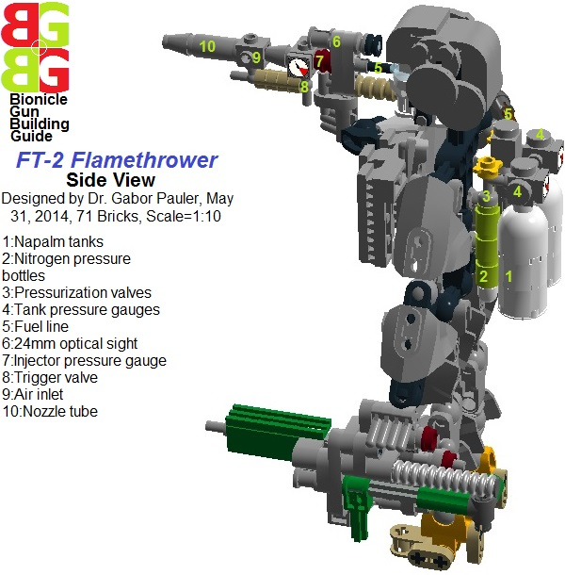
<b>Figure 44: FT-2 flamethrower, back view </b>
See in LDD: <a href=http://www.brickshelf.com/gallery/gjpauler/SmallArms/PaulerFT2Scale1To10.lxf>Here</a>

<big><u>3.11 LM-1 Light Mortar</u></big>

Mortars are not very spectacular and high tech, but very cheap and still effective stuff when the terrain is too bumpy for flat trajectory weapons, or in urban siege situations. We did not design separate historic and modern versions, as the difference is almost in the targeting telescopes. the problem was that light mortar also requires around 1 stud internal bore barrel in scale 1:10. This time we solved lack of such a barrel with series of TLG part ‘Plastic motor cylinder’. ‘Pistons’ are explosive bodies of mortar shells, while stabilizer wings are made of ‘Gear Z8’. Propellants are 3 shock absorber springs with piston rod type bolt. Panoramic type targeting telescope is added.
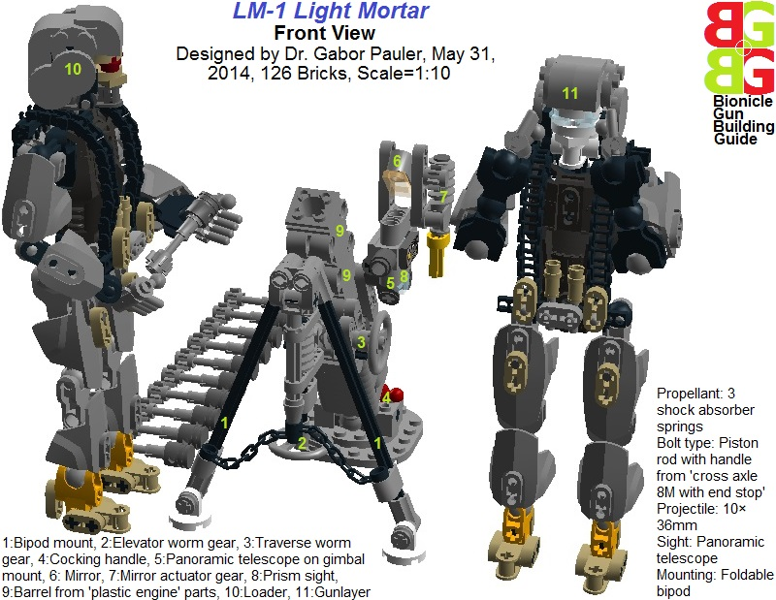
<b>Figure 45: LM-1 light mortar, front view</b>
See in LDD: <a href=http://www.brickshelf.com/gallery/gjpauler/SmallArms/PaulerLM1Scale1To10.lxf>Here</a>

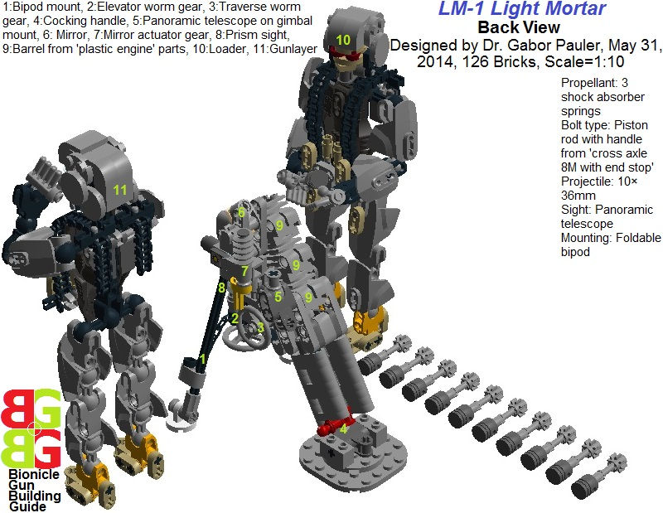
<b>Figure 46: LM-1 light mortar, back view</b>
See in LDD: <a href=http://www.brickshelf.com/gallery/gjpauler/SmallArms/PaulerLM1Scale1To10.lxf>Here</a>

