Revenge OT Sith
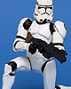Clone Trooper 06
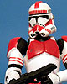Shock Trooper 06
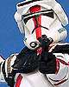Commander Deviss 33
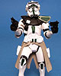Green Clone Commander 33
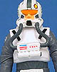Clone Pilot 34
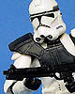AT-TE Pilot 38
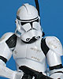Clone Trooper 41
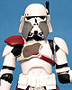Commander Bacara 49
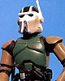AT-RT Pilot 54
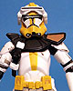Commander Bly 57
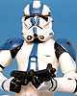
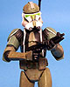Commander Gree 59

Tactical Ops Trooper 65
EXCLUSIVES
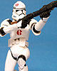91st Trooper
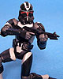Utapau Shadow Trooper
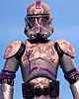Covert Ops Trooper

THE SAGA COLLECTION
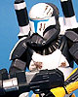 Scorch 21
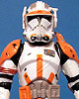Commander Cody 24
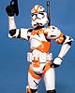Utapau Trooper
26
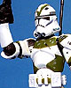442nd Trooper 57
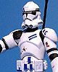5th Fleet Trooper
59
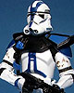Commander Appo 64
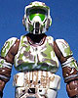Elite Corps Trooper 65
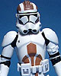Cobat Engineer 68

30th Collection
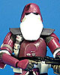Galactic Marine 02
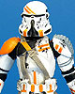Airborne Trooper 07
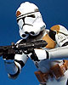 7th Legion Trooper 49
SAGA LEGENDS
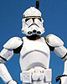Clone Trooper
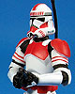Shock Trooper
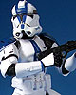501st Trooper
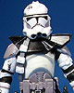Clone Commander
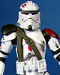Commander Neyo
Utapau Shadow Trooper
Covert Ops Trooper
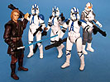
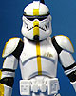Barc Trooper
The Legacy Collection
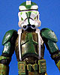Commander Gree
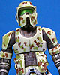Kashyyyk Trooper
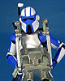Heavy Gunner
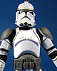Corucant Trooper
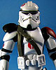Salucami Trooper
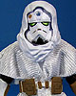Commander Faie
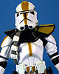327th Trooper
Battle packs
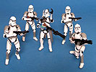
Clone Attack on Corucant

Jedi Temple Assult
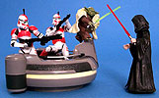
Skirmish in the Senate

