Sample TriMetrix-Related Interview Questions for the Producer/Sales Role

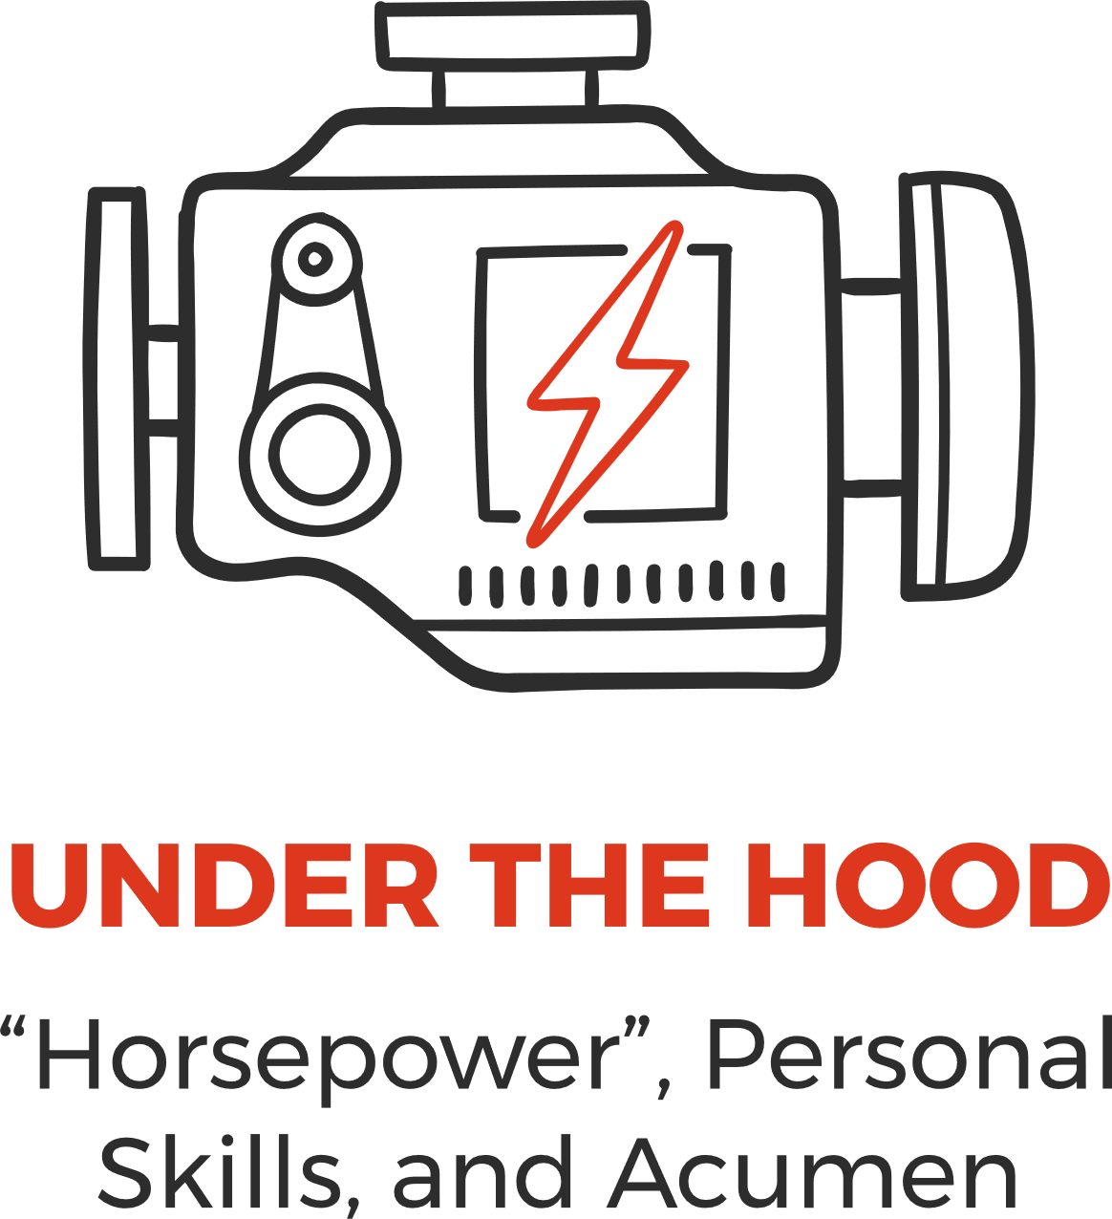
TOP PERSONAL SKILLS INTERVIEW QUESTIONS:
- Goal Achievement
- Describe the most complex project you have ever worked on. How did you establish action steps and milestones for that project? What was the most difficult part of that project for you?
- Share with me 5 goals you have previously set for yourself in your career. How many have you
accomplished? What are the reasons for your successful completion of them? How about those
goals you have not completed.
- Give me an example of a time when you really procrastinated before getting started on something. How did you get started? Did you complete that goal or project?
- Is there one thing in your life that you have accomplished that gives you the most satisfaction? What is it? How tough was it to accomplish?
- Personal Accountability
- What is the worst business decision you have ever made? What made it the worst? Would knowing what you do now have helped you to avoid making that decision?
- Give me an example of a lesson you have learned from making a mistake. What did you do differently?
- Self-Starting Ability
- Tell me about the most aggressive, self-starting person you ever knew. What did you admire most about that person? Least?
- Give me an example of a time when you went and made something happen without much outside prodding.
4. Resiliency
- Tell me about a specific setback you faced at work. How long did it take you to get past it?
- Give me an example of a time when you were forced to take the initiative in the face of a mounting tide of adversity or criticism. How, exactly, did you move past it?
- Do you consider yourself to be a resilient person? Who is the most resilient person you ever knew? How do you compare that person with resiliency?

5. Self-Management
- Give me a specific example of a project that you were responsible for organizing from beginning to end. How did you go about it? How did you deal with changes that arose? How did you ensure that the project stayed on track? What was the outcome? What did you learn from this experience?
- What is the difference between activity and results? How do you personally define this difference?
6. Customer Focus
- Tell me about a situation where you were able to anticipate a customer's needs before the customer even brought up what they wanted.
- Is there ever a time when a customer who is in error should be confronted? If so, give me an example of when that would be and how you would do that.
7. Interpersonal Skills
- Describe for me the most difficult business relationship you have ever had to deal with. Why was it so difficult? What did you do to make the relationship go more smoothly?
- What is your single biggest communication strength? How do you know? What is your greatest business success acquired because of this strength?
- Describe the most difficult, demanding person you have ever encountered. What made them so difficult? What did you do to better understand and relate to them?

8. Results Orientation
- Give me an example of one thing in your life that you have worked on for what you consider to be a very long time with no distraction or break. What did you dislike most about that? How successful were you in completing it? How long a time did you work it?
- Have results ever been less than stellar for a project you have worked on? What caused the results to be less than great? How did it happen?
9. Influencing Others
- What do you consider to be the most effective way to influence someone to a particular point of view? Give me an example of when you have done that successfully. Give me an example of a time when you listened carefully, and you learned something that helped you gain support or convince someone of something. What is the one, single thing you listened to and how did it help you?
- Have you ever seen someone continue to persuade someone even though the other person had already committed to the first person's point of view? What are some signs that communicate that this has happened?
- How often do you use tools or aids to help you persuade someone to your point of view? Give me several examples of what you have used and how you used them. How successful were you?

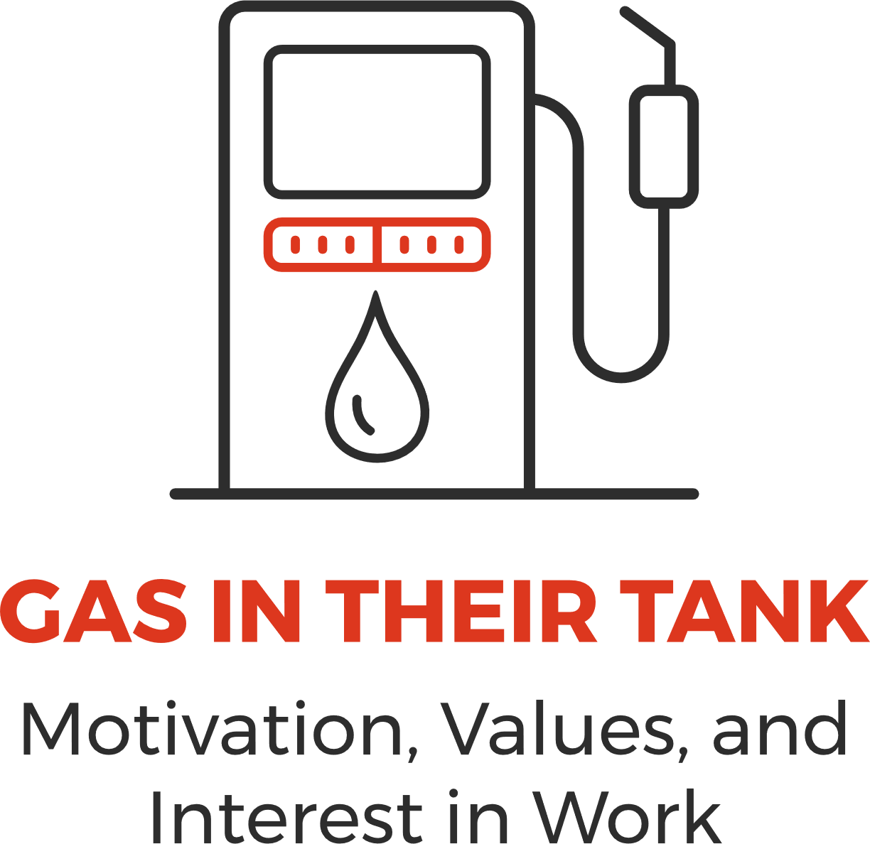

TOP MOTIVATORS INTERVIEW QUESTIONS:
- Utilitarian/Economic
- How important is earning a lot of money to you? What do you consider to be a “lot of money”?
- Where would you like to be, financially, in 5 years? 10 years? Why?
- Would you consider yourself to be a bottom line, practical thinker or are you more theoretical or philosophical? Why do you say that?
- Individualistic/Political
- What role does being in control of a situation play in your job satisfaction? How important is it for you to control your own destiny?
- How important is independence to you? Power? Influencing others? What would be your level of satisfaction with a job if you had none of these?
- How do you go about influencing others to act? Give me a concrete, real-world example of a time when you were able to move a group of people to action and exactly how you did it.
- Theoretical
- Would you consider yourself to be an expert in something? What is it? How did you go about gaining the knowledge?
- How comfortable are you in taking the time, energy and effort required to master a subject or topic you currently know very little about? How about one in which you have very little interest?


TOP BEHAVIORS INTERVIEW QUESTIONS:
- Competitiveness
- How demanding are you on yourself? How demanding are you on others? Do you think you are sometimes too demanding?
- Give me an example of a job situation where being demanding helped achieve the goal. Did it lead to other problems? Would others ever describe you as aggressive? Pushy? Why?
- How important is winning to you? How do you define winning? Give me an example of a situation where you felt you were going to lose. How did it feel? How did you handle it?
- Frequent Interaction with Others
- How do you handle frequent interruptions by other people? How about your response to people who ask you question after question?
- Are you more comfortable with details, people with the big picture, or with bits of data?
- Urgency
- When faced with a deadline, how do you respond?
- How important is it to you to have all the facts before proceeding? Give me an example of a time when you did not have all the facts and you did proceed. How did you feel? How did it work out?

